Level 3 Diploma for Managers
8410-01

January 2023 Version 1.7

Qualification Handbook

Qualification at a glance

Subject area | Management
ILM number | 8410-01
Age group approved | 16+
Entry requirements | None
Assessment | Onscreen Knowledge Test, Portfolio of Evidence, Professional Discussion
Approvals | Available from 1 April 2017
Apprenticeship Standard | Level 3 Team Leader/Supervisor
Registration and certification | Consult the Walled Garden/Online Catalogue for last dates

Title and level | ILM number |  | Accreditation number
Level 3 Diploma for Managers | 8410-01 | 603/1166/6

Version and date | Change detail | Section
1.0 March 2017 | Handbook created | All
1.1 April 2017 | Test specifications added | Units 300, 301, 302, 303
1.2 May 2017 | E-volve Licence application process and onscreen test details added | Assessment
1.3 August 2017 | Guidance around the use of simulation updated  Depth and Assessment Guidance | Appendix 1  Unit 311 – LO1
1.4 October 2017 | Pass marks added for Onscreen Knowledge Tests | Units 300, 301, 302, 303
1.5 July 2018 | Depth | Unit 314, Depth 3.1
1.6 May 2022 | Sample tests added for 317 and 318 | Appendix 6
1.7 January 2023 | ILM Workbook names updated | Units ??

This document is intended for current and prospective Centres of ILM and City & Guilds. All ILM qualifications are awarded by The City and Guilds of London Institute. This document should always be read in conjunction with the ILM Customer Handbook www.i-l-m.com/handbook.

Contents

Qualification at a glance 2
Contents 4
Introduction 5
Centre requirements 10
Delivering the qualification 15
Assessment 17
Knowledge units 23
Skills units 62
Combined knowledge and skills units 111
Appendix 1 Assessment guidance 133
Appendix 2 Conducting professional discussions 137
Appendix 3 Assessment plan template 139
Appendix 4 Assessment record sheet 140
Appendix 5 Sources of general information 142
Appendix 6 Sample Tests 143
Useful contacts 45

Introduction

This document tells you what you need to do to deliver the qualifications:
Area | Description
Qualification aim | To provide learners working in an organisation with the leadership and management knowledge and skills required to progress in their career and on to further study. When taken as part of the Team Leader/Supervisor apprenticeship standard the aim of this qualification is to support preparation for the end point assessment.
Who is the qualification for? | Ideal for professionals taking their first step into line management, or those with some experience of managing a team or project. The learner must be in employment to take this qualification.
Benefits for individuals | - Develop a range of essential management skills applied and refined in a real working environment.  - Build the leadership capability to motivate teams and influence with confidence.  - Gain a broad understanding of key management and leadership theory to underpin and support growth and performance.
Benefits for employers and educators | - Targeted learning and development in complete alignment with the latest apprenticeship standards – ensuring all learning is relevant, with no gaps in knowledge.  - Maximise learner’s confidence and readiness for End Point Assessment.  - Reward learner’s engagement and drives completion with ILM digital credentials.
What opportunities for progression are there? | The qualification allows learners to progress in their career or onto the following ILM qualifications:  - ILM Level 4 Award, Certificate and Diploma in Leadership and Management  - ILM Level 4 Award in Leadership  - ILM Level 5 Diploma for Leaders and Managers  - ILM Level 5 Award, Certificate and Diploma in Leadership and Management  - ILM Level 5 Award and Certificate in Leadership
Is it part of an apprenticeship? | This qualification provides full coverage of the ‘on programme’ element of the Team Leader/Supervisor Apprenticeship Standard. The qualification may also be delivered independent of the apprenticeship.

Structure
To achieve the Level 3 Diploma for Managers learners must achieve all 17 units. To achieve units 300, 301, 302 and 303 the associated onscreen knowledge tests 317 and 318 must be passed.
Level 3 Diploma for Managers
UAN | ILM unit number | Unit title | Level | Credit Value | GLH
Knowledge Units
D/615/5555 | 8410-300 | Leading People | 3 | 2 | 17
H/615/5556 | 8410-301 | Managing People | 3 | 2 | 17
K/615/5557 | 8410-302 | Building Relationships | 3 | 2 | 15
M/615/5558 | 8410-303 | Communication | 3 | 2 | 15
A/615/5563 | 8410-308 | Operational Management | 3 | 2 | 18
F/615/5564 | 8410-309 | Project Management | 3 | 2 | 15
J/615/5565 | 8410-310 | Finance | 3 | 2 | 15
Skills Units
T/615/5559 | 8410-304 | Leading People | 3 | 2 | 3
K/615/5560 | 8410-305 | Managing People | 3 | 2 | 3
M/615/5561 | 8410-306 | Building Relationships | 3 | 3 | 3
T/615/5562 | 8410-307 | Communication | 3 | 2 | 3
L/615/5566 | 8410-311 | Operational Management | 3 | 2 | 3
R/615/5567 | 8410-312 | Project Management | 3 | 2 | 3
Y/615/5568 | 8410-313 | Finance | 3 | 2 | 3
Combined Knowledge and Skills Units
D/615/5569 | 8410-314 | Self-Awareness | 3 | 3 | 15
R/615/5570 | 8410-315 | Management of Self | 3 | 3 | 12
Y/615/5571 | 8410-316 | Problem Solving and Decision Making | 3 | 3 | 12
Onscreen Knowledge Tests
n/a | 8410-317 | Level 3 Leading and Managing People | n/a | n/a | n/a
n/a | 8410-318 | Level 3 Communication and Building Relationships | n/a | n/a | n/a

Total qualification time (TQT)
Total Qualification Time (TQT) is the number of notional hours which represents an estimate of the total amount of time that could reasonably be expected for a learner to achieve and demonstrate the achievement of the level of attainment necessary for the award of a qualification.
TQT is comprised of the following two elements:
(1) the number of hours which an awarding organisation has assigned to a qualification for guided learning, and
(2) an estimate of the number of hours a learner will reasonably be likely to spend in preparation, study or any other form of participation in education or training, including assessment, which takes place as directed by – but, unlike guided learning, not under the immediate guidance or supervision of – a Lecturer, Supervisor, Tutor or other, appropriate provider of education or training.
Extract from: Ofqual, Total Qualification Time Criteria for All Qualifications, Section 1.8

Title and level | GLH | TQT | Credit
Level 3 Diploma for Managers | 172 | 370 | 38

Centre requirements

Approval
Centres must ensure they are approved by ILM to offer this qualification before commencing delivery. Centres must submit a learner journey plan (formerly known as a scheme of work), lesson plans etc. Once approved, the qualification will be listed on a Centre’s Walled Garden Catalogue. Centres should liaise with their Business Development Manager to obtain add-on approval.

Resource requirements
Occupational competence requirements
Centres must demonstrate that staff who are actively involved in the delivery of the qualification meet the occupational competence requirements determined by ILM. It is also the Centre’s responsibility to inform ILM of any changes to staffing by completing and returning a Centre Update Form (CUF). A curriculum vitae (CV) should be available for review by the Quality & Compliance Manager (QCM)/External Verifier (EV) if requested. Centres are responsible for updating the Centre Staffing Matrix.
Tutors, Assessors and Internal Verifiers must demonstrate that they:
- Have current, credible expertise in management and leadership relevant to the level(s)/units they are assessing or verifying.
- Maintain their knowledge and keep themselves up-to-date with developments in management and leadership practice.
- Have a thorough understanding of the Apprenticeship Standards for management and leadership at the level(s) they are delivering, assessing or verifying.
Evidence of occupational competence
ILM qualifications are derived from the Regulated Qualifications Framework (RQF) Level Descriptors and are designed to develop learner’s knowledge, understanding and skills which are then assessed through a range of work related assessments and onscreen tests.
Centre Tutors, Assessors and Internal Verifiers are therefore required as a team to have a combination of appropriate competences in learning, assessment and internal quality assurance methodologies. This must be underpinned by knowledge and experience of leadership, management and team skills within operational environments and sectors. This should be relevant to the qualifications being delivered and the learners undertaking them.
Occupational requirements checklists cannot therefore be prescriptive and the evidence indicators are offered as guidance. Centre staff will only be expected to meet a range of the evidence indicators. The table below shows the generic occupational competence requirements of Tutors, Internal Verifiers and/or Assessors.
Tutor occupational competence requirements | Evidence indicators
Relevant and sufficient occupational experience appropriate to the level and breadth of subject areas of the qualification units for which the Centre is approved. | - Current (within the last three years) experience appropriate to the level and breadth of subject areas of the qualification units for which the Centre has been approved.
A thorough knowledge and understanding of the subject areas appropriate to the level, breadth and content of the qualification units for which the Centre is approved. | - A relevant and sufficient qualification appropriate to the subject areas of the qualification units for which the Centre is approved, that must be equal to or higher than the approved qualification or  - Substantial experience, knowledge and understanding of the subject areas of the qualification units at the level for which the Centre is approved.
Continuing Professional Development. | - Evidence of participation over the past three years in Continuing Professional Development (CPD) appropriate to the level and subject area of the qualification units.  - Desirable but not essential to have membership of a professional institute or association appropriate to the level and subject area of the qualification.
Knowledge, understanding and application of a range of teaching and learning methodologies relevant to the level and subject area of the qualification units for which the Centre is approved. | - Hold a valid and recognised teaching/training qualification or  - Show evidence of current (within the last three years) experience of delivering training appropriate and relevant to the level and subject area of the qualification units.  - If assessing only with no delivery or training responsibilities, hold a valid and recognised assessor qualification or  - Show evidence of current (within the last three years) experience of assessing appropriate and relevant to the level and subject area of the qualification units.
Knowledge of ILM learning and assessment processes. | - Previous experience of delivery of ILM qualification(s) appropriate to the level and subject area of the qualification or  - Knowledge of the RQF (or Qualifications and Credit Framework (QCF)) and level descriptors appropriate to the level of the qualification.
Continuing Professional Development in training and learning. | - Show evidence of participation in CPD in relation to training and learning over the past three years relevant to the level and subject area of the qualification.

Internal Verifier and/or Centre Assessor occupational competence requirements | Evidence indicators
Relevant and sufficient occupational experience appropriate to the level and breadth of subject areas of the qualification units for which the Centre is approved. | - Current (within the last three years) occupational experience appropriate to the level and breadth of subject areas of the qualification units for which the Centre has been approved.
A thorough knowledge and understanding of the subject areas appropriate to the level, breadth and content of the qualification units for which the Centre is approved. | - A relevant and sufficient qualification appropriate to the subject areas of the qualification units for which the Centre is approved that must be equal to or higher than the approved qualification or  - Substantial knowledge and understanding of the subject areas of the qualification units at the level for which the Centre is approved.
Continuing Professional Development. | - Evidence of participation over the past three years in Continuing Professional Development (CPD) appropriate to the level and subject area of the qualification units.  - Desirable but not essential to have membership of a professional institute or association appropriate to the level and subject area of the qualification.
Knowledge, understanding and application of a range of assessment and/or internal quality assurance methodologies relevant to the level and subject area of the qualification units for which the Centre is approved. | - Demonstrate clear and sufficient evidence of current (within the last three years) experience of assessment and/internal verification appropriate and relevant to the level and subject area of the qualification.  - Have a relevant qualification in assessment and/or internal quality assurance (eg TAQA or equivalent) or  - Show evidence of current (within the last three years) experience of assessing and internal verification appropriate and relevant to the level and subject area of the qualification units.
Knowledge of ILM Vocationally Related Qualifications (VRQ) learning and assessment processes. | - Previous experience of delivery of ILM qualification(s) appropriate to the level and subject area of the qualification or  - Knowledge of the RQF (or QCF) and level descriptors appropriate to the level of the qualification.
Continuing Professional Development in assessment and/or internal quality assurance. | - Show sufficient evidence over the past three years of participation in CPD in relation to assessment and/or internal quality assurance relevant to the level and subject area of the qualification.

Learner entry requirements
ILM has not set an entry requirement for this qualification however Centres must ensure that learners are in a position to meet the assessment demands of the qualification, which are work-based and reflective in nature. As this qualification is work-based, learners must be employed in an appropriate role.

Age restrictions
ILM cannot accept any registrations for learners under 16 as this qualification is not approved for under 16s.

Time constraints
- Qualification registration is valid for three years.

Delivering the qualification

Initial assessment
An initial assessment of each learner should be made before the start of their programme to identify:
- if the learner has any specific training needs
- support and guidance they may need when working towards their qualification
- any previous, relevant qualifications or learning where Recognition of Prior Learning can be applied
- the appropriate type and level of qualification.
Centres are required to demonstrate commitment to equal opportunities when recruiting candidates. The Customer Handbook (www.i-l-m.com/handbook) gives guidance in making arrangements for learners requiring reasonable adjustments or special considerations in respect of assessment. This should be done as early as possible in the programme and needs to be approved by ILM before implementation.

Induction
Each programme must start with a short induction of at least two hours and should include written information for learners covering:
- An outline of the qualification and the related learner support available.
- The aim of the ILM Level 3 Diploma for Managers.
- Expectations of, and benefits to, the individual and where relevant, their employer.
- Format of the programme – content, hours, attendance, delivery methods, etc.
- The assessment requirements, including assessment criteria.
- Roles and responsibilities of Centre staff, learners and ILM.
- Learning and study skills, including reference to use of library, internet and any open or online learning to be used.
- Information on tutorial support, advice and guidance, equal opportunities, appeals procedures, authenticity and plagiarism.
- The Institute of Leadership & Management studying membership and benefits.

The following is recommended for this qualification:
Induction | Tutorial support
2 hours induction | At least 7 hours of tutorial support over and above the indicative guided learning hours

Supporting documentation and resources
The following supporting documentation and resources are available for this qualification:
Description | How to access
Sample Knowledge Tests | ILM Website
ILM Workbooks | Via Business Development Manager
ILM Digital Credentials | https://i-l-m.credly.com/#!/sign-in
Behaviours Mapping | ILM Website
Studying membership to The Institute of Leadership of Management | https://www.institutelm.com/membership/student-activation.html

Assessment

Summary of assessment methods
The qualification contains three types of units; knowledge, skills and combined, which will be assessed through either external or internal assessment as follows:
Unit number | Unit title | Assessment method | Description
8410-300 | Leading People | Combined onscreen multiple choice test (8410-317) | Externally set by ILM
8410-301 | Managing People | Combined onscreen multiple choice test (8410-317) | Externally set by ILM
8410-302 | Building Relationship | Combined onscreen multiple choice test (8410-318) | Externally set by ILM
8410-303 | Communication | Combined onscreen multiple choice test (8410-318) | Externally set by ILM
8410-308 | Operational Management | Portfolio of evidence | Internally assessed and externally verified
8410-309 | Project Management | Portfolio of evidence | Internally assessed and externally verified
8410-310 | Finance | Portfolio of evidence | Internally assessed and externally verified
8410-304 | Leading People | Portfolio of evidence | Internally assessed and externally verified
8410-305 | Managing People | Portfolio of evidence | Internally assessed and externally verified
8410-306 | Building Relationship | Portfolio of evidence | Internally assessed and externally verified
8410-307 | Communication | Portfolio of evidence | Internally assessed and externally verified
8410-311 | Operational Management | Portfolio of evidence | Internally assessed and externally verified
8410-312 | Project Management | Portfolio of evidence | Internally assessed and externally verified
8410-313 | Finance | Portfolio of evidence | Internally assessed and externally verified
8410-314 | Self-Awareness | Portfolio of evidence and professional discussion | Internally assessed and externally verified
8410-315 | Management of Self | Portfolio of evidence and professional discussion | Internally assessed and externally verified
8410-316 | Problem Solving and Decision Making | Portfolio of evidence and professional discussion | Internally assessed and externally verified
- To achieve a pass for the qualification, the learner must pass all units. To achieve units 300, 301, 302 and 303, the associated onscreen knowledge tests 317 and 318 must be passed.
- Unit specific assessment guidance is included within each unit.
Assessment strategy
The assessment strategy for this qualification uses the assessment methods to be utilised as part of the End-Point Assessment (EPA) of the Level 3 Team Leader/Supervisor Assessment Plan in order to enable learners to prepare for the EPA.
The purpose of the assessment for this qualification is to:
- Provide a robust, valid and reliable assessment, and to ensure that the learner is able to meet all outcomes as defined in this specification;
- Prepare learners for the End-Point Assessment under the Team Leader/Supervisor Apprenticeship Assessment Plan. To achieve this the assessment strategy of the qualification resembles the assessment plan for this Trailblazer standard.
Please refer to Appendix 1 for additional assessment guidance and further details on; assessment planning and review, quality assurance, workplace assessment/simulation, holistic and integrated assessment, judging sufficiency, grounds for referral, authenticity, communication and assessment decisions, language of assessment, access to assessment and special considerations.
A sample Assessment Plan Template and Assessment Record Sheet are provided in Appendix 3 and 4.

External assessment
Four of the knowledge units in this qualification are externally assessed through ILM set onscreen multiple choice tests. Tests are available on-demand and cover more than one unit.
The learner will need to have sufficient knowledge of all relevant units to be able to undertake each test.
Once a test is passed, the learner has achieved all units assessed via that test. The pass mark for the knowledge tests will be advised separately.
Centres need to make sure that learners are fully prepared to sit the onscreen tests, taking into account the content coverage of each test. If a learner completes a test and does not pass, then they must re-sit the full test.

Overview of onscreen tests
- The tests will have a set number of questions and marks. Please refer to the Assessment Requirements for each unit for more detail.
- The questions will comprise multiple choice, where the learner will be required to select the correct response to a question from one of four options, and multiple response questions, where the learner will be required to select two from five options.
- On completion of an online test, a score report is produced. The score report will indicate whether the learner has passed or been referred, the overall percentage achieved for the test and details a learner’s performance against each specified unit and learning outcome. This breakdown can be used to identify areas of knowledge that learners have not achieved. For further information on the score reports and resulting please refer to the E-Volve User Guide at www.cityandguilds.com/e-volve.
- Sample tests will be available from the ILM website from May 2017. This will provide a sample of the type of questions included in the tests and their structure.
- All centres offering onscreen assessment must comply with the ILM Instructions for Conducting Examinations (ICE).
- Centres are required to obtain a licence in order to offer online tests to candidates. As a part of the approval process for this qualification your Quality & Compliance Manager (QCM) will complete a license application form with you and our approvals team will process this for you.
- Learners can be registered for online tests on Walled Garden using the relevant test numbers. It is important to use the correct number. Please refer to the Walled Garden for these numbers.

Onscreen test structure
For the purposes of assessment, all the content of the units assessed via a knowledge test will be tested against the related assessment criteria. Learners will be assessed across all the learning outcome statements to provide adequate evidence of learning and achievement.
The unit content found in this handbook specifies the knowledge and understanding required in order for learners to be successful in the onscreen tests. Therefore, it is essential that learners have a full knowledge of the unit content before being registered for the onscreen tests.
Test items will not necessarily be sequenced in the order of the assessment criteria. Each test item will be independent from the other items.

Test conditions and invigilation requirements
All tests are required to be sat in closed book conditions, therefore notes or text books cannot be used. The use of mobile telephones and other such devices not used to sit the test is also prohibited during a test. Tests should be taken under supervised conditions, this means that all activities will be completed with an invigilator present. A tutor may act as the invigilator as long as there is another invigilator present, who has not had direct teaching responsibilities to the learners taking a test. Learners should on no account be allowed to take notes or answers away with them.
Further instructions are provided in the ILM Instructions for Conducting Examinations (ICE).

Internal assessment
The majority of the units in this qualification are internally assessed via a portfolio of evidence. This includes three knowledge (8410-308, 8410-309 and 8410-310), all skills and all combined units which are assessed by the Centre and subject to internal and external standards verification.
All assessments created by Centres for the development of a portfolio evidence must be valid, fit for purpose and based on the unit assessment criteria.
To pass each internally assessed unit the learner must:
- Satisfy all assessment criteria by providing sufficient and valid evidence.
- Demonstrate that the evidence is their own.
Assessment decisions can only be determined as competent (pass) or not yet competent (refer) and the only acceptable reason for a referral is a failure to meet one or more assessment criteria.

Types of evidence
Centres can choose the way evidence is gathered to be included in the portfolio for the three knowledge units (8410-308, 8410-309 and 8410-310), and for each skills and combined unit, as long as the methods chosen allow learners to produce valid, sufficient and reliable evidence of meeting the assessment criteria. A balance of evidence types need to be produced demonstrating learners’ understanding and competence.
Suggested types of evidence to cover each internally assessed unit is provided as part of the assessment guidance for each unit. Different types of evidence are recommended to demonstrate achievement of the assessment criteria in the three knowledge units (8410-308, 8410-309 and 8410-310) in comparison to the corresponding skills units (8410-311, 8410-312 and 8410-313). Corresponding knowledge and skill units can be assessed in an integrated manner, in which case it is required that sufficient evidence is generated to demonstrate how each criterion in each unit has been achieved. Demonstration of skills alone would not be considered sufficient to prove the implicit achievement of the knowledge assessment criteria.
Learners must provide tangible evidence to their assessor and this evidence should come from different sources. Only portfolios captured electronically will be accepted for external verification purposes. Should a paper-based format be required due to accessibility requirements this must be agreed in advance with ILM.

Assessment of combined units
The assessment activities and evidence for the combined units may take a variety of forms. One of these must come from a professional discussion for each combined unit in order to confirm, clarify or authenticate the evidence presented in support of the learning outcomes for these units. The professional discussion needs to be a substantial element of the assessment, and provide an overarching view of each unit, covering aspects of each learning outcome.
Professional discussion could therefore be used:
- to provide evidence for assessment criteria that are difficult to evidence through other assessment methods
- to identify and explore key aspects of candidate activity, knowledge or behaviours not readily demonstrated by other evidence
- where observation for a combined unit has been provided by an expert witness to confirm learner understanding.
A professional discussion must be undertaken for each combined unit, covering aspects of each learning outcome. Alternatively a longer discussion covering multiple combined units could also be undertaken, in which case each section of the record produced needs to clearly indicate the unit, learning outcomes and assessment criteria it relates to.
Professional discussions need to be conducted by the Centre Assessor, and a clear audit trail created. Written or audio summaries must be clearly cross referenced to the learning outcomes and assessment criteria to enable the evidence to be internally and externally verified.
Professional discussions could be done face-to-face, over the telephone or virtually using audio or video conferencing tools. All questions and outline responses should be recorded to provide an audit trail. Centres are recommended to request both Assessor and learner sign the record, against a statement confirming that it is a true account of the discussion, and to date the record in order to provide a sound audit trail.
Further guidance on planning and conducting professional discussions is available in Appendix 2.

Behaviours
The Behaviours requirements within the Team Leader/Supervisor Apprenticeship Standard are not assessed as part of this qualification. ILM has however produced a mapping document to highlight areas of the qualification where we expect behaviours evidence to be generated during qualification delivery.

Recognition of prior learning (RPL)
Recognition of prior learning means using a person’s previous experience or qualifications which have already been achieved to contribute to a new qualification. Please refer to the ILM Recognition of Prior Learning Policy (RPL).

Knowledge units

Unit 300 Leading People - Knowledge
UAN: | D/615/5555
Level: | Level 3
Credit value: | 2
GLH: | 17
Relationship to Standard: | Maps to the Leading People element of the Interpersonal Excellence knowledge section of the Apprenticeship Standard for Team Leader/Supervisor
Unit aim: | This unit will provide learners with knowledge of how to effectively lead, support and develop people in the workplace taking into account equality legislation

Learning outcome (LO 1)
The learner will:
1 Understand different leadership styles

Assessment criteria
The learner can:
  - Explain different leadership styles, identifying their strengths and weaknesses
  - Explain the suitability of different leadership styles in different situations

Depth
1.1 How leadership theories and models have developed.
The range of leadership theories and models available (Adair, Hersey and Blanchard, Tannenbaum and Schmidt, Fiedler).
Leadership styles that have been proposed (authoritarian, democratic, laissez faire, situational).
The strengths and weaknesses of each leadership style.

1.2 How leadership styles can be used to respond effectively to different situations.
Aspects that need to be considered when selecting an appropriate leadership style:
- The type of work.
- Time and resource constraints.
- Individual/team style.
- Organisational culture and environment.
The reasons why one leadership style may be more effective than another.

Learning outcome (LO 2)
The learner will:
2 Understand the role coaching plays in the workplace

Assessment criteria
The learner can:
  - Describe the benefits of using coaching to support individuals in the workplace
  - Describe how coaching can be used to improve the performance of individuals in the workplace

Depth
2.1 How coaching can support individuals in the workplace.
The range of benefits that individual coaching can bring to the workplace (improved performance, empowerment, personal development, engagement).

2.2 The links between coaching and improved performance in the workplace.
Principles of coaching and the differences between coaching, mentoring and training.
The range of coaching models and processes available (GROW, ARROW, OSCAR, FUEL).
The skills, abilities and characteristics required of an effective workplace coach.
Different learning styles that people may have and how these may be used to provide effective coaching.

Learning outcome (LO 3)
The learner will:
3 Understand the importance of organisational culture

Assessment criteria
The learner can:
  - Describe different cultures that exist in organisations
  - Identify internal and external factors which can affect an organisation’s culture
  - Explain the effect an organisation’s culture could have on individuals and teams

Depth
3.1 Different types of organisational culture and their key features.
The factors that contribute to organisational culture including assumptions, values and beliefs.
How culture can differ between different divisions/structures within same organisation.

3.2 The internal factors which can affect organisational culture including:
- Organisational structure.
- Power and control mechanisms.
- Leadership role models.
- Values and beliefs.
The external factors that can affect organisational culture including:
- Economic.
- Social.
- Technological.
- Legal.
The description should give examples of how relevant factors relate to specific cultural features.

3.3 How an organisation’s culture affects individuals in different ways.
The implications of different cultures on team working.

Learning outcome (LO 4)
The learner will:
4 Understand equality, diversity and inclusion in the workplace

Assessment criteria
The learner can:
  - Explain the difference between equality, diversity and inclusion
  - Explain the responsibilities of organisations under current equality legislation
  - Describe the potential consequences of not adhering to equality legislation

Depth
4.1 What is meant by equality, diversity and inclusion in a workplace context.
How equality, diversity and inclusion differ.
Codes of practice regarding how to treat people equally in the workplace.
Diversity issues that arise in the workplace and how these may be managed.
Approaches for creating an inclusive workplace.

4.2 Learners must ensure they refer to the latest legislation and what an organisation must do to adhere to this.

4.3 What workplace behaviour is unlawful.
The role of the Equalities and Human Rights Commission to protect, enforce and promote equality.
Actions that may be taken if an organisation does not adhere to relevant legislation at an organisational and individual level.

Assessment requirements
This unit will be externally assessed through an ILM set and marked onscreen test. The onscreen test will be available on-demand.
The knowledge test for this unit is combined with Unit 301 Managing People – Knowledge. The test assesses all of the learning outcomes and assessment criteria of both units and uses the Depth for each unit as a base for the questions.
The onscreen knowledge test 8410-317 must be passed to achieve this unit.
The details for the combined knowledge test are below:
Onscreen test title | Duration | Number of questions | Number of marks
Level 3 Leading and Managing People (8410-317) | 60 minutes | 40 | 47

The pass mark for the test is 26 out of 47 marks.
ILM continually monitors and reviews test performance, as a result pass marks may change – ILM will notify users of any changes to pass marks. Qualification handbooks will always contain the correct pass mark for any test used.
Test specification
Unit title | Learning outcome | Number of marks | Weighting
Unit 300 Leading People - Knowledge | Understand different leadership styles | 5 | 11%
Unit 300 Leading People - Knowledge | Understand the role coaching plays in the workplace | 5 | 11%
Unit 300 Leading People - Knowledge | Understand the importance of organisational culture | 5 | 11%
Unit 300 Leading People - Knowledge | Understand equality, diversity and inclusion in the workplace | 9 | 19%
Unit 301 Managing People - Knowledge | Understand people and team management models | 11 | 22%
Unit 301 Managing People - Knowledge | Understand Human Resource procedures and legal requirements | 5 | 11%
Unit 301 Managing People - Knowledge | Understand performance management methods for individuals | 7 | 15%

Suggested learning resources
ILM Workbook – Leading People.

Unit 301 Managing People - Knowledge
UAN: | H/615/5556
Level: | Level 3
Credit value: | 2
GLH: | 17
Relationship to Standard: | Maps to the Managing People element of the Interpersonal Excellence knowledge section of the Apprenticeship Standard for Team Leader/Supervisor
Unit aim: | This unit will provide learners with knowledge of people and team management models, including team dynamics and motivation techniques. Learners will understand HR procedures, legal requirements and a range of performance management techniques

Learning outcome (LO 1)
The learner will:
1 Understand people and team management models

Assessment criteria
The learner can:
  - Explain the difference between people management and managing teams
  - Describe different approaches to people management
  - Describe the importance of team dynamics
  - Describe different approaches to team management
  - Explain different motivational techniques including how they can be applied to both teams and individuals

Depth
1.1 How the requirements of individual people differ from the requirements of teams.
Different types of team in the workplace.
Team management approaches and styles.
Requirements for managing individuals within a team.
The different roles that people bring to a team, and relevant theories/models (Belbin, FIRO, Benne and Sheats).
The management/leadership skills required to lead different types of teams.

1.2 The different roles that individuals undertake within a team.
The skills of individuals and how these can be used to best effect.
How to make individuals effective within the team.

1.3 What team dynamics are.
How teams develop different dynamics, and the implications for leadership.
The impact that team dynamics can have on leadership and the other people within the team.
The causes of problems in team dynamics.
How team dynamics can be improved.

1.4 Different types of team in the workplace.
How teams develop and the implications for leadership.
Different requirements of teams.
The management/leadership skills required to lead different types of teams.

1.5 The range of motivational theories (Maslow’s Hierarchy, Herzberg’s Two-Factor, Adams Equity, Vroom’s Expectancy).
What motivates individuals in the workplace.
How to apply motivational techniques in the workplace, based on theory.
How to use different approaches at different times.
The different approaches for motivating teams and individuals.

Learning outcome (LO 2)
The learner will:
2 Understand Human Resource procedures and legal requirements

Assessment criteria
The learner can:
  - Explain the legal requirements that must be adhered to when dealing with:
- Recruitment and selection.
- Discipline and grievance.
- Sickness and absence.
- Harassment and bullying.

  - Describe the HR systems and procedures within an organisation and how these meet legal requirements

Depth
2.1 The legal requirements that must be followed for managing people in line with HR procedures.
The leader’s role in fulfilling these legal requirements.

2.2 The HR systems within an organisation (eg specialised recruitment software).
The HR procedures within an organisation that meet the legal requirements for:
- Recruitment and selection.
- Discipline and grievance.
- Sickness and absence.
- Harassment and bullying.
Relevant workplace examples of the above should be described.

Learning outcome (LO 3)
The learner will:
3 Understand performance management methods for individuals

Assessment criteria
The learner can:
  - Describe the following performance management methods:
- Setting goals and objectives.
- Conducting appraisals.
- Absence management.
- Reviewing performance.
  - Explain the importance of providing constructive feedback

Depth
3.1 Performance management techniques and their purpose including:
- Setting of SMART objectives.
- How to conduct an individual performance appraisal in line with organisational requirements.
- The absence management process, and how to follow this in line with organisational requirements.
- How to ensure performance management processes are conducted fairly and objectively.
- How to ensure all performance is reviewed using effective, valid and reliable information/data.
- How to use formal and informal assessment to review performance.
- How to ensure that all processes are two way and involve both parties.
- The communication skills required to ensure that the processes are two way (questioning, active listening).

3.2 Different models of feedback, such as CORBs and the Situation Behaviour Impact (SBI) model, to frame effective feedback.
How to interpret performance data, and observe workplace activities, to make objective judgements on an individual’s performance.
How to give effective feedback by using good practice guidelines.
How to use effective open questions and listening skills to ensure feedback is a two-way process.
How to give feedback that highlights good performance and is not just about improvement.

Assessment requirements
This unit will be externally assessed through an ILM set and marked onscreen test. The onscreen test will be available on-demand.
The knowledge test for this unit is combined with Unit 300 Leading People – Knowledge. The test assesses all of the learning outcomes and assessment criteria of both units and uses the Depth for each unit as a base for the questions.
The onscreen knowledge test 8410-317 must be passed to achieve this unit.
The details for the combined knowledge test are below:
Onscreen test title | Duration | Number of questions | Number of marks
Level 3 Leading and Managing People (8410-317) | 60 minutes | 40 | 47

The pass mark for the test is 26 out of 47 marks.
ILM continually monitors and reviews test performance, as a result pass marks may change – ILM will notify users of any changes to pass marks. Qualification handbooks will always contain the correct pass mark for any test used.
Test specification
Unit title | Learning outcome | Number of marks | Weighting
Unit 300 Leading People - Knowledge | Understand different leadership styles | 5 | 11%
Unit 300 Leading People - Knowledge | Understand the role coaching plays in the workplace | 5 | 11%
Unit 300 Leading People - Knowledge | Understand the importance of organisational culture | 5 | 11%
Unit 300 Leading People - Knowledge | Understand equality, diversity and inclusion in the workplace | 9 | 19%
Unit 301 Managing People - Knowledge | Understand people and team management models | 11 | 22%
Unit 301 Managing People - Knowledge | Understand Human Resource procedures and legal requirements | 5 | 11%
Unit 301 Managing People - Knowledge | Understand performance management methods for individuals | 7 | 15%

Suggested learning resources
ILM Workbook – Managing People. – suggest managing teams?

Unit 302 Building Relationships - Knowledge
UAN: | K/615/5557
Level: | Level 3
Credit value: | 2
GLH: | 15
Relationship to Standard: | Maps to the Building Relationships element of the Interpersonal Excellence knowledge section of the Apprenticeship Standard for Team Leader/Supervisor
Unit aim: | This unit will provide learners with the knowledge of how to manage customer and stakeholder relationships, and facilitate cross team working to deliver organisational objectives

Learning outcome (LO 1)
The learner will:
1 Understand approaches to customer and stakeholder relationship management

Assessment criteria

The learner can:
  - Describe the skills required to build and manage business relationships
  - Describe approaches to effectively build and manage customer relationships
  - Describe approaches to effectively build and manage stakeholder relationships

Depth
- The skills that are needed to:
- Gather information about the parties involved to understand their perspective and priorities.
- Establish trust and rapport.
- Effectively adapt communication methods and style.
- Set and manage expectations.
- Maintain engagement.
- Influence decision-making.
- Create and maintain records of interactions.

- How to communicate with customers to identify their needs and wants.
How to use questioning, listening and acknowledging techniques to demonstrate understanding of the customer, leading to an improved relationship.
How to negotiate and influence customers to achieve win/win situations using appropriate strategy, tactics and behaviours.
How to maintain records of customer interactions for future relationship management.
How customer relationship management differs from customer service.

1.3 How to identify stakeholders and determine their interests, expectations and influence using relevant techniques (eg stakeholder analysis/mapping).
How to communicate with stakeholders to meet their expectations (eg as identified from the stakeholder analysis/mapping).
How to negotiate and influence stakeholders to achieve win/win situations, using appropriate strategy, tactics and behaviour.
How to maintain records of stakeholder interactions for future relationship management.
How stakeholder relationship management differs from customer relationship management.

Learning outcome (LO 2)
The learner will:
2 Understand cross team working

Assessment criteria
The learner can:
  - Explain the benefits and challenges of cross team working
  - Describe how to build relationships across teams to achieve organisational objectives

Depth
2.1 How cross-functional teams work together to reach an organisational goal or objective.
The benefits of cross team working (diversity, broaden the range of skills, build team spirit, empowering people).
The challenges of cross team working (conflict, practical management difficulties, lack of shared understanding, increased stress and anxiety).

2.2 The key relationships that facilitate cross team working.
How to reach consensus regarding how different teams will work together (formal/informal communication structures, relevant organisational processes, guidelines for highlighting issues).
How to communicate with all team members to develop shared purpose and goals for the achievement of organisational objectives.
The communication methods/media available and know how to select the most effective method/media (rather than the easiest).
How to empower individuals and teams to achieve cross team goals.

Learning outcome (LO 3)
The learner will:
3 Understand the importance of emotional intelligence in the workplace

Assessment criteria

The learner can:
  - Define emotional intelligence
  - Explain the importance of emotional intelligence in the workplace

Depth
3.1 What is meant by emotional intelligence in the workplace, using a relevant theory (Goleman, Salovey and Mayer, Petrides and Furnham).
How managing own emotions can assist in building effective working relationships.

3.2 How emotional intelligence theories can enhance working relationships (Goleman, Salovey and Mayer, Petrides and Furnham).
The characteristics of emotional intelligence, and how these can benefit working relationships.
The potential impact of not demonstrating emotional intelligence in interactions with different stakeholders.

Learning outcome (LO 4)
The learner will:
4 Understand the importance of conflict management in the workplace

Assessment criteria

The learner can:
  - Explain the importance of conflict management
  - Describe a range of conflict management models

Depth
4.1 How to recognise conflicts as they arise to limit negative impact(s) and increase the positive aspects.
The role that effective on-going conflict management can play in building long term relationships.
The impact that conflicts may have when they are ignored, or are poorly managed.

4.2 Conflict management models and styles (Thomas-Kilmann, Problem Solving Cycles, Interest-Based Relational Approach, Lederach).

Assessment requirements
This unit will be externally assessed through an ILM set and marked onscreen test. The onscreen test will be available on-demand.
The knowledge test for this unit is combined with Unit 303 Communication – Knowledge. The test assesses all of the learning outcomes and assessment criteria of both units and uses the Depth for each unit as a base for the questions.
The onscreen knowledge test 8410-318 must be passed to achieve this unit.
The details for the combined knowledge test are below:
Onscreen test title | Duration | Number of questions | Number of marks
Level 3 Communication and Building Relationships (8410-318) | 60 minutes | 40 | 45

The pass mark for the test is 24 out of 45 marks.
ILM continually monitors and reviews test performance, as a result pass marks may change – ILM will notify users of any changes to pass marks. Qualification handbooks will always contain the correct pass mark for any test used.
Test specification
Unit title | Learning outcome | Number of marks | Weighting
Unit 302 Building Relationships - Knowledge | Understand approaches to customer and stakeholder relationship management | 8 | 18%
Unit 302 Building Relationships - Knowledge | Understand cross team working | 7 | 15%
Unit 302 Building Relationships - Knowledge | Understand the importance of emotional intelligence in the workplace | 4 | 9%
Unit 302 Building Relationships - Knowledge | Understand the importance of conflict management in the workplace | 4 | 9%
Unit 303 Communication - Knowledge | Understand different forms of communication and their application | 4 | 9%
Unit 303 Communication - Knowledge | Know how to chair a meeting | 9 | 20%
Unit 303 Communication - Knowledge | Understand how to manage challenging conversations | 9 | 20%

Suggested learning resources
ILM Workbook – Managing Relationships at Work.

Unit 303 Communication - Knowledge
UAN: | M/615/5558
Level: | Level 3
Credit value: | 2
GLH: | 15
Relationship to Standard: | Maps to the Communication element of the Interpersonal Excellence knowledge section of the Apprenticeship Standard for Team Leader/Supervisor
Unit aim: | This unit will provide learners with knowledge of different forms of communication. Learners will know how to chair meetings, hold difficult conversations, deliver constructive feedback and understand how to raise concerns

Learning outcome (LO 1)
The learner will:
1 Understand different forms of communication and their application

Assessment criteria

The learner can:
  - Compare different forms of communication including their strengths and weaknesses
  - Explain when and why each form of communication can be most effectively used

Depth
1.1 The different forms of communication that can be used, including verbal, non-verbal, written, visual and digital/electronic.
How the types of communication differ from each other, including examples of each.
How formal and informal communication relates to the different types.
How synchronous and asynchronous communication can be applied effectively.
The potential strengths of each type of communication.
The potential weaknesses of the different forms of communication.
1.2 How to choose an appropriate communication form according to the situation.
The reasons for choosing each communication form.
How each communication form can increase the effectiveness of communication.
How to communicate the same message using different forms of communication, to meet the needs of different audiences.
The potential impact(s) of using the wrong type of communication.

Learning outcome (LO 2)
The learner will:
2 Know how to chair a meeting

Assessment criteria

The learner can:
  - Describe key documentation that a chairperson should produce and circulate prior to and after a meeting
  - Identify the steps a chairperson needs to undertake when preparing for a meeting.
  - Explain how to effectively facilitate a meeting
  - Describe the steps that a chairperson needs to undertake to ensure that actions agreed during a meeting are completed

Depth
2.1 The documentation a chairperson should produce before a meeting including:
- Agenda.
- Previous minutes (if applicable).
- Protocols and procedures for meeting (if appropriate).
- Other documents/information to be discussed.
The description should include the purpose of each of the documents, with best practice guidelines on what should be included, and how this information should be presented.
How to circulate documents prior to a meeting, taking any confidentiality requirements into account.
When the key documentation should be circulated to maximise contributions from others.
How to distribute information after a meeting.

2.2 How to prepare effectively for a meeting, to ensure that:
- The venue/environment is suitable.
- The timing and length of meeting is appropriate.
- All relevant participants can attend.
- All attendees can contribute effectively.
This should be presented as logical steps which must be undertaken prior to the meeting taking place.

2.3 The leadership styles a chairperson may use in meetings to ensure they are effective.
How to manage time, based on the agenda and meeting objectives.
How to use effective communication skills to ensure all participants contribute to a successful meeting (questioning, listening, body-language, rapport building).
How to regulate the flow of discussion so that relevant people contribute (those with expertise, drawing out opinions from quieter people, minimising dominant participants).
How to guide the meeting to address each agenda item fully, and ensure that all intended points are covered effectively.
How to clarify and summarise discussions to agree actions.
How to work with the minute taker to ensure all key information is recorded.

2.4 The process for finalising the minutes of the meeting with the minute taker.
When to distribute information after a meeting.
How to communicate the actions agreed at the meeting to relevant people.
How to follow up on actions as and when required.
How to manage others in achieving their actions as and when required.

Learning outcome (LO 3)
The learner will:
3 Understand how to manage challenging conversations

Assessment criteria

The learner can:
  - Explain how to prepare for a difficult or challenging conversation
  - Describe the techniques that can be used to manage challenging conversations
  - Explain how to effectively deliver constructive feedback
  - Describe the circumstances under which issues should be escalated

Depth
3.1 The reasons why people do not like challenging conversations and why they avoid them.
The importance of considering the purpose of the challenging conversation.
The techniques that can be used to clarify and understand the situation (consider personal emotions, values, bias and filters).
How to use personal communication style and the style of the other person involved to prepare effectively.
How to use workplace evidence and feedback from others to prepare for challenging conversations.
How to create notes to prepare effectively for challenging communications.
The role that the working environment and culture plays in a challenging conversation.

3.2 The most effective communication styles to use for challenging conversations.
How to use questioning effectively during a challenging conversation.
How to actively listen to, respect, and fully consider others’ opinions.
How to hold the conversation in a neutral and non-emotive manner.
The language that is most effective when having challenging conversations, and words that should be avoided.
How to re-frame personal mindset to create a positive and constructive approach.
Techniques to remain calm during challenging discussions.

3.3 The different models and techniques that can be used to deliver constructive feedback (CORBs, Situation Behaviour Impact (SBI) model, Pendleton, STAR).
How to use effective open questions and listen actively to ensure feedback is a two-way process.
The difference between objective constructive information compared to subjective destructive information.
How to avoid responding defensively during the challenging conversation.
How the working environment affects the successful delivery of feedback.

3.4 The reasons an issue would need to be escalated following a challenging conversation.
How to recognise limits of personal responsibility, and escalate the issue including:
- The process and timing.
- Lines of authority relevant to the issue.

Assessment requirements
This unit will be externally assessed through an ILM set and marked onscreen test. The onscreen test will be available on-demand.
The knowledge test for this unit is combined with Unit 302 Building Relationships – Knowledge. The test assesses all of the learning outcomes and assessment criteria of both units and uses the Depth for each unit as a base for the questions.
The onscreen knowledge test 8410-318 must be passed to achieve this unit.
The details for the combined knowledge test are below:
Onscreen test title | Duration | Number of questions | Number of marks
Level 3 Communication and Building Relationships (8410-318) | 60 minutes | 40 | 45

The pass mark for the test is 24 out of 45 marks.
ILM continually monitors and reviews test performance, as a result pass marks may change – ILM will notify users of any changes to pass marks. Qualification handbooks will always contain the correct pass mark for any test used.
Test specification
Unit title | Learning outcome | Number of marks | Weighting
Unit 302 Building Relationships - Knowledge | Understand approaches to customer and stakeholder relationship management | 8 | 18%
Unit 302 Building Relationships - Knowledge | Understand cross team working | 7 | 15%
Unit 302 Building Relationships - Knowledge | Understand the importance of emotional intelligence in the workplace | 4 | 9%
Unit 302 Building Relationships - Knowledge | Understand the importance of conflict management in the workplace | 4 | 9%
Unit 303 Communication - Knowledge | Understand different forms of communication and their application | 4 | 9%
Unit 303 Communication - Knowledge | Know how to chair a meeting | 9 | 20%
Unit 303 Communication - Knowledge | Understand how to manage challenging conversations | 9 | 20%

Suggested learning resources
ILM Workbook – Communication and Interpersonal Skills.

Unit 308 Operational Management - Knowledge
UAN: | A/615/5563
Level: | Level 3
Credit value: | 2
GLH: | 18
Relationship to Standard: | Maps to the Operational Management element of the Organisational Performance knowledge section of the Apprenticeship Standard for Team Leader/Supervisor
Unit aim: | This unit will provide learners with knowledge of how to manage data, achieve operational/team objectives and effectively manage change within a team

Learning outcome (LO 1)
The learner will:
1 Understand how organisational strategy is developed

Assessment criteria
The learner can:
  - Explain the process of developing an organisational strategy
  - Explain how the operational plans of departments/teams relate to the overall organisation’s strategy

Depth
1.1 How organisational strategy is developed by an organisation, including:
- Analysis and assessment of current internal and external environments
- Strategy formulation and planning at a high-level.
- How the high-level plan is translated into operational planning and team/individual actions.

1.2 The relationship between the operational plans of the department/team and the organisations strategy including:
- How department/team objectives contribute to the achievement of organisational goals.
- Why objectives need to be SMART to help achieve goals.
- How the department/team contribute to the overall organisational goals.
- How the department/team are supported by other teams.
- How the department/team supports other departments/teams.

Assessment guidance
The learner must:
1.1 Explain the complete end to end process of developing one organisational strategy.
1.2 Explain how the operational plans of the department/teams relate to the organisational strategy. Examples from own workplace may be used.

Suggested evidence may come from (but is not restricted to):
Written explanation or report, professional discussion record, Q & A, work products showing organisational strategy and operational plans.

Learning outcome (LO 2)
The learner will:
2 Know how to effectively implement operational/team plans given resources available

Assessment criteria
The learner can:
  - Describe the actions needed to implement operational/team plans within agreed timescales and budget
  - Explain how operational/team plans are revised in response to changes in organisational objectives

Depth
2.1 How to identify the actions necessary to implement team plans.
How to translate operational/team objectives into SMART objectives for individual team members.
Planning how team objectives can be achieved through the use of resources (including people, time, materials and equipment).
How to maximise available resources and identify shortfalls (eg using resource plans, workflow systems etc).
How to operate within agreed budgets and timescales.

2.2 How working practices operate and how to make improvements where required.
The relationship between organisational objectives and operational plans.
The reasons why plans may need to be revised.
How to revise objectives and minimise the impact of revisions.

Assessment guidance
The learner must:
2.1 Describe at least two actions needed to implement operational/team plans.
Describe how these actions will operate within both agreed timescales and budget.
2.2 Explain how the operational/team plans are revised in response to changes in organisational objectives giving two examples.

Suggested evidence may come from (but is not restricted to):
Written explanation or report, professional discussion records, Q & A, work products showing organisational strategy and operational plans, action plans.

Learning outcome (LO 3)
The learner will:
3 Know how to manage change within a team

Assessment criteria
The learner can:
  - Describe the positive and negative impacts change can have within a team
  - Describe techniques that could be used to support a team through change

Depth
3.1 How change can affect the team and individuals in different ways.
The negative responses to change (eg uncertainty, fear, increased stress etc).
The positive reactions to change (eg potential opportunities for development, potential to improve team working practices, personal growth etc).
How to manage change within a team when individuals are reacting differently, and some are resisting the change.

3.2 Techniques that can be used to support a team through change such as:
- How to assess change readiness.
- Planning of change activities and support requirements.
- Using a change management model and processes (eg Kotter, Adkar, McKinsey 7s, Burke-Litwin etc).
- Effective communication techniques.
- Consulting and involving the team in decision making.
- Use of empathy and emotional intelligence.
- Use of appropriate leadership styles.
- Regularly reviewing the required changes to fully understand the feelings of and impact on the team.

Assessment guidance
The learner must:
3.1 Describe both the positive and negative impacts change can have within a team including at least one example of each.
3.2 Describe at least two techniques that can be used to support a team through change.

Suggested evidence may come from (but is not restricted to):
Work products showing change activities, reports, written account/statement, Q & A, professional discussion records.

Learning outcome (LO 4)
The learner will:
4 Understand how data is managed in the workplace

Assessment criteria
The learner can:
  - Describe how operational data is managed in the workplace
  - Describe the importance of data protection
  - Explain how technology can be used to improve data management in the workplace

Depth
4.1 How both quantitative and qualitative data is collected and analysed.
How data is accessed and stored in line with legislation such as the Data Protection Act.
How data is used to make decisions.
The people who are responsible for managing operational data.

4.2 The importance of maintaining the integrity of customer data and relationships.
How to protect sensitive data relating to organisational plans or strategies.
Current data protection legislation and the purpose of the legislation.
The implications for organisational processes relating to data collection (eg informing individuals, handling and storage).
The implications of not adhering to data protection legislation.

4.3 How technology is used to manage and interpret data in the workplace.
How technology allows data to be used in different ways and to be presented in a range of formats to suit the end purpose.
How innovative technology can change the way that data is managed to improve quality, efficiency and productivity.

Assessment guidance
The learner must:
4.1 Describe how operational data is managed in the workplace using examples of two different types of data.
4.2 Describe the importance of data protection. This should address the importance of data protection and not a description of the terminology.
4.3 Explain how technology can be used to improve data management in the workplace clearly addressing how the technology can be used to improve data management.

Suggested evidence may come from (but is not restricted to):
Work products showing data collection and use of technology, reports, written account/statement, Q & A, professional discussion records.

Assessment requirements
This unit will be internally assessed through a centre set and marked portfolio of evidence which is subject to internal and external verification.
To pass this unit the evidence that the learner presents for assessment must demonstrate that they have met the required standard specified in the learning outcomes and assessment criteria and the requirements of the Assessment Strategy. The unit will be assessed as pass/refer.
Learners will agree with their assessor appropriate evidence which reflects their role and responsibility. Learners can use one piece of evidence to prove their skills across different assessment criteria and/or across different units. It is not necessary for learners to have each assessment criterion assessed with a separate piece of evidence.
Evidence for this unit is likely to come from naturally occurring activities from the workplace and may include (but is not restricted to):
- Written explanation/report.
- Products from the learner’s work.
- Outcomes from oral or written questioning.
- Personal statements and/or reflective accounts.
- Professional discussion.
- Authentic statements/witness testimony.
Learners must carry the tasks out individually. Learners may carry out research and collect the information they want to use under unsupervised conditions.

Links to other units
This section provides guidance on where links to other units may be found.
Unit | Learning outcome
Operational Management – Skills | LO 1 Be able to deliver against an operational plan  LO 2 Be able to adapt to change  LO 3 Be able to work with data and create reports

Suggested learning resources
ILM Workbook – Operational Planning and Management.

Unit 309 Project Management - Knowledge
UAN: | F/615/5564
Level: | Level 3
Credit value: | 2
GLH: | 15
Relationship to Standard: | Maps to the Project Management element of the Organisational Performance knowledge section of the Apprenticeship Standard for Team Leader/Supervisor
Unit aim: | This unit will provide learners with knowledge of the project lifecycle and how to successfully deliver a project

Learning outcome (LO 1)
The learner will:
1 Understand the project lifecycle and roles within a project

Assessment criteria
The learner can:
  - Describe the key stages in the lifecycle of a project
  - Explain the key roles in a project team

Depth
1.1 The key stages in the lifecycle of a project including:
- Initiation.
- Planning.
- Execution and control.
- Closure and review.
The main activities that take place at each project stage, and the people that are involved.

1.2 The key roles and responsibilities in a project team including:
- Project Board Member.
- Project Sponsor.
- Project Manager.
- Project Team Lead.
- Project Team Members.
- Subject Matter Experts.
- Project Administrator.
The explanation should consider the activities that each role undertakes and key relationships.

Assessment guidance
The learner must:
1.1 Describe the key stages in the lifecycle of a project covering all parts of the process.
1.2 Explain all of the key roles on a project team. These should be explained and not identified.

Suggested evidence may come from (but is not restricted to):
Project management documentation, Professional discussion records, Q & A, written description/explanation.

Learning outcome (LO 2)
The learner will:
2 Know how to deliver a project

Assessment criteria
The learner can:
  - Explain the purpose of key project documentation
  - Compare a range of different project management tools and how they can be applied to a project
  - Describe how to manage resources to effectively deliver a project
  - Explain how to use a project management tool to monitor project progress
  - Describe the importance of reviewing project performance

Depth
2.1 The key project documentation that may be used to deliver a project (eg project plan, brief/terms of reference, project roles definitions, risk log (RAID), project monitoring records, Gantt chart, progress reports etc).
How the key project documents are used to ensure effective project delivery.

2.2 The use of appropriate project management tools at appropriate phases of the project including:
- Planning – understand how to use tools such as SWOT, Work Breakdown Structures (WBS), PERT Diagrams, set SMART objectives, Gantt charts, Plan on a Page, RACI matrix etc.
- Monitoring – understand how to monitor using relevant plans, communicating with key stakeholders, progress charts, risk log, action plans etc.
- Review – understand how to review against the plans during project team review meetings etc.
- Overall Change Management Frameworks (such as Kotter) and the use of the tools which support change.
- Comparison of how the different tools could be applied to a specific workplace project.

2.3 The techniques used to manage resources effectively when delivering a project covering:
- People.
- Technology.
- Equipment.
- Budget.
- Materials and other supplies.
- Venues and other physical facilities.

2.4 The project information available that shows project progress and performance.
How to interpret information to understand project status (eg RAG status).
How to use a project management tool to gather this information.

2.5 The ways that project performance can be reviewed, and why this is important.
How to capture the lessons learnt during the project, for the benefit of future projects.
The benefits of project reviews to all stakeholders.

Assessment guidance
The learner must:
2.1 Explain the purpose of key project documentation giving examples for at least two pieces of documentation.
2.2 Compare at least three different project management tools
Include how each can be applied to a project.
2.3 Describe how to manage at least two resources to effectively manage a project.
2.4 Explain how to use one project management tool to monitor project progress. The explanation should take account of monitoring over a period of time relevant to the project.
2.5 Describe the importance of reviewing project performance. Emphasis should be on the importance and not a description of the process.

Suggested evidence may come from (but is not restricted to):
Project management documentation, reflective accounts, reports, written explanations/descriptions, professional discussion records, Q & A.

Learning outcome (LO 3)
The learner will:
3 Know how to manage project risks and issues

Assessment criteria
The learner can:
  - Explain the difference between project risks and issues
  - Explain how to identify and mitigate risks
  - Explain how to manage issues

Depth
3.1 Examples of project risks that may arise.
Examples of project issues that may arise.
How risks and issues differ in terms of impact on the project.
The implications of how issues and risks are managed and tracked.

3.2 The role of risk identification in planning, creation of a risk log and maintaining awareness of potential risks.
How to consult key stakeholders to agree the project approaches to risk management.
How to use the risk management log to mitigate risk.
How to use leadership skills to manage any risks that materialise.
How to communicate with key roles/stakeholders within a project to advise on risks.
How to amend plans when the risks have an impact on the critical path or other timelines.

3.3 The process for managing issues, the importance of identifying them early and how to limit or eliminate their impact.
How to engage others to act to resolve issues that arise.

Assessment guidance
The learner must:
3.1 Explain the difference between both project risks and issues.
3.2 Explain how to both identify and mitigate risks.
3.3 Explain how to manage at least two issues.

Suggested evidence may come from (but is not restricted to):
Project management documentation, reflective accounts, reports, written explanations/descriptions, professional discussion records, Q & A.

Assessment requirements
This unit will be internally assessed through a centre set and marked portfolio of evidence which is subject to internal and external verification.
To pass this unit the evidence that the learner presents for assessment must demonstrate that they have met the required standard specified in the learning outcomes and assessment criteria and the requirements of the Assessment Strategy. The unit will be assessed as pass/refer.
Learners will agree with their assessor appropriate evidence which reflects their role and responsibility. Learners can use one piece of evidence to prove their skills across different assessment criteria and/or across different units. It is not necessary for learners to have each assessment criterion assessed with a separate piece of evidence.
Evidence for this unit is likely to come from naturally occurring activities from the workplace and may include (but is not restricted to):
- Project management documents.
- Outcomes from oral or written questioning.
- Personal statements and/or reflective accounts.
- Q & A.
- Professional Discussion.
- Written description/explanations.
Learners must carry the tasks out individually. Learners may carry out research and collect the information they want to use under unsupervised conditions.

Links to other units
This section provides guidance on where links to other units may be found.
Unit | Learning outcome
Project Management – Skills | LO 1 Be able to plan a project  LO 2 Be able to deliver against a project plan

Suggested learning resources
ILM Workbook – Project Management.

Unit 310 Finance - Knowledge
UAN: | J/615/5565
Level: | Level 3
Credit value: | 2
GLH: | 15
Relationship to Standard: | Maps to the Finance element of the Organisational Performance knowledge section of the Apprenticeship Standard for Team Leader/Supervisor
Unit aim: | This unit will provide learners with knowledge of how to deliver value for money and monitor budgets to control costs and ensure efficiencies, whilst adhering to organisational finance-related governance and compliance

Learning outcome (LO 1)
The learner will:
1 Understand finance related governance and compliance

Assessment criteria
The learner can:
  - Describe the purpose of governance and compliance in finance
  - Identify governance and compliance processes relating to:
- Financial reporting.
- Dealing with income.
- Record keeping.
- Audits.
  - Describe the implications to an organisation of unresolved governance and compliance issues

Depth
1.1 The key aims of governance and compliance.
The framework of rules and practices that are put in place within an organisation.
The issues that governance and compliance aim to avoid and mitigate.
How governance and compliance relate to the financial management of an organisation.
External and internal financial compliance requirements.

1.2 The processes that exist in different organisational functions to satisfy governance and compliance requirements.
The processes and documents that are used for financial reporting (eg policies, accounting manuals, cash flow, balance sheet etc).
The processes used to track income and expenditure.
How organisational records are set up and maintained to meet the requirements of governance and compliance.
How audits are carried out to provide stakeholder assurance that financial statements are accurate.

1.3 The governance and compliance issues that may arise.
The potential consequences of unresolved governance and compliance issues (eg potential fines, negative publicity, loss of organisational reputation, decreased revenue etc).
The actions that external stakeholders may take to respond to governance and compliance issues.

Assessment guidance
The learner must:
1.1 Describe the purpose of both governance and compliance. Emphasis must be on the purpose as it will not be sufficient to define the terms.
1.2 Identify both governance and compliance processes relating to all aspects specified in the Assessment Criteria.
1.3 Describe an implication to an organisation of unresolved governance issues and an implication of unresolved compliance issues.

Suggested evidence may come from (but is not restricted to):
Organisational governance and compliance procedures, written description, Q & A, work reports, professional discussion records.

Learning outcome (LO 2)
The learner will:
2 Know how to deliver value for money

Assessment criteria
The learner can:
  - Explain the concept of value for money
  - Describe how an organisation can achieve value for money when working with suppliers and customers
  - Describe how teams/departments within organisations can deliver value for money

Depth
2.1 How the concept of value for money supports the organisation to achieve:
- Maximum benefit from the goods and/or services it acquires.
- Maximum benefit for the goods and/or services it provides.
How the value for money concept ensures that an organisation is efficient, effective and economical.
How the value for money concept encourages the optimal use of organisational resources to achieve objectives.
The statutory responsibilities of an organisation to achieve value for money when using public funds (if appropriate).
The responsibilities of an organisation to achieve value for money for its stakeholders.

2.2 The techniques used to achieve value for money when purchasing goods and services from suppliers.
The techniques used to achieve value for money when working with suppliers and customers.
The actions that an organisation can take to achieve value for money.
How an organisation monitors and gathers evidence to report on the achievement of value for money.

2.3 How teams can source and implement solutions which achieve the best mix of quality and effectiveness for the least outlay.
The processes and evidence available within the organisation to make decisions about best value for money.
How to work collaboratively across teams to maximise value for money linked to organisational goals.
How to question the use of financial resources to ensure value for money.
Where opportunities to achieve value for money may exist and how to realise them.

Assessment guidance
The learner must:
2.1 Explain the concept of value for money. This should entail some detail and not just a definition of the term.
2.2 Describe how an organisation can achieve value for money when working with both suppliers and customers.
2.3 Describe how teams/departments within organisations can deliver value for money – giving at least two examples.

Suggested evidence may come from (but is not restricted to):
Work products detailing work with suppliers and customers, financial documents showing value for money, reports, professional discussion records, Q & A, written explanations/descriptions.

Learning outcome (LO 3)
The learner will:
3 Know how to set and monitor budgets

Assessment criteria
The learner can:
  - Explain how to set realistic budgets and plan for contingencies
  - Describe the process of monitoring budgets to ensure efficiencies and control costs

Depth
3.1 The key components of a budget.
How to set realistic budgets, using information available within the organisation (eg previous budgets, market trends etc).
The importance of accurate budget forecasting.
The purpose of contingency planning when budgeting, and how to plan based on the likelihood of occurrence.

3.2 How to regularly monitor and report against budgets to assess whether targets are being met.
The process for revising a budget when required.
Methods to monitor variance of actual financial performance against the set budget.
The causes of variance and how to be able to reduce their adverse effects (where possible).
How to identify, and respond to, changes in the external environment or internal activities that require budget revisions.
How to review and identify areas for improvement in the budget.

Assessment guidance
The learner must:
3.1 Explain how to set budgets that are realistic. This may relate to own workplace.
Explain how to plan for contingencies.
3.2 Describe the process of monitoring budgets over a period of time relevant to the budget period. Account must be taken of ensuring efficiencies and ways of controlling costs.

Suggested evidence may come from (but is not restricted to):
Budget documentation, monitoring documentation, reports, professional discussion records, Q & A, written explanations/descriptions.

Assessment requirements
This unit will be internally assessed through a centre set and marked portfolio of evidence which is subject to internal and external verification.
To pass this unit the evidence that the learner presents for assessment must demonstrate that they have met the required standard specified in the learning outcomes and assessment criteria and the requirements of the Assessment Strategy. The unit will be assessed as pass/refer.
Learners will agree with their assessor appropriate evidence which reflects their role and responsibility. Learners can use one piece of evidence to prove their skills across different assessment criteria and/or across different units. It is not necessary for learners to have each assessment criterion assessed with a separate piece of evidence.
Evidence for this unit is likely to come from naturally occurring activities from the workplace and may include (but is not restricted to):
- Products from the learner’s work.
- Financial records/documents/reports.
- Personal statements and/or reflective accounts.
- Professional discussion reports.
- Written explanations/descriptions.
- Q & A.
Learners must carry the tasks out individually. Learners may carry out research and collect the information they want to use under unsupervised conditions.

Links to other units
This section provides guidance on where links to other units may be found.
Unit | Learning outcome
Finance – Skills | LO 1 Be able to apply organisational governance and compliance requirements to ensure effective budget controls

Suggested learning resources
ILM Workbook – Financial Practices.

Skills units

Unit 304 Leading People - Skills
UAN: | T/615/5559
Level: | Level 3
Credit value: | 2
GLH: | 3
Relationship to Standard: | Maps to the Leading People element of the Interpersonal Excellence skills section of the Apprenticeship Standard for Team Leader/Supervisor
Unit aim: | This unit will provide learners with the skills needed to effectively lead people, including communication, development of others and managing change

Learning outcome (LO 1)
The learner will:
1 Be able to communicate organisational strategy and team purpose

Assessment criteria
The learner can:
  - Communicate organisational strategy, confirming the understanding of the audience
  - Communicate team purpose, ensuring team members understand the role they play in achieving/fulfilling this

Depth
1.1 Translate organisational strategy by identifying relevant components that are appropriate to the team.
Keep the message simple whilst still covering the important, relevant details needed.
Inspire team members through communication of the strategy.
Check audience understanding using questioning.

1.2 Translate departmental/organisational requirements to confirm the team’s purpose.
Use team briefings and meetings to convey team purpose.
Use appropriate communication channels to convey purpose to all team members.
Use questioning to confirm team members understand the role they play in fulfilling team purpose.
Encourage questions from team members to clarify their understanding and confirm commitment.

Assessment guidance
The learner must:
1.1 Communicate organisational strategy to their team.
Show how they have checked understanding of the audience.
1.2 Communicate the team purpose to their team.
Show how they ensure team members understand how their role helps to achieve the organisation strategy. This can be in a team environment and/or within 1-2-1 meetings with team members.

Suggested evidence may come from (but is not restricted to):
Work products linked to strategy/objectives with the inclusion of their relevant use, individual feedback, briefings/meetings used in team sessions, team Q & A session, observations of communication of purpose linking strategy to the team, witness statements from team members, personal statements.

Learning outcome (LO 2)
The learner will:
2 Be able to use coaching to support the development of others

Assessment criteria
The learner can:
  - Produce a plan to support the development of a team member using coaching
  - Implement the coaching plan to support the development of a team member
  - Review how coaching has improved the performance of a team member
  - Act as a role model to promote company values and behaviours throughout the coaching process

Depth
2.1 Consider work activities and identify the development needs of a team member.
Create a development plan for a team member that clearly outlines:
- The dates, location and duration of coaching sessions.
- The team member’s development goals
- The coaching activities that will be carried out.
The plan should clearly link to individual development in the areas identified.

2.2 Follow the coaching plan developed to address development areas.
Follow a process of coaching using a recognised coaching model (eg GROW, ARROW, OSCAR etc).
Use appropriate coaching skills such as effective questioning, listening skills, creating rapport etc.
The different learning styles people may have and the implications of using these in coaching.
Record coaching sessions in line with organisational requirements.

2.3 Review the impact that the coaching activities have had, and the improvements achieved.
Document the individual’s achievements in line with organisational requirements.
Compare what happened during the coaching sessions against what was planned, noting anything that could have been done to improve the outcomes.
2.4 Understand the requirements of the organisation in terms of values and behaviours.
Demonstrate these values and behaviours consistently.
Act with integrity while demonstrating the values and behaviours during the coaching process.

Assessment guidance
The learner must:
2.1 Produce one development plan for one team member through the use of coaching.
2.2 Implement the coaching plan for the team member. To produce sufficient evidence, it is recommended that learners plan, implement and review at least six hours of coaching activity.
2.3 Review how the coaching activities has improved the performance of the team member. Emphasis should be place on the review of activities as a description will not be sufficient.
2.4 Show how they have acted as a role model to promote both company values and behaviours.

Suggested evidence may come from (but is not restricted to):
Written accounts/statements, professional discussion records, development plan, coaching plan, work product, team member feedback, reflective coaching log/journal.

Learning outcome (LO 3)
The learner will:
3 Be able to manage change effectively

Assessment criteria
The learner can:
  - Describe a change situation in the workplace that affects the leader and their team
  - Assess potential positive and negative impacts of the change
  - Plan how potential barriers to the change can be overcome
  - Manage own team through a change, ensuring they are supported throughout
  - Review how effectively the team were managed through the change

Depth
3.1 Identify a key workplace change that affects the team and leader.
Who the stakeholders are and the reasons for the change.
Consider how the change may affect both individuals and the team.

3.2 Identify the potential positive impacts of change, (eg new opportunities, innovation, increased efficiency, positive atmosphere, excitement etc).
Identify the potential negative impacts of change (eg stress, fear, anxiety, resentment, decreased motivation, anger etc).
Consider how different members of the team respond differently to change.

3.3 Consider the impacts of the change that are relevant to self and team.
The potential barriers to the change from individuals and the overall team.
The steps that can be taken to overcome barriers (eg greater involvement in decision making, increased support, communicating clear direction, acknowledging achievements at each stage etc).
The steps that can be taken to eliminate or mitigate barriers as much as possible.

3.4 Use project planning techniques (eg SWOT, Gantt charts, network planning etc).
Explain the rationale for change and focus on the benefits of the change.
Set SMART objectives and convey these to the team.
Create and communicate the plan.
Understand the end goals.
Identify the key players in the team who can help to drive the change.
Appropriately delegate tasks.
Set realistic objectives.
Manage expectations.
Hold people accountable for their roles in the changes.
Recognise how people feel during change (both positive and negative) and manage them through the process.
Overcome the barriers that were identified during the planning stages.
Demonstrate empathy and emotional intelligence in terms of support while still progressing to the end goal.
3.5 Consider the change that has taken place and review own performance in leading the change effectively, including:
- Planning activities.
- Communication (initial and throughout).
- The support given to the team and individuals.
- The effectiveness of support networks.
- How barriers were overcome.
- How any unexpected impacts were overcome.
- What was, and was not, achieved.
The review should clearly indicate the aspects that were effective and note any areas that could be improved in the future.

Assessment guidance
The learner must:
3.1 Describe one change situation within the workplace that affects both the leader and their team.
3.2 Assess both positive and negative impacts of the change.
3.3 Plan how to overcome at least two potential barriers to change.
3.4 Manage and support the team through the change identified.
3.5 Review how effectively the team were managed through the change.

Suggested evidence may come from (but is not restricted to):
Work products linked to planning change, planning tools and techniques, email communication, briefing/meeting minutes outlining objectives, mid-point project or change reviews, manager observation, team feedback, professional discussion records, witness testimony, reflections on own performance and ability to offer support to manage/lead the team through change and unexpected impacts.

Assessment requirements
This unit will be internally assessed through a centre set and marked portfolio of evidence which is subject to internal and external verification.
To pass this unit the evidence that the learner presents for assessment must demonstrate that they have met the required standard specified in the learning outcomes and assessment criteria and the requirements of the Assessment Strategy. The unit will be assessed as pass/refer.
Learners will agree with their assessor appropriate evidence which reflects their role and responsibility. Learners can use one piece of evidence to prove their skills across different assessment criteria and/or across different units. It is not necessary for learners to have each assessment criterion assessed with a separate piece of evidence.
Evidence for this unit is likely to come from naturally occurring activities from the workplace and may include (but is not restricted to):
- Products from the learner’s work.
- Records of Team Minutes/Briefings/Network Meetings.
- Direct observation of the learner’s performance by their assessor.
- Outcomes from oral or written questioning.
- Personal statements and/or reflective accounts.
- Professional discussion/Recordings (Mp3/Mp4).
- Authentic statements/Witness testimony.
- Coaching Plans/Reflective Diaries.
- Change Plans/Project Planning tools.
- Mid-point reviews, Management review.

Learners must carry the tasks out individually. Learners may carry out research and collect the information they want to use under unsupervised conditions.

Links to other units
This section provides guidance on where links to other units may be found.
Unit | Learning outcome
Communication – Skills | LO 1 Be able to communicate effectively  LO 2 Be able to chair a meeting  LO 3 Be able to actively listen
Building Relationships - Skills | LO 1 Be able to build trust across a team
Managing People - Skills | LO 1 Be able to build an effective team  LO 2 Be able to set, monitor and provide feedback on operational objectives for a team  LO 3 Be able to set, monitor and provide feedback on personal goals for team members
Operational Management - Skills | LO 1 Be able to deliver against an operational plan  LO 2 Be able to adapt to change
Project Management – Skills | LO 1 Be able to plan a project

Suggested learning resources
ILM Workbook – Leading People.

Unit 305 Managing People - Skills
UAN: | K/615/5560
Level: | Level 3
Credit value: | 2
GLH: | 3
Relationship to Standard: | Maps to the Managing People element of the Interpersonal Excellence skills section of the Apprenticeship Standard for Team Leader/Supervisor
Unit aim: | This unit will provide learners with the skills needed to build and maintain a high performing team

Learning outcome (LO 1)
The learner will:
1 Be able to build an effective team

Assessment criteria
The learner can:
  - Support and develop team members to improve their performance
  - Motivate team members to achieve personal and team objectives
  - Manage the ongoing performance of the team to ensure objectives are met

Depth
1.1 Supporting team members by conducting regular 1-2-1 meetings which include setting of objectives, how these fit into the overall team objectives and review of own performance.
Provide informal support to team members on a day-to-day basis through being visible and available.
Developing team members including:
- Being able to identify development needs using their job description
- Feedback from others and tools (e.g. SWOT).
Select an appropriate range of activities to develop performance (eg coaching, mentoring, training courses, e-learning etc).
In terms of team development - lead them though the team development cycle, handling conflict, difficult situations and creating the environment for trust to be established.
In terms of team support - can conduct team meetings, set and review team objectives and communicate with all team members on team requirements.

1.2 Identify what motivates individual team members through discussion with team members and observation of their performance and behaviour at work.
Apply a motivational theory appropriately to different individual team members (eg Maslow’s Hierarchy, Herzberg’s Two-Factor, Adams’ Equity, Locke’s Goal, Vroom’s Expectancy, McClelland’s Three Needs).

1.3 Review performance indicators and performance standards to ensure team is performing to the appropriate level (as established by managers/organisation).
Communicate with individuals and team on current performance, making effective use of questioning to establish reasons for any underperformance/issues/future requirements.
Use praise effectively to reinforce and continue on-going good/high performance.
Rectify poor performance by using available processes such as 1-2-1’s, performance reviews and appropriate organisational performance management systems.

Assessment guidance
The learner must:
1.1 Support and develop team members to improve their performance.
1.2 Motivate team members to achieve both personal and team objectives.
1.3 Manage ongoing performance of the team to ensure objectives are met.
The ongoing nature of the performance management activities will reflect the duration of the objectives set within the workplace.
Suggested evidence may come from (but is not restricted to):
Team member observation, informal discussion, witness statements/accounts of the monitoring and managing of team key objectives, records of monthly team/departmental KPI performance against targets, 1-2-1 review discussions, personal accounts.

Learning outcome (LO 2)
The learner will:
2 Be able to set, monitor and provide feedback on operational objectives for a team

Assessment criteria
The learner can:
  - Set and agree realistic operational objectives for the team
  - Provide support and guidance on how to achieve operational objectives
  - Monitor team performance and achievement of operational objectives
  - Provide feedback on performance and objective achievement

Depth
2.1 Interpret the requirements for team objectives based on the organisational/department objectives.
Translate these requirements into SMART operational objectives for the team.
Use the resources available to set team objectives (eg planning tools, organisational guidelines, online templates etc).
Communicate objectives to the team in a way that motivates and achieves commitment from the team.

2.2 Guide the team on the best ways to approach achieving objectives.
Refer the team to relevant organisational guidance that can support their work.
Keep up to date with team progress so that any support needs can be addressed at the first opportunity.

2.3 Review performance indicators and performance standards to ensure team is achieving/on track to achieve objectives.
Track the performance/achievements of individual team members and the overall team.
Adjust resources to manage any shortfall in achievement of objectives.

2.4 Interpret performance data and use observations to make objective judgements on performance (that can be used as the basis of the feedback).
Effectively communicate overall team performance to the team.
Provide constructive feedback for areas that could be improved.
Give praise where objectives have been met/exceeded, to highlight where the team has performed well.
Report on team performance to own manager/other stakeholders, and keep records.

Assessment guidance
The learner must:
2.1 Set and agree at least two operational objectives for the team.
2.2 Provide both support and guidance to the team to achieve operational objectives.
2.3 Monitor both team performance and achievement of the operational objectives.
2.4 Provide feedback on both performance and achievement of objectives.

Suggested evidence may come from (but is not restricted to):
Performance reviews, work product evidence of the collation and interpretation of KPI performance data outputs eg graphs/records, organisational policies and procedures and interpretation of their relevance, personal statements, personal reflection on support and guidance provided, team or departmental briefs and updates.

Learning outcome (LO 3)
The learner will:
3 Be able to set, monitor and provide feedback on personal goals for team members

Assessment criteria
The learner can:
  - Set achievable individual goals for team members
  - Provide support and guidance on how to achieve personal goals
  - Monitor the achievement of individual goals, providing guidance on how to ensure success
  - Provide clear feedback on individual performance and goal achievement

Depth
3.1 Interpret the requirements for individual team member goals based on the team goals.
Set SMART goals for individuals.
Ensure that individual goals contribute to the wider team objectives.
Ensure goals are achievable based on the resources and time available, and the skills of the individual they’re being assigned to.
Engage individuals to achieve commitment and agreement for the SMART goals.

3.2 Guide individuals on the best ways to approach achieving their goals.
Create guidance for and share best practice with individuals on how to achieve goals.
Keep up to date with individual team member progress, so that any support needs can be addressed at the first opportunity.

3.3 Review performance indicators and performance standards to ensure each individual team member is achieving/on track to achieve goals.
Remain familiar with individual goals to track their progress, and ensure that opportunities to achieve them are created for individuals.
Keep up to date with individual progress so that any support needs can be addressed at the first opportunity.

3.4 Be available to team members for guidance and on-going feedback.
Provide appropriate motivational feedback on individual performance to recognise success and address any underperformance.
Inform/ask questions to confirm individual success, and clearly show how the individual has contributed to the team and organisational performance.

Assessment guidance
The learner must:
3.1 Set at least two individual goals for team members.
3.2 Provide both support and guidance on how to achieve personal goals.
3.3 Monitor the achievement of individual goals over a period of time relevant to organisational requirements.
Provide guidance on how to achieve success on at least one occasion.
3.4 Provide clear feedback on both individual performance and goal achievement.

Suggested evidence may come from (but is not restricted to):
Work product to review individual performance in line with wider team objectives. SMART performance plans, 1-2-1 supervisions, review meetings, appraisals, PDP, mid progress reviews, work based observation, team feedback.

Assessment requirements
This unit will be internally assessed through a centre set and marked portfolio of evidence which is subject to internal and external verification.
To pass this unit the evidence that the learner presents for assessment must demonstrate that they have met the required standard specified in the learning outcomes and assessment criteria and the requirements of the Assessment Strategy. The unit will be assessed as pass/refer.
Learners will agree with their assessor appropriate evidence which reflects their role and responsibility. Learners can use one piece of evidence to prove their skills across different assessment criteria and/or across different units. It is not necessary for learners to have each assessment criterion assessed with a separate piece of evidence.
Evidence for this unit is likely to come from naturally occurring activities from the workplace and may include (but is not restricted to):
- Products from the learner’s work.
- Performance management data.
- Output records/documents/KPI reports.
- Witness statements/accounts.
- Personal statements and/or reflective accounts.
- Professional discussion.
- Performance improvement plans.

Learners must carry the tasks out individually. Learners may carry out research and collect the information they want to use under unsupervised conditions.

Links to other units
This section provides guidance on where links to other units may be found.
Unit | Learning outcome
Communication – Skills | LO 1 Be able to communicate effectively  LO 3 Be able to actively listen
Building Relationships - Skills | LO 1 Be able to build trust across a team
Operational Management - Skills | LO 1 Be able to deliver against an operational plan
Leading People – Skills | LO 1 Be able to communicate organisational strategy and team purpose  LO 2 Be able to use coaching to support the development of others
Project Management – Skills | LO 2 Be able to deliver against a project plan
Finance - Skills | LO 2 Be able to create accurate financial updates

Suggested learning resources
ILM Workbook – Managing People.

Unit 306 Building Relationships - Skills
UAN: | M/615/5561
Level: | Level 3
Credit value: | 3
GLH: | 3
Relationship to Standard: | Maps to the Building Relationships element of the Interpersonal Excellence skills section of the Apprenticeship Standard for Team Leader/Supervisor
Unit aim: | This unit will provide learners with the skills needed to effectively build trust across teams, and build and manage customer relationships

Learning outcome (LO 1)
The learner will:
1 Be able to build trust across a team

Assessment criteria
The learner can:
1.1 Demonstrate behaviours and actions that build trust across a team by:
- Valuing the contribution of team members
- Responding to feedback from the team
- Using an open communication style
- Having a non-judgemental approach
- Encouraging the contribution of the whole team.

Depth
1.1 Lead by example, demonstrating the behaviours identified and those required from the team (eg integrity, respect, creative etc).
Communicate openly with the whole team in an honest manner.
Knowledge of individual team members, to understand what is important to them.
The issues/perceptions that could affect trust within the team.
How to facilitate and encourage the contribution of all team members.

Assessment guidance
The learner must:
1.1 Include at least one example from each of the behaviours and actions specified in the Assessment Criteria.

Suggested evidence may come from (but is not restricted to):
Team meetings, minutes, individual feedback from and to the team, presentations used in team sessions, observation of communication to the team, witness statements from team members, personal statements.

Learning outcome (LO 2)
The learner will:
2 Be able to negotiate and influence

Assessment criteria
The learner can:
  - Prepare for a negotiation, by setting out the objectives and the potential benefits for the other party
  - Influence a negotiation to achieve an outcome above the minimum acceptable
  - Produce an agreement and course of action that is acceptable to both parties
  - Review own performance in the negotiation process

Depth
2.1 The approach to negotiation including goal setting, considering alternative positions, anticipating other parties’ demands.
The benefits to the other party in order to identify potential win/win scenarios, or things that can be offered to achieve a desirable outcome.
The minimum required from the negotiation to understand the limits of what may be accepted.

2.2 The benefits to the other party of a compromise, to highlight a win/win scenario.
The benefits of establishing a relationship.
Use positive language and emotional intelligence to guide the negotiation to a positive resolution.
Communicate effectively using questioning to establish the other parties’ position.
Listen to outcomes and react to any new information within the parameters of set goals.
The effective questioning and listening skills to establish what other parties want, their goals and their aims.
The range of techniques to create rapport to develop the relationship (eg finding common ground, empathy, mirroring etc).
Use personal impact to be clear about personal aims/wants, and to align other parties to this outcome.
Use language positively to convey an argument, alternative point of view and other suggested options.
Create rapport to develop the relationship and seek a win/win position.

2.3 The documents required by the organisation to show the terms agreed.
The actions that each party have agreed.
Obtain formal confirmation and sign off to meet organisational requirements.

2.4 Honestly review own performance following the negotiation.
Seek and use feedback from others to review own negotiation performance.
Identify ways that could have influenced the negotiation to achieve a better/different outcome.

Assessment guidance
The learner must:
2.1 Prepare for one negotiation.
Set out at least two objectives.
Set out at least two potential benefits for the other party.
2.2 Influence the negotiation.
Achieve an outcome so that the outcome does not negatively affect the business and leave it in a worse position than when the negotiation started – above the minimum acceptable.
2.3 Produce one agreement.
Produce a course of action.
Show that the agreement and course of action are agreeable to both parties.
2.4 Review own performance throughout the whole negotiation process.

Suggested evidence may come from (but is not restricted to):
Written account/statement or professional discussion records, work products showing negotiation process and outcome, personal review documentation, feedback from managers and colleagues that contribution to review of performance.

Learning outcome (LO 3)
The learner will:
3 Be able to manage conflict

Assessment criteria
The learner can:
  - Plan how to resolve an identified workplace conflict
  - Apply a conflict management model to resolve a conflict
  - Communicate the agreed resolution to relevant stakeholders

Depth
3.1 How to recognise the signs of conflict and the stage the conflict is at.
The ways to plan a resolution that is best for everyone and consider how best to present this.

3.2 Communicate effectively with all parties using clear language, effective questioning skills and listen to both what is said and interpret body language/vocal patters for unsaid messages.
Use a recognised approach to resolve conflict (eg Interest-Based Relational Approach, Problem Solving Cycles. Thomas-Kilmann, PEACE model etc).
The ways to create rapport between parties to seek a resolution which can satisfy all parties.

3.3 The different ways of communicating the outcome of conflict to all parties involved, and selecting the right approach.
The approaches to achieve buy-in to realise the resolution reached.

Assessment guidance
The learner must:
3.1 Identify one potential or actual case of conflict within the workplace.
Simulation is permissible if conflicts have not occurred naturally.
Produce a plan showing how to resolve the conflict.
3.2 Apply one conflict management model.
3.3 Communicate the agreed resolution to all the stakeholders.

Suggested evidence may come from (but is not restricted to):
Work products showing conflict resolution documentation, resolution report, written account/statement, professional discussion records, witness testimony, communication examples.

Learning outcome (LO 4)
The learner will:
4 Be able to provide feedback to cross team discussions

Assessment criteria
The learner can:
  - Input effectively into cross team discussions to help the team achieve goals
  - Provide constructive feedback within a cross team discussion
  - Identify and share good practice across teams

Depth
4.1 Communicate effectively using clear language and effective personal impact to convey points to other teams.
Use questioning and listening skills to support points being made and explore issues.
Create rapport to build relationships with other teams to enable points to be considered.
Be resilient and have confidence to make points and use relevant evidence to support them.

4.2 Use feedback techniques to frame effective feedback (eg CORBs, Situation Behaviour Impact (SBI) model etc).
Give effective feedback by using good practice guidelines for giving feedback.
Interpret performance data and make observations to make objective judgements on performance to use as the basis of the feedback.
Use effective open questions to ensure feedback is a two way process.
Check that recipients of the feedback have understood the points made.

4.3 Interpret information sources (eg KPIs, performance indicators, customer feedback, staff feedback) to understand working practices and identify areas of good practice.
Use relevant good practice guidelines as a benchmark.
Communicate good practice to all parties using a range of communication skills.
Use points of good practice to create rapport and maximise team engagement.

Assessment guidance
The learner must:
4.1 Input into at least two cross team discussions to help the team achieve goals
4.2 Provide constructive feedback within one cross team discussion.
4.3 Identify and share one example of good practice across the teams.

Suggested evidence may come from (but is not restricted to):
Work products including evaluation of good practice, team meeting minutes, records of feedback, video evidence, personal statement, observation records, witness testimony.

Learning outcome (LO 5)
The learner will:
5 Be able to build and manage customer relationships

Assessment criteria
The learner can:
  - Build a positive working relationship with a customer
  - Manage an existing customer relationship ensuring customer satisfaction
  - Resolve issues to maintain a positive customer relationship

Depth
5.1 Communicate effectively with external customers, using conversation control techniques including effective questioning and listening to establish customer wants and need.
Create rapport with the customer and learn their motivators.
Build trust with a customer.
Meet customer needs in areas of control and liaise with areas outside of your control to meet those customer needs.
Persuade and influence the customer to achieve a successful outcome.

5.2 Respond to customer queries, meet SLAs and monitor customer satisfaction levels.
Record interactions with the customer and maintain accurate records.
Manage internal and external customers.

5.3 Understand customer complaints and resolve them to achieve a satisfactory outcome.
Use positive language and emotional intelligence to effectively manage interactions with the external customer.
Promote a positive approach and image of the organisation.

Assessment guidance
The learner must:
5.1 Build a positive working relationship with at least one customer.
5.2 Manage one existing customer relationship with evidence shown of customer satisfaction
5.3 Resolve at least two issues to maintain a positive customer relationship.

Suggested evidence may come from (but is not restricted to):
Work product including records of internal and external customer feedback, complaints, compliments, emails, Service Level Agreements (SLA), analysis of customer feedback, meeting notes.

Assessment requirements
This unit will be internally assessed through a centre set and marked portfolio of evidence which is subject to internal and external verification.
To pass this unit the evidence that the learner presents for assessment must demonstrate that they have met the required standard specified in the learning outcomes and assessment criteria and the requirements of the Assessment Strategy. The unit will be assessed as pass/refer.
Learners will agree with their assessor appropriate evidence which reflects their role and responsibility. Learners can use one piece of evidence to prove their skills across different assessment criteria and/or across different units. It is not necessary for learners to have each assessment criterion assessed with a separate piece of evidence.
Evidence for this unit is likely to come from naturally occurring activities from the workplace and may include (but is not restricted to):
- Products from the learner’s work.
- Records of Team Minutes/agendas.
- Direct observation of the learner’s performance by their assessor.
- Outcomes from oral or written questioning.
- Personal statements and/or reflective accounts.
- Professional discussion.
- Authentic statements/witness testimony.
- Records of External Customer communications.

Learners must carry the tasks out individually. Learners may carry out research and collect the information they want to use under unsupervised conditions.

Links to other units
This section provides guidance on where links to other units may be found.
Unit | Learning outcome
Communication – Skills | LO 1 Be able to communicate effectively  LO 2 Be able to chair a meeting and present information  LO 3 Be able to actively listen
Leading People – Skills | LO 1 Be able to communicate organisational strategy and team purpose
Managing People – Skills | LO 1 Be able to build an effective team  LO 2 Be able to set, monitor and provide feedback on operational objectives for a team  LO 3 Be able to set, monitor and provide feedback on personal goals for team members

Suggested learning resources
ILM Workbook – Managing Relationships at Work.

Unit 307 Communication - Skills
UAN: | T/615/5562
Level: | Level 3
Credit value: | 2
GLH: | 3
Relationship to Standard: | Maps to the Communication element of the Interpersonal Excellence skills section of the Apprenticeship Standard for Team Leader/Supervisor
Unit aim: | This unit will provide learners with the skills needed to effectively communicate in a range of situations in a number of different formats

Learning outcome (LO 1)
The learner will:
1 Be able to communicate effectively

Assessment criteria
The learner can:
  - Communicate effectively in verbal, written and digital formats
  - Adapt communication style and method to suit the message and audience

Depth
1.1 The range of methods available to communicate at work.
Able to select the most appropriate method to achieve personal goals.
Selected methods could include face to face, telephone, written (eg letters, memos, reports, e-mail, web-sites, social media, blogs etc).
Understand the conventions associated with each format, both internally (eg organisation conventions) and wider externally (eg business environment, sector or cultural).

  - Adapt style and method considering:
- The primary and secondary audience, potential gatekeepers etc.
- The communication purpose and objectives.
- The communication cycle (eg Shannon & Weaver) and how to apply this to match objectives.
Select the correct channel(s) to suit the audience achieve the communication purpose.
Awareness of own communication style and use of personal impact (visual, vocal, verbal) to achieve communication objectives.

Assessment guidance
The learner must:
1.1 Use the following formats - verbal, written and digital – at least once each.
1.2 Adapt the communication style and method in at least two situations to suit both the message and audience.

Suggested evidence may come from (but is not restricted to):
Work products including email communication, Skype, webinars, social media, blogs, meeting minutes, telephone calls, observation of communication to the team, digital group messaging, written reports, witness statements, professional discussion records.

Learning outcome (LO 2)
The learner will:
2 Be able to chair a meeting and present information

Assessment criteria
The learner can:
  - Define the purpose and objectives of a meeting
  - Prepare and distribute key documents prior to, during and following a meeting
  - Chair a meeting effectively, that discusses all business and reaches clear decisions
  - Constructively challenge an existing concept, process or point of view
  - Present information during a meeting to team and management, confirming understanding
  - Work with colleagues to ensure agreed actions from the meeting are achieved
  - Evaluate effectiveness of the meeting and identify points for future improvement

Depth
2.1 As chair, understand the type of meeting - information, decision making or a combination.

2.2 Prepare before the meeting by arranging the agenda, consider who is appropriate to attend the meeting and arrange to invite them.
Arrange an appropriate venue based on numbers and purpose of the meeting, and associated equipment requirements.
Consider the participants and if they have any issues/hidden agendas/challenging personalities.
Consider the procedures and protocols for your meeting and ensure everyone is aware of them.

2.3 Work with the minute taker/secretary to ensure all pre meeting requirements are met (eg issue of agendas, appropriate papers etc).
Use appropriate leadership styles to ensure the meeting is successful.
Use emotional intelligence to adapt leadership style where required, to ensure clear decisions are reached.
Use effective communication skills such as questioning, listening, rapport building, and to ensure all participants contribute to a successful meeting.
Guide the meeting to a successful conclusion using the above skills and agenda ensuring all associated actions are agreed and understood.
Ensure all minutes are issued within an agreed timescale.
Follow up activities as agreed as part of the associated actions.

2.4 Use non-confrontational approaches when challenging others (eg tact, reduce perceptions of threat, encourage collaboration).
Acknowledge other opinions positively and provide an alternative option.
The challenge made may, or may not, result in a change.

2.5 Understand what information is needed to be presented and in what format, using relevant organisational templates and guidelines.
Consider the appropriate format for the presentation of information (eg tables, graphs, pie chart etc).
Use the format which will best convey the message.
Use a logical structure to present the information in an efficient way.
Use questioning to confirm understanding and gather thoughts from other team members.

2.6 Following the meeting, communicate the actions agreed at the meeting to relevant people.
Liaise with colleagues and stakeholders to ensure the agreed meeting actions are carried out.

  - Effectiveness should relate to:
- Suitability of venue.
- Effectiveness of technology used.
- Contributions/engagement of attendees.
- Clarity of outcomes and action points.
- Timings.

Assessment guidance
The learner must:
2.1 Define the purpose and objectives of one meeting
2.2 Prepare key documentation and distribute prior to, during and following one meeting.
2.3 Chair one meeting and show that a comprehensive business discussion has taken place and that clear decisions have been reached.
2.4 Constructively challenge one of the following during one meeting - existing process, concept or point of view.
2.5 Present information during one business meeting.
Confirm understanding of the audience of the information communicated.
2.6 Work with colleagues to ensure actions from one meeting are achieved.
2.7 Evaluate the effectiveness of one meeting and identify at least two key improvement points.

Suggested evidence may come from (but is not restricted to):
Work product including emails, agendas, minutes, actions, observation records/witness testimony from attendees, professional discussion records, personal reflective statement, evaluation documentation.

Learning outcome (LO 3)
The learner will:
3 Be able to actively listen

Assessment criteria
The learner can:
  - Demonstrate the ability to actively listen during a conversation
  - Clarify understanding of conversation

Depth
3.1 Show interest by using appropriate body language (eg open posture, give full concentration, non-verbal gestures etc).
Observe and respond to others’ body language (if present).
Make appropriate comments to show interest (especially if non-visual communication).
Examples of where this could be demonstrated include 1-2-1 meetings or in a coaching context.

3.2 Share own understanding of the conversation with the other party.
Use questioning to address any areas of uncertainty, seek clarity and confirm understanding.
Reflect the key communication messages back, to confirm understanding with the other party.

Assessment guidance
The learner must:
3.1 Demonstrate active listening during one conversation (can be face to face or remote).
3.2 Clarify understanding of one conversation with any parties involved.

Suggested evidence may come from (but is not restricted to):
Video evidence, coaching sessions, witness testimony, assessor observation reports, written personal statements, professional discussion records, recordings of discussion.

Assessment requirements
This unit will be internally assessed through a centre set and marked portfolio of evidence which is subject to internal and external verification.
To pass this unit the evidence that the learner presents for assessment must demonstrate that they have met the required standard specified in the learning outcomes and assessment criteria and the requirements of the Assessment Strategy. The unit will be assessed as pass/refer.
Learners will agree with their assessor appropriate evidence which reflects their role and responsibility. Learners can use one piece of evidence to prove their skills across different assessment criteria and/or across different units. It is not necessary for learners to have each assessment criterion assessed with a separate piece of evidence.
Evidence for this unit is likely to come from naturally occurring activities from the workplace and may include (but is not restricted to):
- Products from the learner’s work.
- Direct observation of the learner’s performance by their assessor.
- Outcomes from oral or written questioning.
- Personal statements and/or reflective accounts.
- Professional discussion.
- Authentic statements/witness testimony.
Learners must carry the tasks out individually. Learners may carry out research and collect the information they want to use under unsupervised conditions.

Links to other units
This section provides guidance on where links to other units may be found.
Unit | Learning outcome
Leading People – Skills | LO 1 Be able to communicate organisational strategy and team purpose  LO 2 Be able to use coaching to support the development of others
Building Relationships – Skills | LO 1 Be able to build trust across a team  LO 2 Be able to negotiate and influence  LO 4 Be able to provide feedback to cross team discussions
Finance – Skills | LO 2 Be able to create accurate financial updates
Managing People – Skills | LO 1 Be able to build an effective team  LO 2 Be able to set, monitor and provide feedback on operational objectives for a team  LO 3 Be able to set, monitor and provide feedback on personal goals for team members
Project Management - Skills | LO 2 Be able to deliver against a project plan
Operational Management – Skills | LO 3 Know how to manage change within a team

Suggested learning resources
ILM Workbook – Communication and Interpersonal Skills.

Unit 311 Operational Management - Skills
UAN: | L/615/5566
Level: | Level 3
Credit value: | 2
GLH: | 3
Relationship to Standard: | Maps to the Operational Management element of the Organisational Performance skills section of the Apprenticeship Standard for Team Leader/Supervisor
Unit aim: | This unit will provide learners with the skills needed to be able to effectively lead a team in line with organisational strategy and operational plans

Learning outcome (LO 1)
The learner will:
1 Be able to deliver against an operational plan

Assessment criteria
The learner can:
  - Translate an operational plan into deliverable actions for the team
  - Communicate actions to the team ensuring team members understand their roles and responsibilities
  - Organise, prioritise and allocate work within the team ensuring resources are used effectively
  - Monitor and manage the team to ensure actions are delivered

Depth
1.1 Translate an operational plan into actionable objectives for the team.
Ensure that the objectives are clearly linked to operational plans and can be measured.
Ensure that objectives are SMART.

1.2 Effectively communicate the team’s actions that are required to deliver operational plans.
Communicate information about actions in a way that meets the needs of the audience.
Provide relevant supporting documents to assist team members to understand what is required.
Confirm individual team member roles and responsibilities for achieving these actions.

1.3 Plan the team’s workload to achieve objectives.
Take account of operational priorities when organising work.
Make effective use of all team members’ skills when allocating work.
Consider different working hours and patterns when allocating work.
Consider working relationships within the team when allocating work.
Ensure all resources are identified and their use maximised to achieve objectives.

1.4 Ensure that all objectives have a supporting KPI to allow monitoring of performance.
Monitor outcomes on a regular basis and take corrective action if required.
Track and report on progress and achievements.

Assessment guidance
The learner must:
  - Translate at least one operational plan into deliverable actions. The plan must contain at two actions for the team.
  - Communicate the actions to the team.
Show how they have ensured the team members understand their roles and responsibilities.
  - Organise, prioritise and allocate work within the team.
Show how they have ensured that at least two resources are used effectively.
  - Both monitor and manage the team to ensure actions are delivered.
The actions must have been or are in the process of being delivered.

Suggested evidence may come from (but is not restricted to):
Work products showing operational plans and monitoring and managing, observation of communication to the team, witness statements confirming communication and monitoring and managing the team.

Learning outcome (LO 2)
The learner will:
2 Be able to adapt to change

Assessment criteria
The learner can:
  - Describe the operational challenges created by a change.
  - Implement solutions to overcome these challenges

Depth
2.1 The operational challenges created by a specific change within the organisation are acknowledged, and planned for, (eg lack of resources, lack of time, and lack of suitably trained staff to manage change, cultural issues, risk aversion, the lack of support etc).
The individual challenges within team during the specific change are acknowledged, and planned for, (eg fear of failure, anxiety, stress, insecurity, loss of self-esteem, change fatigue, lack of work/life balance, isolation due to lack of support etc).

2.2 Communicate with senior managers to request additional resources, increased time, adequate training, additional support etc.
Provide objective evidence to make the business case for any requests to senior managers.
Action the agreed solutions in a timely and efficient manner.
The solutions implemented to support the team in overcoming their resistance to change, including:
- Providing communication and support
- Demonstrating empathy and emotional intelligence with team members.
Providing clear actions to help the team through the change process.

Assessment guidance
The learner must:
2.1 Describe at least two operational challenges created from one change within the workplace.
2.2 Implement at least two solutions for the operational challenges.
Solutions must have been implemented or are in the process of being implemented.

Suggested evidence may come from (but is not restricted to):
Written account/statement, professional discussion, work products showing implementation of the solutions. Simulation is not sufficient for this outcome.

Learning outcome (LO 3)
The learner will:
3 Be able to work with data and create reports

Assessment criteria
The learner can:
  - Collate data, from primary and secondary sources, that can contribute to a management report
  - Analyse the data to create outputs that can inform decision making
  - Produce clear, usable reports to inform decision making

Depth
3.1 The data that can be collected and the sources it can be gathered from.
Use primary sources of data, such as statistical data, organisational systems, workplace documents, surveys, emails etc.
Use secondary sources of data, such as articles in professional journals and books.
Relevant data is organised ready for further work and analysis.
Separate facts from opinions in the data.

3.2 Interrogate data to understand what it means and what it shows.
Use this data to arrive at conclusions relevant to the purpose of the analysis/report.
Use the outputs of the analysis to inform decisions, with explanations about why the information is relevant.
Present the collected data in charts, graphs or any appropriate format.

3.3 Reporting conventions, taking into account own organisations requirements.
Structure reports so they are fit for purpose, (eg reports could include content page, executive summary, main content structured into sections, appropriate use of statistics and/or visual materials and appendices).
Write concisely to achieve the objectives of the report clearly.
Consider the reader(s) when producing reports, so that the format aids their decision making.
Use effective and appropriate tone, language and level of formality within the report.

Assessment guidance
The learner must:
3.1 Collate data which must have come from both primary and secondary sources.
Data must be suitable to contribute to at least one management report.
3.2 Analyse the data to create at least two outputs that can inform decision making.
3.3 Produce at least two reports to inform decision making.

Suggested evidence may come from (but is not restricted to):
Work products showing data collection, outputs and reports, written account/statement, professional discussion records, decision making records.
Assessment requirements
This unit will be internally assessed through a centre set and marked portfolio of evidence which is subject to internal and external verification.
To pass this unit the evidence that the learner presents for assessment must demonstrate that they have met the required standard specified in the learning outcomes and assessment criteria and the requirements of the Assessment Strategy. The unit will be assessed as pass/refer.
Learners will agree with their assessor appropriate evidence which reflects their role and responsibility. Learners can use one piece of evidence to prove their skills across different assessment criteria and/or across different units. It is not necessary for learners to have each assessment criterion assessed with a separate piece of evidence.
Evidence for this unit is likely to come from naturally occurring activities from the workplace and may include (but is not restricted to):
- Products from the learner’s work.
- Direct observation of the learner’s performance by their assessor.
- Outcomes from oral or written questioning.
- Personal statements and/or reflective accounts.
- Professional discussion record.
- Authentic statements/witness testimony.
Learners must carry the tasks out individually. Learners may carry out research and collect the information they want to use under unsupervised conditions.

Links to other units
This section provides guidance on where links to other units may be found.
Unit | Learning outcome
Leading People – Skills | LO 1 Be able to communicate organisational strategy and team purpose  LO 3 Be able to manage change effectively
Communication – Skills | LO 1 Be able to communicate effectively
Finance – Skills | LO 1 Be able to create accurate financial updates
Managing People – Skills | LO 1 Be able to build an effective team  LO 2 Be able to set, monitor and provide feedback on operational objectives for a team
Operational Management – Knowledge | LO 2 Know how to effectively implement operational/team plans given resources available  LO 3 Know how to manage change within a team  LO 4 Understand how data is managed in the workplace

Suggested learning resources
ILM Workbook – Operational Planning and Management.

Unit 312 Project Management - Skills
UAN: | R/615/5567
Level: | Level 3
Credit value: | 2
GLH: | 3
Relationship to Standard: | Maps to the Project Management element of the Organisational Performance skills section of the Apprenticeship Standard for Team Leader/Supervisor
Unit aim: | This unit will provide learners with the skills required to effectively deliver a project

Learning outcome (LO 1)
The learner will:
1 Be able to plan a project

Assessment criteria
The learner can:
  - Confirm project objectives and timescales
  - Identify project resource requirements
  - Create project documentation. To include:
- Project plan.
- Communication plan.
- Risk and issue log.

Depth
1.1 Communicate with the line manager or project sponsor to clarify the requirements of the project, and the role to be performed.
Ensure that own understanding of project objectives and timescales is accurate and in-line with organisational expectations.

1.2 Consider, and secure, the resources required to deliver the project effectively, covering:
- Time available.
- People.
- Technology.
- Equipment.
- Budget.
- Materials and other supplies.
- Venues and other physical facilities.

1.3 Use project management tools to set up a project plan which identifies the project stages, actions, responsibilities of project team members and target timescales.
Create a communication plan that identifies the stakeholders that need to be kept up to date throughout the project, what they will need to know and at what time/within what timescale.
Create a risk and issues log which identifies known and potential risks, how likely they are, their potential impact and what steps have been (or can be) taken to mitigate or avoid them.
The three documents created should clearly link to each other.

Assessment guidance
The learner must:
1.1 Confirm at least two objectives with relevant timescales for a project.
1.2 Identify at least two different project resource requirements.
1.3 Create a project plan, a communication plan and a risk and issue log that relate to the same project and conform to recognised and accepted principles as outlined in the unit’s depth statement.

Suggested evidence may come from (but is not restricted to):
Project management documentation, witness statements and/or personal statements showing the confirmed objectives and timescales, written narrative to identify resources within the created plans. Statements of objectives.

Learning outcome (LO 2)
The learner will:
2 Be able to deliver against a project plan

Assessment criteria
The learner can:
  - Manage resources and risk within a project to achieve project milestones
  - Monitor progress of a project to ensure project milestones are achieved
  - Take corrective action when issues arise to ensure successful project delivery
  - Report on project outcomes against plan
  - Review overall project performance

Depth
2.1 Use the project plan (eg Gantt Chart, PERT chart, Plan on a Page), to regularly communicate the agreed project stages and the actions required to meet milestones.
Use the project plan to maintain an overview of resource utilisation, and make amendments as required.
Confirm understanding of project stakeholders of the roles they play and any expectations that may exist.
Use the risk and issues log to monitor risks within the project, taking action when required.

2.2 Use the project plan (e.g. Gantt Chart, PERT chart, Plan on a Page) to keep track of the progress of project, recording actual progress against identified milestones.
Measure progress by obtaining information from the project team members, during update meetings, 1-2-1 meetings, task/workload progress reviews.
Manage the influx of information to ensure progress is being accurately measured.

2.3 Diagnose the problem/issue and find the root cause of the problem using a problem solving process.
Implement actions/mitigation plans identified in risk and issues log.
Take action to prevent similar problems from recurring.
Simulation is permissible if the need for corrective action doesn’t occur naturally.

2.4 Provide regular updates on what the project has delivered, explaining any deviations from the project plan.

  - Be able to review the performance of the project, identify phases or aspects that went well and why, as well as detailing lessons learned.

Assessment guidance
The learner must:
2.1 Manage both project resources and risk to achieve at least two project milestones within one project.
2.2 Monitor progress of one project to ensure at least two project milestones are achieved
2.3 Take corrective action when two or more issues arise to ensure successful project delivery.
“What if” simulation is permissible if the need for corrective actions does not occur naturally.
2.4 Report on at least two project outcomes against the plan.
2.5 Review overall project performance.
The chosen project must be able to be implemented (or be in the process of being implemented) and reviewed within the timescale agreed with the assessor for this unit.

Suggested evidence may come from (but is not restricted to):
Project management documentation, witness testimony, reflective accounts, narrative to support (for instance) how the project was managed and/or monitored. “Before and after” project plans showing changes made and/or personal statements. Reports, emails, meeting minutes or witness statements of presentations undertaken.

Learning outcome (LO 3)
The learner will:
3 Be able to use relevant project management tools

Assessment criteria
The learner can:
  - Demonstrate the use of relevant project management tools throughout the project.

Depth
3.1 Be able to use appropriate project management tools at appropriate phases of the project:
- Communicating project plan – be able to use tools such as SWOT, Work Breakdown Structures (WBS), PERT Diagrams, set SMART objectives, Gantt charts, RACI matrix.
- Monitoring – be able to monitor using Gantt charts or similar, communicating with key stakeholders using tools such as progress charts and actions plans.
Be able to review against the plans and charts, using methods such as project review meetings.

Assessment guidance
The learner must:
3.1 Demonstrate the use of at least two relevant project management tools throughout the project.
Suggested evidence may come from (but is not restricted to):
Project management documentation, witness statements and/or personal statements. Cross referencing of evidence provided elsewhere. Narrative to explain the tools used and their relevance. Witness statements of project activities.
Assessment requirements
This unit will be internally assessed through a centre set and marked portfolio of evidence which is subject to internal and external verification.
To pass this unit the evidence that the learner presents for assessment must demonstrate that they have met the required standard specified in the learning outcomes and assessment criteria and the requirements of the Assessment Strategy. The unit will be assessed as pass/refer.
Learners will agree with their assessor appropriate evidence which reflects their role and responsibility. Learners can use one piece of evidence to prove their skills across different assessment criteria and/or across different units. It is not necessary for learners to have each assessment criterion assessed with a separate piece of evidence.
Evidence for this unit is likely to come from naturally occurring activities from the workplace and may include (but is not restricted to):
- Project management documents and products of the learner’s work.
- Direct observation of the learner’s performance by their assessor.
- Outcomes from oral or written questioning.
- Personal statements and/or reflective accounts.
- Authentic statements/witness testimony.
- Written narrative to develop or explain evidence.
- What if, simulated responses to evidence AC 2.3.
- Meeting minutes.
Learners must carry the tasks out individually. Learners may carry out research and collect the information they want to use under unsupervised conditions.

Links to other units
This section provides guidance on where links to other units may be found.
Unit | Learning outcome
Leading People – Skills | LO 1 Be able to communicate organisational strategy and team purpose  LO 3 Be able to manage change effectively
Communication – Skills | LO 1 Be able to communicate effectively  LO 2 Be able to chair a meeting and present information  LO 3 Be able to actively listen
Finance – Skills | LO 2 Be able to create accurate financial updates
Managing People – Skills | LO 2 Be able to set, monitor and provide feedback on operational objectives for a team
Project Management - Knowledge | LO1 Understand the project lifecycle and roles within a project  LO2 Know how to deliver a project

Suggested learning resources
ILM Workbook – Project Management.

Unit 313 Finance - Skills
UAN: | Y/615/5568
Level: | Level 3
Credit value: | 2
GLH: | 3
Relationship to Standard: | Maps to the Finance element of the Organisational Performance skills section of the Apprenticeship Standard for Team Leader/Supervisor
Unit aim: | This unit will provide learners with the skills required to apply governance and compliance requirements to ensure effective budget controls

Learning outcome (LO 1)
The learner will:
1 Be able to apply organisational governance and compliance requirements to ensure effective budget controls

Assessment criteria
The learner can:
  - Monitor and manage a budget controlling expenditure in line with targets
  - Demonstrate how organisational governance and compliance procedures have ensured effective budget controls throughout the process

Depth
1.1 Use the budget process in line with area of authority, following organisational governance and compliance requirements.
Show understanding of expenditure requirements in line with area of authority.
Monitor budget on an ongoing basis as required (eg monthly).
Regularly report against budgets to confirm whether targets are being met.
Use relevant methods to monitor variance of actual financial performance against budget.
The causes of variance and the steps to take to reduce their adverse effects (where possible).
Make revisions to budgets as required within own limits of authority.
Make efficient and effective use of all financial resources.

1.2 Budget managed in accordance with organisational governance and compliance requirements including:
- Delivering value for money and efficiency.
- Monitoring budgets to ensure costs are controlled.
- Accountability measures and budgetary responsibilities.
Identify specific governance and compliance procedures, and demonstrate how they
have been followed.
Use effective budget controls at various stages throughout the budget setting, monitoring and management process.
External and internal financial compliance requirements (eg audits).

Assessment guidance
The learner must:
1.1 Manage and monitor a budget, controlling expenditure in line with at least two targets. To provide sufficient evidence, it is likely that the activities will take place over a period of time that is appropriate to the budget and own organisational requirements.
1.2 Demonstrate how both the organisation’s governance and compliance procedures ensure that the process of determining budget controls is effective.

Suggested evidence may come from (but is not restricted to):
Budget work products, meeting minutes/notes, professional discussion records, personal accounts of how effective budget controls are ensured, organisational governance and compliance procedures with explanation.

Learning outcome (LO 2)
The learner will:
2 Be able to create accurate financial updates

Assessment criteria
The learner can:
  - Gather and interpret financial information needed to create financial updates for the team/department
  - Provide accurate financial updates for the team/department to management

Depth
2.1 Access the range of sources of financial data that is available for the team/department.
Use relevant analytical techniques to interpret the data.
Compare reports against budgets to assess whether targets are being met.
Ensure that the information gathered is accurate and will allow key financial indicators to be understood and presented.

2.2 Able to present financial data, in the required organisational format, within own area of authority.
Follow the required timing for financial updates, and any cut off dates specified.
How to check accuracy before final reporting.
Communicate key points, giving accurate financial ideas and explaining any variance.

Assessment guidance
The learner must:
2.1 Gather and interpret financial information that can be used to create at least two financial updates for the team/department.
2.2 Provide at least two accurate financial updates for the team/department to management.

Suggested evidence may come from (but is not restricted to):
Reports/correspondence produced for management of team/department financial updates, expert statements to verify the accuracy of the information provided, financial information collected, explanations of process.

Assessment requirements
This unit will be internally assessed through a centre set and marked portfolio of evidence which is subject to internal and external verification.
To pass this unit the evidence that the learner presents for assessment must demonstrate that they have met the required standard specified in the learning outcomes and assessment criteria and the requirements of the Assessment Strategy. The unit will be assessed as pass/refer.
Learners will agree with their assessor appropriate evidence which reflects their role and responsibility. Learners can use one piece of evidence to prove their skills across different assessment criteria and/or across different units. It is not necessary for learners to have each assessment criterion assessed with a separate piece of evidence.
Evidence for this unit is likely to come from naturally occurring activities from the workplace and may include (but is not restricted to):
- Products from the learner’s work.
- Performance evidence.
- Financial records/documents/reports.
- Witness statements/accounts.
- Expert statements.
- Personal statements and/or reflective accounts.
- Professional discussion record.
- Internal correspondence/historic data.
Learners must carry the tasks out individually. Learners may carry out research and collect the information they want to use under unsupervised conditions.

Links to other units
This section provides guidance on where links to other units may be found.
Unit | Learning outcome
Communication – Skills | LO 1 Be able to communicate effectively
Operational Management – Skills | LO 3 Be able to work with data and create reports
Project Management – Skills | LO 2 Be able to deliver against a project plan
Finance - Knowledge | LO1 Understand finance related governance and compliance

Suggested learning resources
ILM Workbook – Financial Practices.

Combined knowledge and skills units

Unit 314 Self-Awareness – Knowledge and Skills
UAN: | D/615/5569
Level: | Level 3
Credit value: | 3
GLH: | 15
Relationship to Standard: | Maps to the Self-Awareness element of the Personal Effectiveness knowledge and skills section of the Apprenticeship Standard for Team Leader/Supervisor
Unit aim: | This unit will provide learners with knowledge of the importance of self-awareness and emotional intelligence, along with the skills needed to improve performance through feedback.

Learning outcome (LO 1)
The learner will:
1 Know how to be self-aware

Assessment criteria
The learner can:
  - Explain the concept of self-awareness
  - Describe the potential impact of own behaviour on others
  - Describe how to adapt behaviour to improve the impact on others
  - Explain the importance of emotional intelligence in leadership

Depth
1.1 What self-awareness is and how it can be applied in the workplace.
Tools which can aid self-awareness, such as:
- Psychometric tools (eg ILM72, MTQ48, MBTI, VIA strengths, OPQ32).
- Management or practical tools (eg 360-degree feedback, engagement surveys).
- Feedback from others.
- Coaching tools (eg Johari window, wheel of life, personal SWOT, self-awareness cards).
- Self-reflection techniques and tools (eg using a journal, listening to inner voice, mindfulness).
- Unconscious bias tests (eg Implicit Association Test).
How to identify personal emotional triggers.

1.2 The benefits of understanding how own behaviour can be perceived by others.
Situations where own behaviour is likely to be perceived positively.
Situations where own behaviour is likely to be perceived negatively.
The impact that own behaviour as a leader can have on others’ performance.
How the impact of own behaviour can affect working relationships.

1.3 How to understand and recognise when own behaviour is impacting on others negatively.
How to seek feedback and support about the changes in behaviour that are required.
How to effectively adapt own behaviour to minimise negative impacts and maximise positive impacts on others.
The types of changes that can be made to own behaviour and what the intention of these changes are.

1.4 The concept of emotional intelligence linked to relevant theory (eg Goleman, Salovey and Mayer, Petrides and Furnham).
The benefits of displaying emotional intelligence and how these are particularly important when leading.
How emotional intelligence can make leaders more effective.

Assessment guidance
The learner must:
1.1 Explain the concept of self-awareness. This should be in detail and not purely a definition of the term.
1.2 Describe one potential impact of own behaviour on others.
1.3 Describe how to adapt behaviour to improve the impact on others giving two examples.
1.4 Explain the importance of emotional intelligence in leadership. Emphasis should be placed on the importance of emotional intelligence as it will not be sufficient to define the term.

Suggested evidence may come from (but is not restricted to):
Written account, reflective accounts. Professional discussion is a mandatory assessment method within this unit.

Learning outcome (LO 2)
The learner will:
2 Understand inclusivity and unconscious bias

Assessment criteria
The learner can:
  - Explain what is meant by unconscious bias
  - Explain what is meant by inclusivity
  - Explain how unconscious bias can impact on inclusion
  - Describe how unconscious bias can be avoided

Depth
2.1 The types of unconscious bias that occur in the workplace (eg confirmation, conformity, similarity etc).
The reasons why human thinking processes are biased.
What can be done to limit the impact of unconscious bias on workplace inclusivity, such as:
- Balance of selection panels – gender/age/ethnicity.
- Policies and procedures.
- Timings/scheduling of meetings.
Challenge stereotypes.

2.2 There is no depth section for this assessment criterion.

2.3 The relationship between unconscious bias and inclusivity.
How unconscious bias can affect inclusivity in an organisation.
The effects on inclusivity when unconscious bias is avoided.

2.4 Situations where the risk of unconscious bias is more prevalent.
The steps and techniques that can be used to mitigate and avoid unconscious bias.

Assessment guidance
The learner must:
2.1 Explain what is meant by unconscious bias. This should be in detail and not purely a definition of the term.
2.2 Explain what is meant by inclusivity. This should be in detail and not purely a definition of the term.
2.3 Explain the impact of unconscious bias on inclusion. Emphasis should be placed on the impact of unconscious bias on inclusion.
2.4 Describe how unconscious bias can be avoided giving at least two examples.

Suggested evidence may come from (but is not restricted to):
Written or verbal accounts, reflective accounts, work product eg relevant policies and procedures. Professional discussion is a mandatory assessment method within this unit.

Learning outcome (LO 3)
The learner will:
3 Understand different learning styles

Assessment criteria
The learner can:
  - Describe a range of learning styles
  - Explain how different learning styles might be addressed when providing training and development
  - Identify learning style of self and team members

Depth
3.1 The range of different learning styles theories including Honey & Mumford, VARK, Gardner’s Multiple intelligences, Felder-Silverman etc.

3.2 How to match different learning preferences to different learning and development opportunities.

3.3 How to identify different individual learning styles using relevant tools and techniques.
The ways that individual learning preferences within a team may differ.

Assessment guidance
The learner must:
3.1 Describe at least three learning styles.
3.2 Explain how at least two different learning styles might be addressed when providing training and development.
3.3 Identify own learning style and that of one team member.

Suggested evidence may come from (but is not restricted to):
Use of diagnostic tools, work product, written explanation. Professional discussion is a mandatory assessment method within this unit.

Learning outcome (LO 4)
The learner will:
4 Understand feedback mechanisms

Assessment criteria
The learner can:
  - Describe different feedback mechanisms
  - Explain the importance of gathering feedback from different sources

Depth
4.1 The broad range of positive and negative feedback mechanisms that are available to a leader (eg KPI reports, customer complaints, surveys, engagement reports, online reviews etc).
How to select the most appropriate feedback mechanism to use, according to the situation).

4.2 The purpose of seeking feedback from a range of different sources.
The benefits of considering different perspectives.
How performance can appear contradictory from different perspectives and the need to consider why this is the case.

Assessment guidance
The learner must:
4.1 Describe at least two different feedback mechanisms.
4.2 Explain the importance of gathering feedback from different sources. Emphasis should be placed on the importance of gathering feedback from different sources.

Suggested evidence may come from (but is not restricted to):
Written report, Q & A. Professional discussion is a mandatory assessment method within this unit.

Learning outcome (LO 5)
The learner will:
5 Be able to seek feedback, reflect on own performance and make improvements based on feedback

Assessment criteria
The learner can:
  - Seek feedback on own performance and leadership style
  - Reflect on own performance in light of feedback
  - Evaluate own leadership style
  - Apply learning from feedback to improve performance

Depth
5.1 How to gather feedback on own performance using sources such as line manager, peers, own team, other relevant stakeholders and customers.
Gain feedback in a meaningful format (eg honest opinions from direct reports).

5.2 Reflect on performance considering the feedback given by line manager, peers, own team, other relevant stakeholders and customers.
How to accept feedback positively and ask for clarification, and examples if required.
Ability to question in a positive manner to generate deeper understanding.

5.3 The information required to assess own leadership including feedback from others, organisational requirements and culture. Awareness of own leadership style and how this aligns with the organisation’s management style and culture.
The ways that own leadership style can impact on others.

5.4 Ability to recognise strengths from the feedback received, and continue to apply these strengths whilst leading others.
Ability to identify what needs to be learnt/changed/adapted to improve performance.
Acknowledgement of the leadership skills that require improvement, and take steps to improve performance.
Plan improvements, action them and then seek feedback to ensure performance has improved.

Assessment guidance
The learner must:
5.1 Seek feedback on both own performance and leadership style.
5.2 Reflect on own performance. This should link to the feedback received in the Assessment Criteria above.
5.3 Evaluate own leadership style. To ensure sufficiency, learners must evaluate and not describe own leadership style.
5.4 Apply learning from feedback. The learning must be shown to have been applied and to have been used to improve performance.

Suggested evidence may come from (but is not restricted to):
Written report, Q & A, feedback received, personal reflection, leadership evaluation. Professional discussion is a mandatory assessment method within this unit.

Assessment requirements
This unit will be internally assessed through a centre set and marked portfolio of evidence and a mandatory professional discussion which are both subject to internal and external verification.
To pass this unit the evidence that the learner presents for assessment must demonstrate that they have met the required standard specified in the learning outcomes and assessment criteria and the requirements of the Assessment Strategy. The unit will be assessed as pass/refer.
A professional discussion must be used as an assessment method within this unit. Assessors should determine the proportion of the assessment criteria that will be achieved through the professional discussion.
The discussion should be formally recorded by the assessor and referenced to the assessment criteria. Note should be taken of the Professional Discussion guidance in Appendix 2. The professional discussion will be used by the assessor to touch on assessment criteria across the unit and will be used to:
- Address any gaps in existing evidence.
- Authenticate knowledge and skills shown.
- Confirm understanding.
- Explore and expand ideas.
Evidence for this unit is likely to come from naturally occurring activities from the workplace and may include (but is not restricted to):
- Written reports.
- Products from the learner’s work.
- Direct observation of the learner’s performance by their assessor.
- Outcomes from oral or written questioning.
- Personal statements and/or reflective accounts.
- Authentic statements/witness testimony.
- Professional discussion – mandatory.
Learners must carry the tasks out individually. Learners may carry out independent research and collect the information they want to use under unsupervised conditions.

Links to other units
This section provides guidance on where links to other units may be found.
Unit | Learning outcome
Management of Self – Knowledge and Skills | LO 2 Be able to create an effective personal development plan

Suggested learning resources
ILM Workbook – Self-Awareness.

Unit 315 Management of Self – Knowledge and Skills
UAN: | R/615/5570
Level: | Level 3
Credit value: | 3
GLH: | 12
Relationship to Standard: | Maps to the Management of Self element of the Personal Effectiveness knowledge and skills section of the Apprenticeship Standard for Team Leader/Supervisor
Unit aim: | This unit will provide learners with knowledge and skills required to effectively plan and manage their own personal development and workload

Learning outcome (LO 1)
The learner will:
1 Understand approaches to personal development planning for the workplace

Assessment criteria
The learner can:
  - Explain the purpose of planning own personal development
  - Explain the key stages involved in personal development planning

Depth
1.1 The reasons for planning own development.
The benefits of planning own development.

1.2 The personal development cycle and the stages involved in development planning.
The purpose that each stage of the development planning fulfils.
The activities involved at each stage.

Assessment guidance
The learner must:
1.1 Explain the purpose of planning own personal development. Emphasis should be placed on explaining the purpose of planning own personal development. It will not be sufficient to explain the process.
1.2 Explain all the key stages involved in personal development planning.

Suggested evidence may come from (but is not restricted to):
Written account of Personal Development Planning. Professional discussion is a mandatory assessment method within this unit.

Learning outcome (LO 2)
The learner will:
2 Be able to create an effective personal development plan

Assessment criteria
The learner can:
  - Identify own personal development needs
  - Create a personal development plan to address identified development needs

Depth
2.1 Consider the skills, knowledge and behaviours required by current and potential future roles. Identify the skills, knowledge and behaviours that are required to do the job well, using relevant sources of information (eg job descriptions, organisational competencies, good practice guides etc).
Assess own current skill, knowledge and behaviours levels.
Compare the assessment with what is required to identify the skills, knowledge and behaviours gaps that exist.

2.2 Develop a personal development plan to address the skills gaps identified in 2.1 with:
- Clear SMART objectives, that are prioritised.
- Resources required.
- Identified support mechanisms.
- Timescales for achievement of each objective.
- How success will be measured.
The plan should cover a range of objectives.

Assessment guidance
The learner must:
2.1 Identify at least two own personal development needs.
2.2 Create one personal development plan to address own identified needs. Agreed documentation from own workplace may be used for this purpose.

Suggested evidence may come from (but is not restricted to):
SWOT analysis, Evidence of Appraisal with own line manager, 360 degree feedback from within team/organisation, Personal Development Plan template. Professional discussion is a mandatory assessment method within this unit.

Learning outcome (LO 3)
The learner will:
3 Be able to maintain a Continuous Professional Development (CPD) log

Assessment criteria
The learner can:
  - Record personal development in a CPD log
  - Evaluate outcomes of own CPD

Depth
3.1 Use a CPD log to record learning and development activities including:
- The date and duration of development activities.
- The learning and development undertaken (this may be formal and informal).
- Why this was appropriate, and how it matched to identified development needs.
- How what was learnt will be applied in the workplace.

3.2 Use a range of methods to measure changes in skills, knowledge and behaviour levels (eg feedback from manager and colleagues, assessment against organisational competencies, diagnostic tests etc).
Review CPD at different stages of career and personal development.

Assessment guidance
The learner must:
3.1 Record personal development in a CPD log. This may use agreed documentation from own workplace. Personal development activities are likely to follow workplace conventions and take place over a period of time agreed within the workplace.
3.2 Evaluate the outcomes of personal CPD. It will not be sufficient to describe activities. The outcomes of CPD must be evaluated.

Suggested evidence may come from (but is not restricted to):
Skills diagnostic testing, CPD log, own organisational appraisal reports, personal development planning, written report. Professional discussion is a mandatory assessment method within this unit.

Learning outcome (LO 4)
The learner will:
4 Understand time management tools and techniques

Assessment criteria
The learner can:
  - Explain the importance of time management
  - Compare a range of time management tools and techniques
  - Describe how to prioritise activities and the benefits of doing this

Depth
4.1 The benefits of time management to individuals and teams.
The consequences of not managing time effectively/poor time management.
How time management supports other planning and management activities (eg workload planning and management).

4.2 The purpose of time management tools and techniques, how they can be applied in the workplace and how they impact on the process of workload planning.
Consider a range of time management techniques such as:
- Eisenhower grid (urgent/important matrix).
- Lakeins ABC.
- 4 Ds of time management (do, delay, drop, delegate).
- Delegation.
How these compare to one another and the types of work, environments and personnel they may work best with.

4.3 The techniques that can be used to prioritise workload.
The benefits of prioritising workload for individuals and teams.

Assessment guidance
The learner must:
4.1 Explain the importance of time management. Emphasis should be placed on the importance of time management as a description of the process will not be sufficient.
4.2 Compare at least three time management tools and techniques.
4.3 Describe both how to prioritise activities and the benefits of doing this.

Suggested evidence may come from (but is not restricted to):
Work product including use of time management tools, personal statement, management report. Professional discussion is a mandatory assessment method within this unit.

Learning outcome (LO 5)
The learner will:
5 Be able to use time management techniques to manage own workload

Assessment criteria
The learner can:
  - Prioritise activities to support workload planning
  - Apply time management techniques to manage own workload
  - Review effectiveness of time management techniques in managing workload

Depth
5.1 Define a list of activities and prioritise them based on factors such as importance, timescales, and needs of stakeholders.

5.2 Use the knowledge from 4.2 to select a relevant time management technique and apply this to own workload.
Use a range of time management techniques such as:
- Eisenhower grid (urgent/important matrix).
- Lakeins ABC.
- 4 Ds of time management (do, delay, drop, delegate).
- Delegation.
Try different techniques to find the most suitable for own personal style.

5.3 Review own use of time management techniques, including:
- Using a range of methods to measure changes in own time management.
- Identifying the benefits achieved.
- Consideration of which were the most appropriate techniques to use.
Reach a conclusion as to whether other approaches may be more beneficial.

Assessment guidance
The learner must:
5.1 Prioritise activities to support workplace planning. These should relate to own workload.
5.2 Apply at least two time management techniques to manage own work load.
5.3 Review the effectiveness of at least two time management techniques in managing own workload. The effectiveness of the techniques should be reviewed not described.

Suggested evidence may come from (but is not restricted to):
Management report, work products, time management techniques. Professional discussion is a mandatory assessment method within this unit.

Assessment requirements
This unit will be internally assessed through a centre set and marked portfolio of evidence and a mandatory professional discussion which are both subject to internal and external verification.
To pass this unit the evidence that the learner presents for assessment must demonstrate that they have met the required standard specified in the learning outcomes and assessment criteria and the requirements of the Assessment Strategy. The unit will be assessed as pass/refer.
A professional discussion must be used as an assessment method within this unit. Assessors should determine the proportion of the assessment criteria that will be achieved through the professional discussion.
The discussion should be formally recorded by the assessor and referenced to the assessment criteria. Note should be taken of the Professional Discussion guidance in Appendix 2. The professional discussion will be used by the assessor to touch on assessment criteria across the unit and will be used to:
- Address any gaps in existing evidence.
- Authenticate knowledge and skills shown.
- Confirm understanding.
- Explore and expand ideas.
Evidence for this unit is likely to come from naturally occurring activities from the workplace and may include (but is not restricted to):
- Written reports.
- Products from the learner’s work.
- Outcomes from oral or written questioning.
- Personal statements and/or reflective accounts.
- Authentic statements/witness testimony.
- Professional discussion – mandatory.
Learners must carry the tasks out individually. Learners may carry out independent research and collect the information they want to use under unsupervised conditions.

Links to other units
This section provides guidance on where links to other units may be found.
Unit | Learning outcome
Self-Awareness – Knowledge and Skills | LO 5 Be able to seek feedback, reflect on own performance and make improvements based on feedback

Suggested learning resources
ILM Workbook – Managing Self.

Unit 316 Problem Solving and Decision Making – Knowledge and Skills
UAN: | Y/615/5571
Level: | Level 3
Credit value: | 3
GLH: | 12
Relationship to Standards: | Maps to the Decision Makingbuildin element of the Personal Effectiveness knowledge and skills section of the Apprenticeship Standard for Team Leader/Supervisor
Unit aim: | This unit will provide learners with knowledge and skills required to effectively solve problems and make informed decisions

Learning outcome (LO 1)
The learner will:
1 Understand problem solving and decision making techniques

Assessment criteria
The learner can:
  - Explain the importance of clearly understanding the nature, scope and impact of a problem
  - Explain the difference between problem solving and decision making
  - Explain the different techniques used for problem solving and decision making

Depth
1.1 The different ways that problems arise in the workplace.
The nature of a problem may be related to people, processes or resources etc.
Scope can include: what is affected, who is affected, how many people are affected, who is able to resolve it.
Impact may be short, medium or long term. Impact may include financial loss, loss of customers, staff disengagement etc.
The potential impact on the organisation when the problem has not been fully understood.

1.2 The common definitions of both problem solving and decision making.
How problem solving differs from decision making in the workplace, using examples to demonstrate understanding.

1.3 How to select an appropriate problem solving technique.
Problem solving techniques can include: full problem solving cycle, PDCA, 8D problem solving and FOCUS model, Problem-Definition process etc.
How to select an appropriate decision making technique.
Decision making techniques can include: pros and cons, weighted decision-making grids, decision tree, Pareto analysis, paired comparison analysis etc.

Assessment guidance
The learner must:
1.1 Explain the importance of clearly understanding the nature, scope and impact of one problem. This must emphasise importance as it will not be sufficient to define the terms.
1.2 Explain the difference between problem solving and decision making.
1.3 Explain at least two different problem solving techniques and at least two different decision making techniques.

Suggested evidence may come from (but is not restricted to):
Written explanations and Q & A. Professional discussion is a mandatory assessment method within this unit.

Learning outcome (LO 2)
The learner will:
2 Be able to use problem solving techniques to inform decision making

Assessment criteria
The learner can:
  - Identify the nature, scope and impact of a problem
  - Use problem solving techniques to identify different solutions
  - Evaluate the options and decide on the best solution

Depth
2.1 Specification of an actual workplace problem that needs to be resolved.
The nature of a problem may be related to people, processes or resources etc.
Scope can include: what is affected, who is affected, how many people are affected, who is able to resolve it.
Impact may be short, medium or long term. Impact may include financial loss, loss of customers, staff disengagement etc.

2.2 Problem solving techniques can include: full problem solving cycle, PDCA, 8D problem solving and FOCUS model, Problem-Definition process etc.

2.3 Interpretation of information available to inform decision making.
Use of an appropriate decision-making technique to compare the options available.
Identify a clear, evidenced-based decision to resolve the problem.

Assessment guidance
The learner must:
2.1 Identify one problem including the nature of the problem, the scope of the problem and the impact of the problem.
2.2 Use at least two problem solving techniques to identify at least two different solutions to resolve the problem.
2.3 Evaluate the options and decide on one best option.
Evidence must come from a real work situation.

Suggested evidence may come from (but is not restricted to):
Written answers, work products evidencing of the use of problem solving and the use of decision making techniques. Professional discussion is a mandatory assessment method within this unit.

Learning outcome (LO 3)
The learner will:
3 Be able to escalate issues when required

Assessment criteria
The learner can:
  - Identify an issue that would require escalating and where it should be escalated to
  - Escalate an issue through the appropriate channel
  - Ensure the issue is managed through to resolution

Depth
3.1 How to recognise the boundaries and limits of own authority.
Use organisational escalation processes to seek advice and resolve issues.
The people within the organisation who help resolve issues.
Reasons for escalation may include:
- Outside own area of responsibility.
- Lacking appropriate knowledge.
- All options explored.
- Organisational policies stating it should be escalated.

3.2 The processes and procedures for escalating an issue within an organisation.
The documentation and systems used to escalate an issue.
Appropriate channels could include:
- Line manager.
- HR Department.
- H&S Department.

3.3 How to retain some ownership of the issue to ensure it is followed through and resolved.
The additional documentation and inputs that may be required by the person the issue has been escalated to.
Ensure that affected parties are kept informed of progress and outcomes at relevant stages.

Assessment guidance
The learner must:
3.1 Identify one issue that would require escalating.
Identify where the issue should be escalated to.
3.2 Escalate one issue through the appropriate channel. This should relate to procedures within own workplace.
3.3 Show how they ensured that the issue is managed through to resolution following procedures within own workplace.

Suggested evidence may come from (but is not restricted to):
Documentation used to record and monitor the issue, evidence of correct procedures being followed, communications/emails of the progress made to resolve the issue, witness statements. Minutes from meetings. Professional discussion is a mandatory assessment method within this unit.

Assessment requirements
This unit will be internally assessed through a centre set and marked portfolio of evidence and a mandatory professional discussion which are both subject to internal and external verification.
To pass this unit the evidence that the learner presents for assessment must demonstrate that they have met the required standard specified in the learning outcomes and assessment criteria and the requirements of the Assessment Strategy. The unit will be assessed as pass/refer.
A professional discussion must be used as an assessment method within this unit. Assessors should determine the proportion of the assessment criteria that will be achieved through the professional discussion.
The discussion should be formally recorded by the assessor and referenced to the assessment criteria. Note should be taken of the Professional Discussion guidance in Appendix 2. The professional discussion will be used by the assessor to touch on assessment criteria across the unit and will be used to:
- Address any gaps in existing evidence.
- Authenticate knowledge and skills shown.
- Confirm understanding.
- Explore and expand ideas.
Evidence for this unit is likely to come from naturally occurring activities from the workplace and may include (but is not restricted to):
- Written reports.
- Products from the learner’s work.
- Direct observation of the learner’s performance by their assessor.
- Outcomes from oral or written questioning.
- Personal statements and/or reflective accounts.
- Authentic statements/witness testimony.
- Professional discussion – mandatory.
Learners must carry the tasks out individually. Learners may carry out independent research and collect the information they want to use under unsupervised conditions.

Links to other units
No clear links but evidence may be available from other units depending on activities the learners complete.

Suggested learning resources
ILM Workbook – Problem Solving and Decision Making.

Appendix 1 Assessment guidance

This appendix provides further information on how to assess all internally-assessed units.
Assessment planning and review
Centres need to produce an Assessment Plan for each learner to show what evidence is required. Assessment Plans should indicate clearly which assessment criteria are being targeted. Centres are encouraged to create strong links between the assessment of the knowledge units and the skills units to reinforce the relationship between knowledge and understanding and the job-related competencies.
An initial Assessment Plan must be continually reviewed and up-dated throughout the learner’s progress on the programme. This ensures effective time management and targeting of achievement. It is essential for ensuring steady progress and avoiding non-completion of the programme. A suggested Assessment Plan template is provided in Appendix 4.
The Assessment Plan should clearly indicate the actions, resources and timescale for completion, and be agreed and completed at each meeting of the learner and their assessor. At subsequent meetings the Plan should build with feedback and review and further actions agreed.
Copies of the Plan should be held by the learner and also by the Centre - usually with the assessor. External Verifiers will require access to the Plans to verify the Centre’s compliance with the requirements in this respect.
Quality assurance
Centres should be aware that any assessment decision made within the centre is subject to verification by ILM. It is important that Centres have a procedure for explaining this clearly to learners - possibly during the induction process, or in learner handbooks, etc. Learners should be told that assessment decisions are informal, until confirmed by both internal and external verification processes. This should form part of the routine feedback to learners on assessment decisions.
Documentation should be in place to allow Internal Verifiers and External Verifiers to trace exactly how the assessment decision was reached. It is important that the assessor is able to record how the learner’s evidence demonstrates their competence so that the assessor judgement and decision is clear. Centres may like to consider the example Assessment Record Sheet provided in Appendix 4.
Centres should refer to the ILM Internal Quality Assurance Policy for full details of both Internal and External Quality Assurance guidance.

Workplace assessment
Learners are expected to demonstrate competence to the standards required over a period of time. Therefore, to ensure validity, evidence should be naturally occurring and collected through performance in the workplace.
It is acknowledged that not all employers’ workplaces are the same, therefore assessment conditions may not be identical. However, to safeguard the integrity of the qualification and ensure a robust and consistent approach to assessment the Assessor must ensure the assessment conditions reflect, as far as possible, those in which the learner is expected to work.
It is imperative the learner is not placed under more, or less, pressure than found normally in the workplace during assessment. It could be the case the learner may feel more pressure simply because he or she is being assessed.
Simulation
Simulation is only allowed where naturally occurring evidence cannot be generated in the workplace. Where simulation is used it should only form a small part of the evidence for the qualification.
Evidence may be produced through simulation solely in exceptional circumstances. The exceptional circumstances, under which simulation is possible, are those situations that are not naturally or readily occurring.
Simulation must be undertaken in a ‘realistic working environment’ (RWE). A RWE is ‘an environment which replicates the key characteristics in which the skill to be assessed is normally employed’. The RWE must provide conditions the same as the normal day-to-day working environment, with a similar range of demands, pressures and requirements for cost-effective working.
Holistic and integrated assessment
A holistic approach towards the collection of evidence for this qualification is encouraged. The focus should be on assessment activities generated in the workplace, through naturally occurring evidence, rather than focusing on specific tasks. Taken as a whole, the evidence must show the learner meets all learning outcomes and assessment criteria across the depth consistently, over a period of time. It should be clear where each learning outcome/assessment criteria has been covered and achieved.
Holistic assessment could be achieved through the use of integrated assessments. Skills and combined units do not have to be assessed one-by-one; they can be assessed in combination. When a single assessment instrument, e.g. a project or presentation, is used for two or more units, this is called ‘integration’.
A rationale for integrating assessments is needed, for example, either sequencing (ie one unit naturally follows and builds on another) or content overlap (ie there are common areas between units, eg communication). The same integration principles can be applied to individual learning outcomes from different units.
The ‘Links to other units’ section within the unit assessment guidance indicates where links between units occur.
All the assessment criteria from the units being integrated need to be included in the assessment exactly as worded in the unit. However, to save the learner from having to do much of the same thing repeatedly, one piece of work by the learner may well simultaneously satisfy two or more similar criteria.
Further guidance on integrating assessments could be found in the ILM Guidelines for integrating assessment for two or more ILM units.
Judging sufficiency
Judging the sufficiency of a learner’s piece of work is often a key aspect in assessment. The test of whether the evidence is of sufficient quantity and quality is very much informed by the qualification level and, in particular, by the verb used in the relevant assessment criterion. The higher levels expect a fuller learner response with greater breadth and depth.
Some sufficiency indicators are provided in the unit assessment guidance for the skills and combined units. In addition to these, assessors, tutors and learners must examine the verb used in the assessment criterion. At Level 3, lower level of demand assessment verbs such as ‘identify’, ‘describe’ and ‘explain’ are commonly used in criteria. At Level 5, more demanding assessment verbs like ‘assess’ and ‘analyse’ are used. Definitions of key assessment verbs can be found on the ILM Assessment Verb Glossary.
Evidence presented by the learner can be claimed against more than one assessment criterion as long as it meets the criterion requirements. For example, evidence from a work project undertaken by the learner could provide sufficient evidence to meet the requirements of a number of assessment criteria from a number of different units.
Documentation should be in place to allow Internal and External Verifiers to trace exactly how the assessment decision was reached.
Grounds for referral
Although there can be grounds for being unable to review a portfolio of evidence, learners cannot be referred purely because of poor literacy, presentation or missing a deadline. The reason must relate to the requirements of the assessment as articulated by the assessment criteria.
Authenticity
It is a regulatory requirement that every learner must formally declare the authenticity of their work for each submission for assessment. Declarations must be in an auditable form. ILM External Verifiers cannot ratify any assessments where the learner has not specifically confirmed it is their own work.
ILM provides a Submission Cover Sheet that Centres are recommended to use for this purpose, which could be found in the ILM Plagiarism, Collusion and Cheating Policy. If a Centre opts not to use the cover sheet, it is essential that some mechanism is used to require learners to specifically confirm the authenticity of each assessment.
Communication of assessment decisions
Centres should be aware that any assessment decision made within the Centre is subject to ratification by ILM. It is important that Centres have a procedure for explaining this clearly to learners - possibly during the induction process, or in learner handbooks. Learners should be told that assessment decisions are informal, until confirmed by internal and external verification and the awarding body. This should form part of the routine feedback to learners on assessment decisions.
Language of assessment
Assessment of all units for this qualification will be available in English. All learner work must be in English.
Access to assessment
Both external and internal assessments need to be administered fairly to all learners.
Access arrangements allow candidates to show what they know and can do without changing the demands of the assessment. For example, through the use of readers, scribes and Braille question papers. Access arrangements are agreed before an assessment. They allow candidates with special educational needs, disabilities or temporary injuries to access the assessment.
Further information on how to apply for access arrangements and reasonable adjustments can be found in the ILM Reasonable Adjustment policy. It should be used in conjunction with the Joint Council for Qualifications (JCQ) document Access Arrangements, Reasonable Adjustments and Special Consideration for General and Vocational Qualifications.
Special considerations
A Special Consideration is a post-assessment adjustment reflecting an unforeseen circumstance which could affect a learner’s performance during or near the time of an assessment. Further information on how to apply for special considerations can be found in the ILM Special Considerations policy.

Appendix 2 Conducting professional discussions

Purpose
A professional discussion is a planned, in-depth, two-way conversation between an assessor and a learner and provides a holistic approach to assessing performance, knowledge and understanding. It can be used to probe the level of competence of the learner so the assessor is certain that their actions are based on a firm understanding of principles which support practice. It can be used to test the validity and reliability of a learner’s evidence and confirm authenticity where this is questionable. It can help a learner who finds written evidence difficult to produce or used to address any gaps in the learner’s product evidence. It enables the assessor to make a judgement of competence against agreed standards.
Planning the discussion
Learners and assessors should plan for a professional discussion. It should be a structured process where a time and date are agreed in advance. Appropriate time must be allowed for the discussion to take place and the specific areas of activity to be explored. The methods by which the discussion will be conducted must be clearly identified and agreed in advance.
The assessor needs to be clear about the required outcomes and should agree with their learner a list of areas/points they wish them to cover. It is recommended that learners receive a written copy of these points in advance of the discussion. Assessors should ensure that learners have a good understanding of the relevant standards and the assessment process.
Facilitating the discussion
The assessor must be skilled in putting the learner at ease and should be experienced in the interviewing process in order to make their learners feel comfortable about the process. Therefore, the assessor’s interpersonal skills are key in achieving positive results. The assessor’s role is to manage the process in order to allow their candidate to prove their knowledge and understanding in a supported environment but without the assessor constantly directing and leading the conversation.
As the beginning of the discussion, the assessor is likely to be doing most of the talking (ie recapping the reason for the discussion and agreeing how the main points of the discussion will be assessed and recorded). However as the discussion progresses, the learner should be doing most of the talking with the Assessor ensuring the discussion remains focused and effective. They may periodically summarise points covered, question to probe for more information or clarify certain points of the discussion whilst using language the learner understands. The discussion needs to be time managed by the assessor.
Recording the discussion
When using this assessment method, the discussion becomes the evidence and it is how the discussion is managed, recorded and referenced that will make it valid, relevant and reliable. The discussion may take place face-to-face or remotely and arrangements for this should be agreed in advance.
A professional discussion is a planned event which is recorded. The recording can use a variety of techniques including written notes, verbal recording, video, Skype, recording on Smart phones and online Instant Messaging. The discussion must be saved and included as part of the learner evidence with the assessment criteria annotated as to where they have been addressed.
A record of the discussion should be produced to show how the points relate to the standards/evidence requirements. Whatever recording method is selected, the assessor needs to ensure that the evidence resulting from the discussion is clearly referenced to the appropriate standards/evidence requirements. This is important to enable effective verification and is a way of formalising the process.
If handwritten notes are taken by the assessor it is good practice for the learner to authenticate them and confirm them as a true record of the conversation. If audio is used, it is important that the learning outcomes/assessment criteria are mapped to the recording – ideally with the time when the criteria was addressed via the discussion. For example, 1m 55 secs AC 3.1, 2m 43 secs AC 5.4 and 5.5.
The learner’s evidence and the assessor’s decision about the evidence must be available to all those involved with quality assurance. There is not a need to transcribe recordings but annotated time counters will allow the Quality Assurance team to pinpoint material more easily during the verification process.
Common mistakes when conducting a professional discussion
- Lack of preparation.
- No clear link between the discussion and relevant standards.
- Lack of prior agreement between assessor and learner about the format/content.
- No specified time or dedicated space for the discussion.
- Not referencing the discussion correctly.
- Use of group discussion instead of required individual discussion.
- Ineffective questioning and discussion techniques, such as:
- Asking too many questions at once.
- Asking a question and then the assessor answering it themselves.
- Always asking the same kind of question.
- Not giving the learner time to think and answer.
- Asking difficult questions too early in the conversation.
- Leading the learner.

Appendix 3 Assessment plan template

This record is for ongoing use throughout the assessment process. It is intended for the learner and assessor to detail agreed planning for assessment of skills and combined units.
Qualification: |  |  | Learner Name:
Unit:

Date  Date the action is agreed | Action  The activity to be carried out, resources needed, type of evidence or assessment, and links to units | By When  Date by which action is to be completed | Feedback and Review  Feedback on the outcome of the action and consideration of what is next. Leads to new action agreed in next row

The actions, feedback and review outlined above have been agreed between the assessor and learner.

Signature of learner: |  | Date:

Signature of assessor: |  | Date:

Appendix 4 Assessment record sheet

Qualification: |  |  | Learner Name:
Unit:

Evidence  reference  or location | Evidence title | Links to other units | Assessment Criteria

I confirm that the evidence provided is a result of my own work.
Signature of learner: |  | Date:

I confirm that the learner has demonstrated competence by satisfying all of the assessment criteria for this unit.

Signature of assessor: |  | Date:

Appendix 5 Sources of general information

The following documents contain essential information for Centres delivering ILM qualifications. They should be referred to in conjunction with this handbook. To download the documents and to find other useful documents, go to the ILM Website www.i-l-m.com.

ILM Customer Handbook contains all of the essential information you need to work with ILM, including your contract and our policies. Specifically, the document includes sections on:
- Section A: Introducing ILM
- Section B: How to become an ILM Approved Centre and Recognised Provider
- Section C: Your contract with ILM
- Section D: Policies and Guidance

Team Leader/Supervisor Standard
https://www.gov.uk/government/uploads/system/uploads/attachment_data/file/526930/Team_Leader_Supervisor.pdf

Team Leader/Supervisor Assessment Plan
https://www.gov.uk/government/uploads/system/uploads/attachment_data/file/526962/Team_Leader_Assessment_Plan.pdf

Linking to this document from web pages
We regularly update the name of documents on our website, therefore in order to prevent broken links we recommend that you link to our web page that the document resides upon, rather than linking to the document itself.

Appendix 6 Sample Tests


8410-317 Leading and Managing People – Sample test

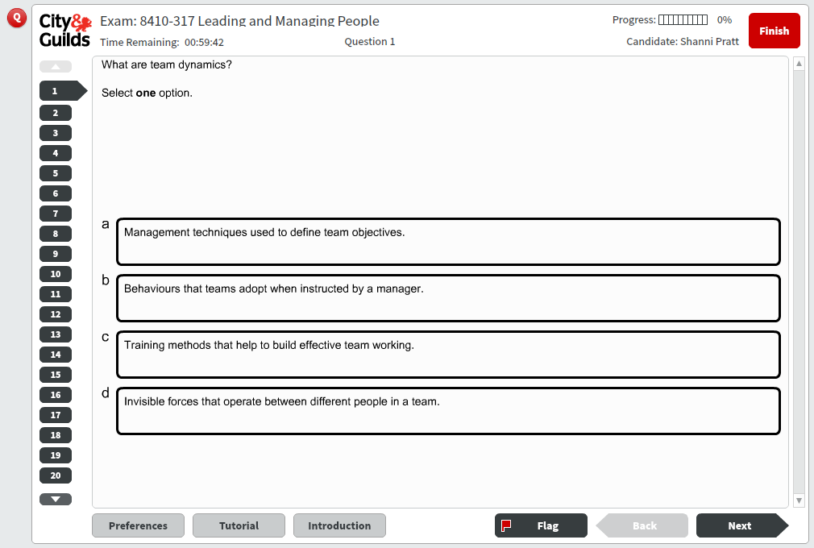

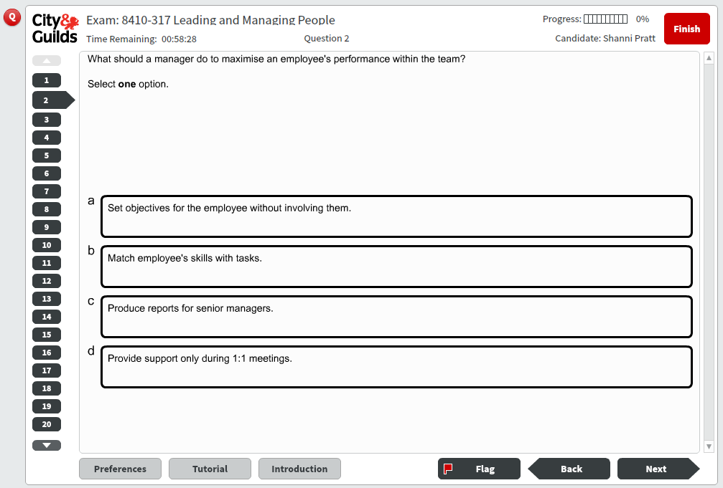

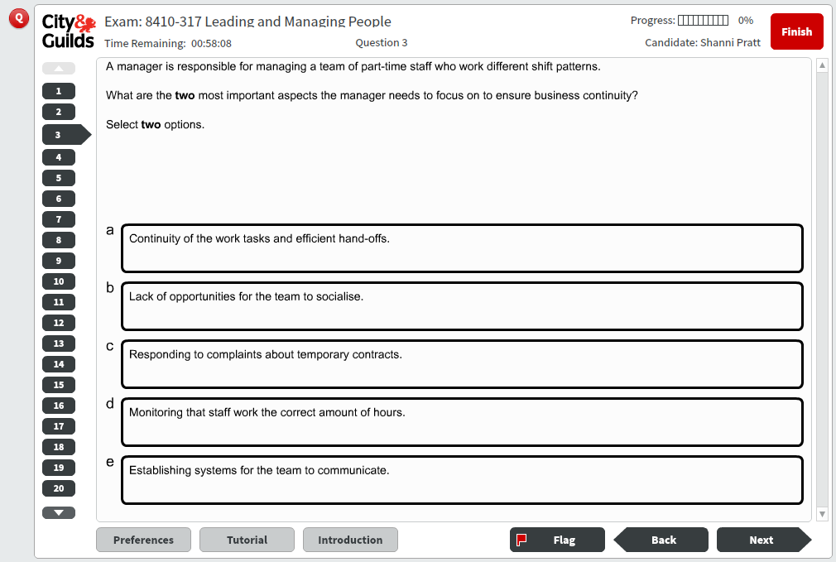

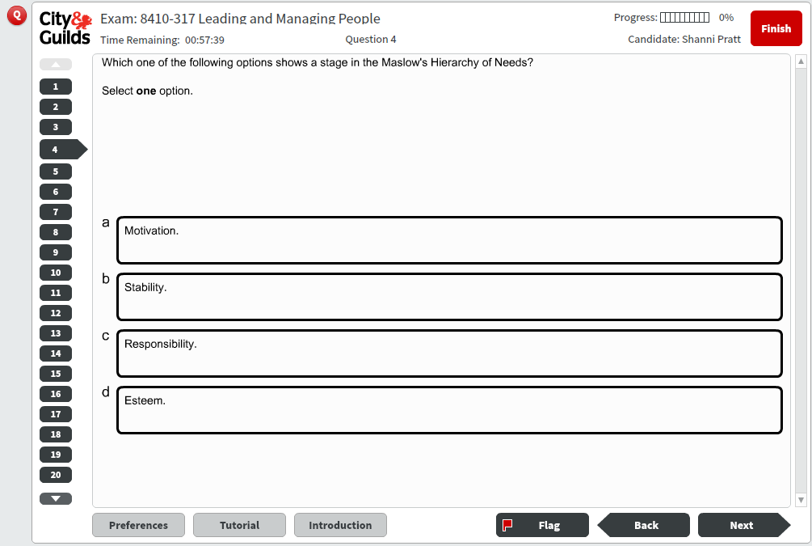

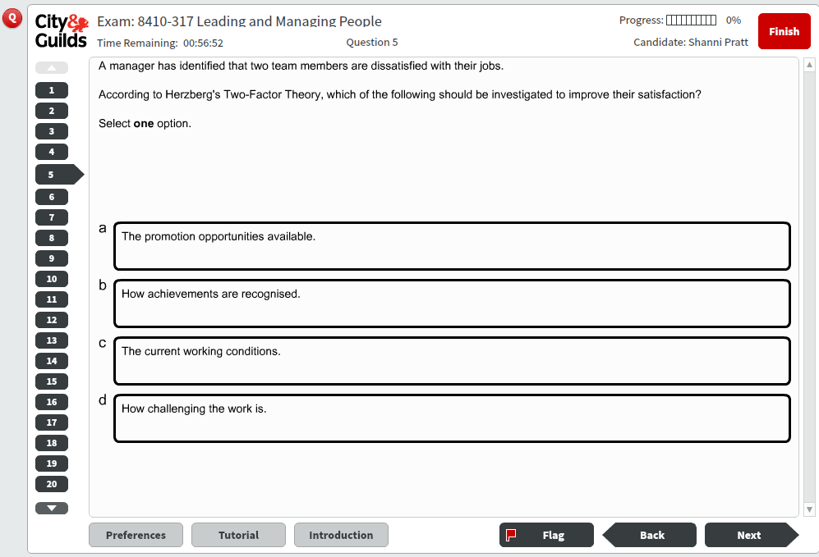

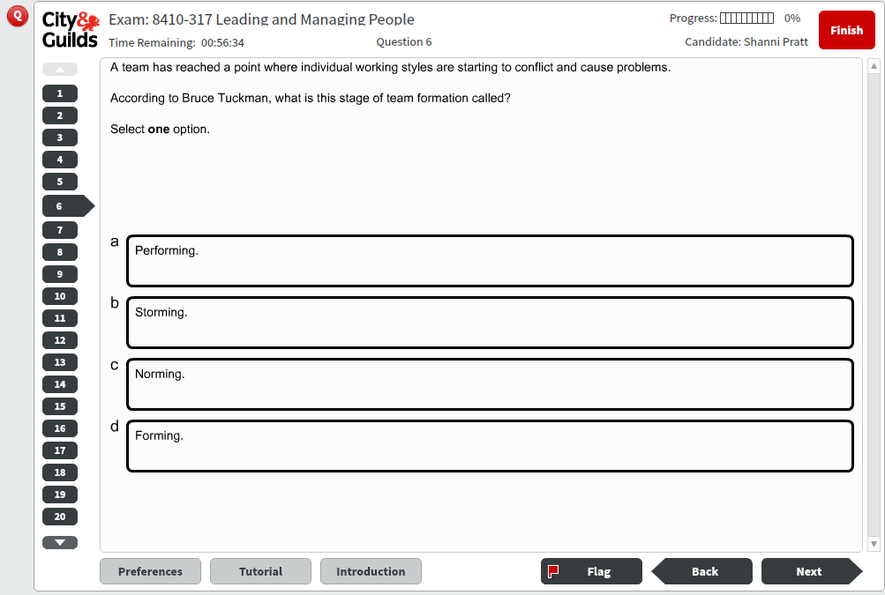

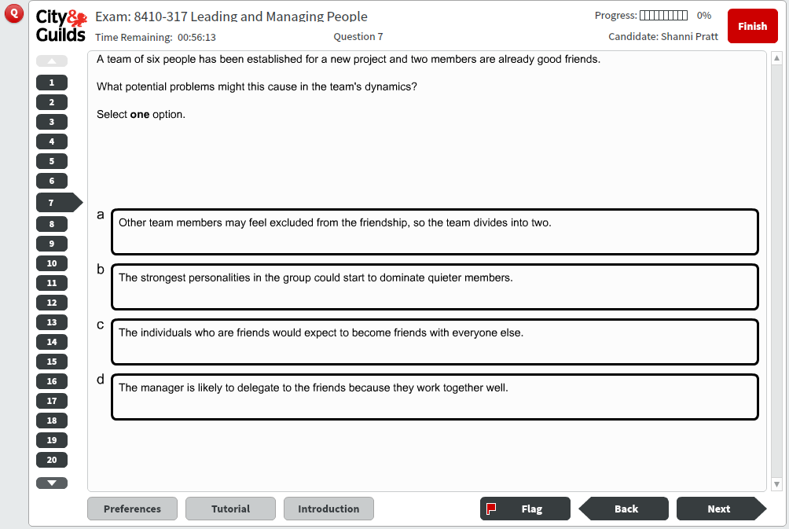

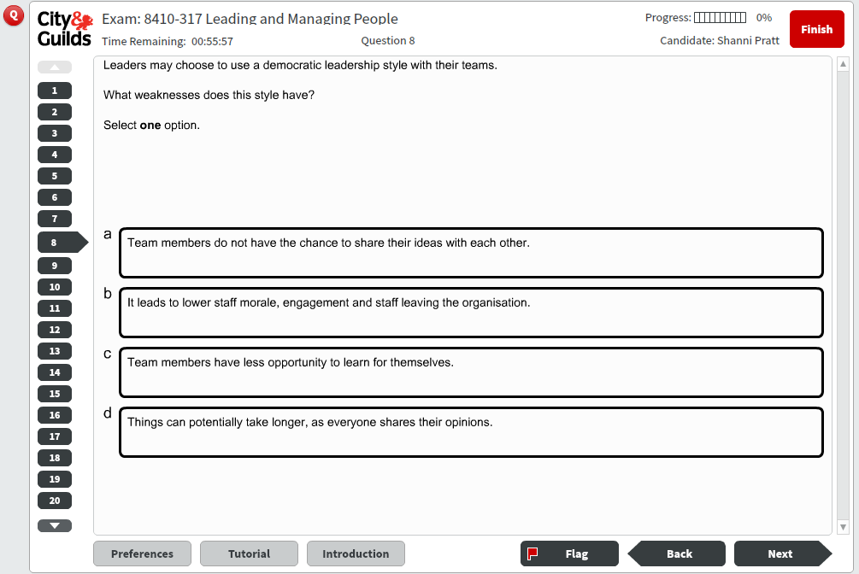

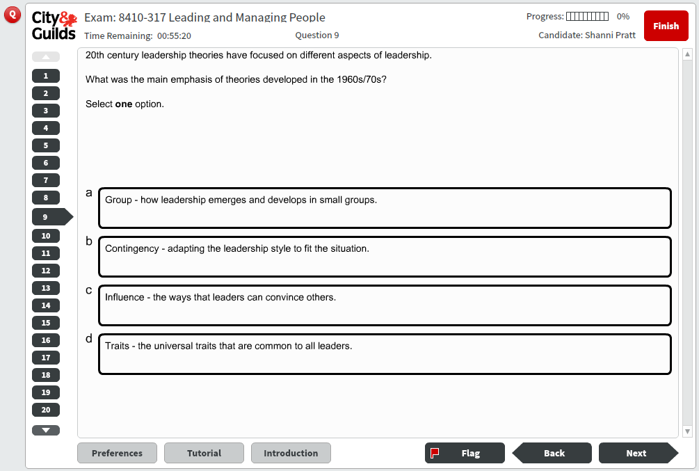

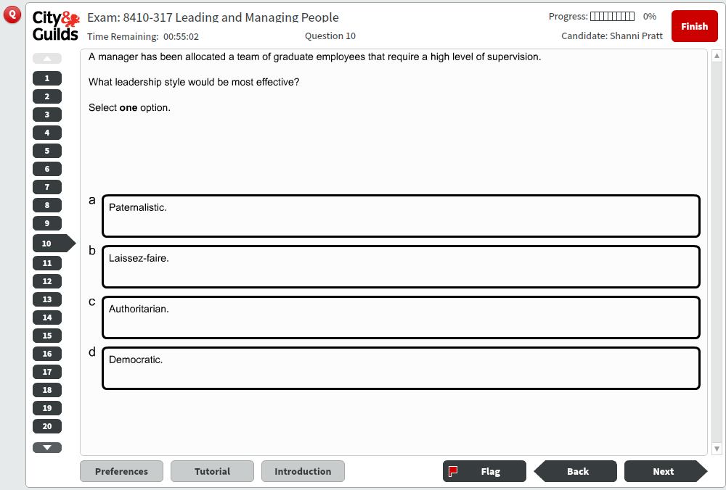

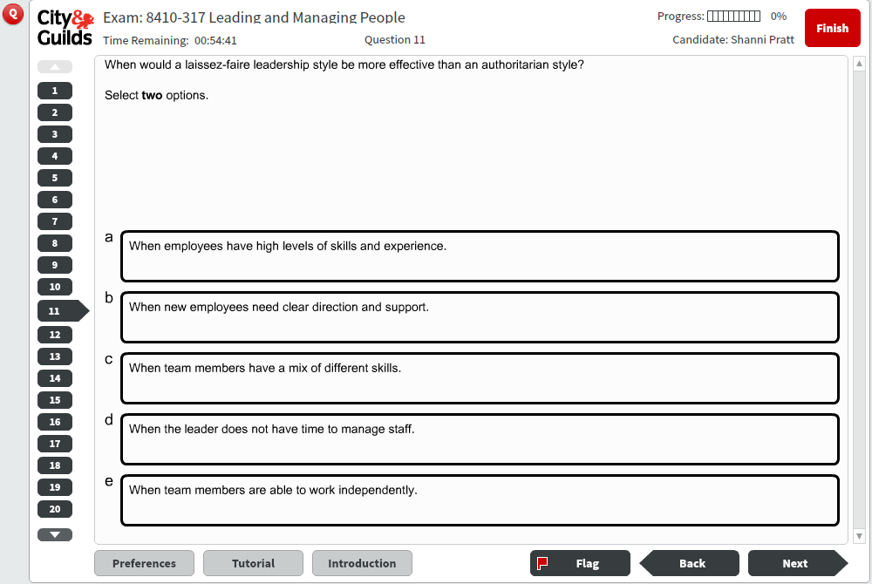

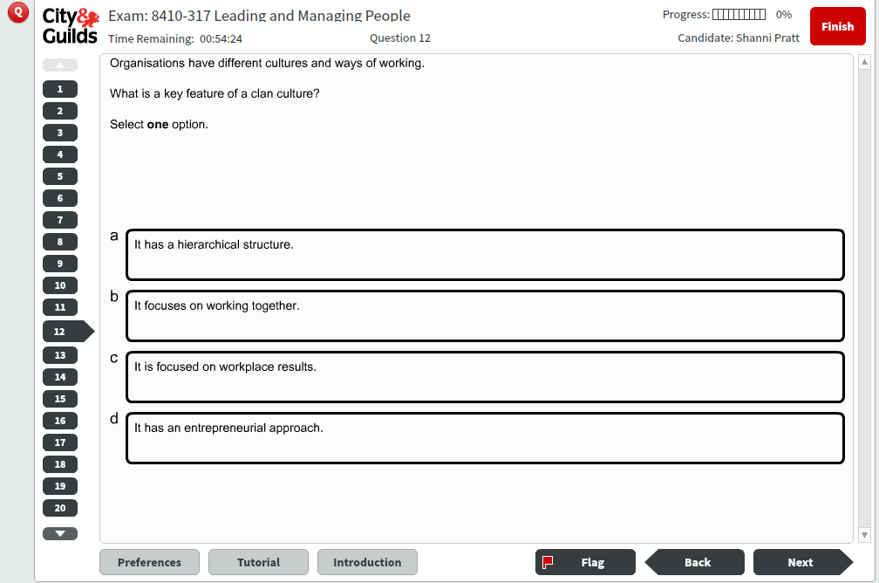

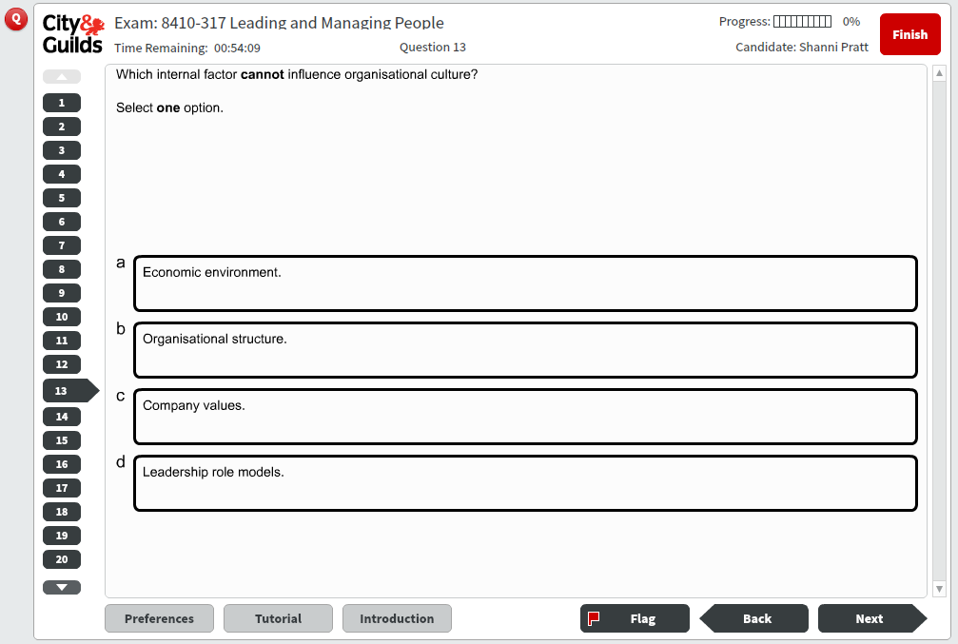

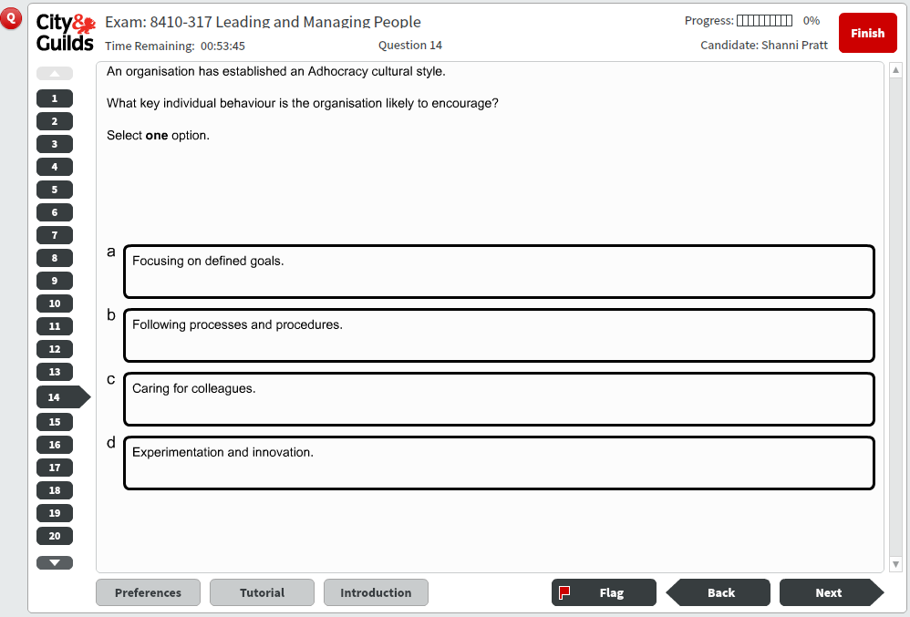

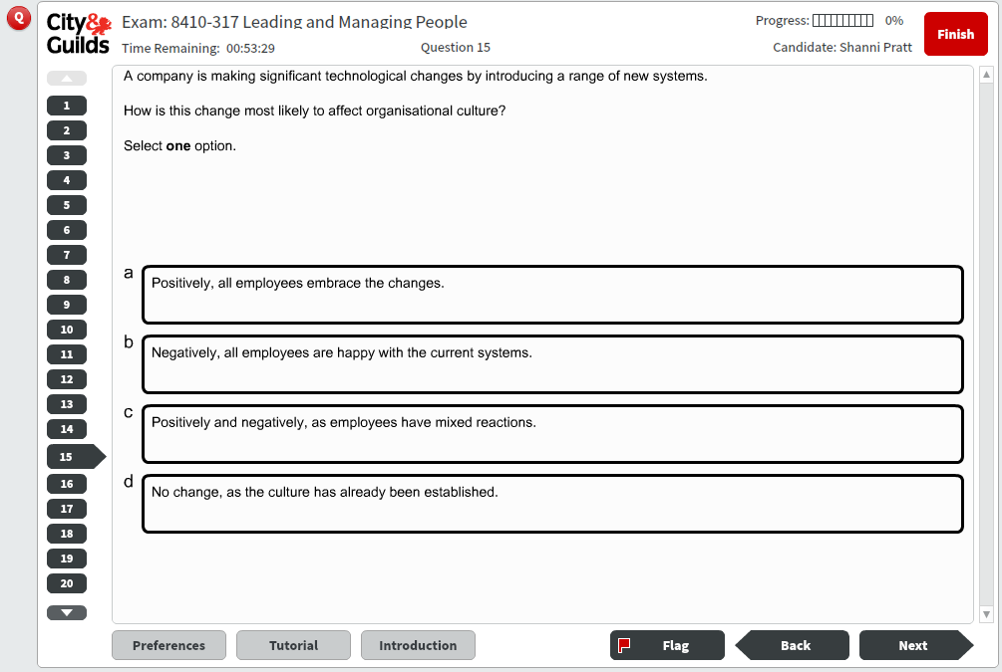

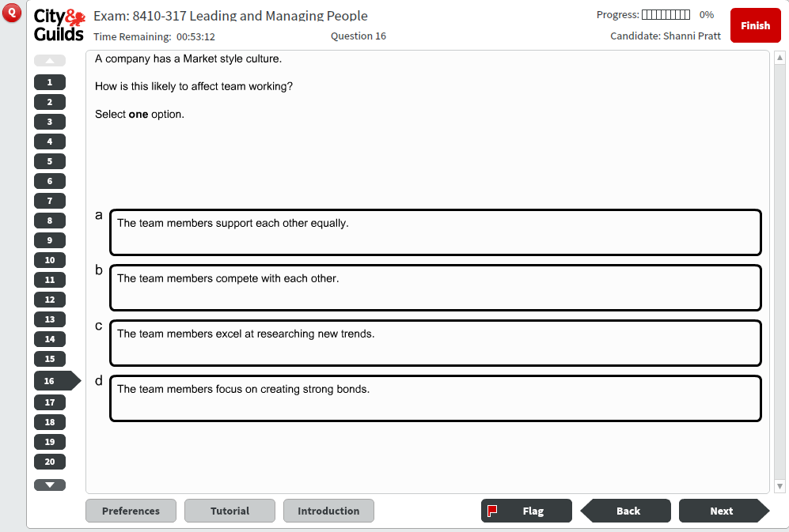

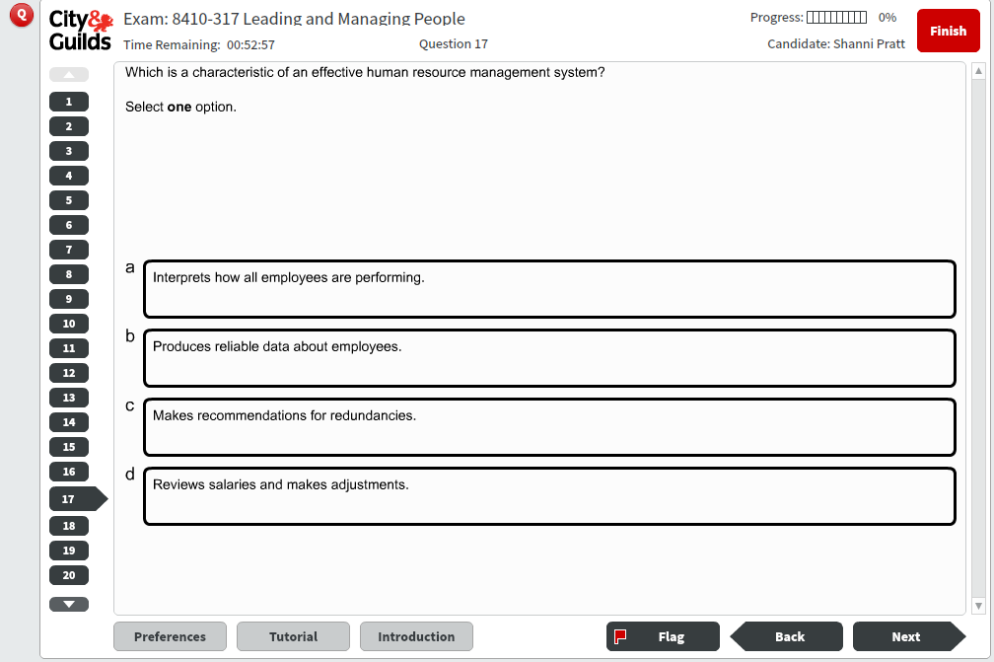

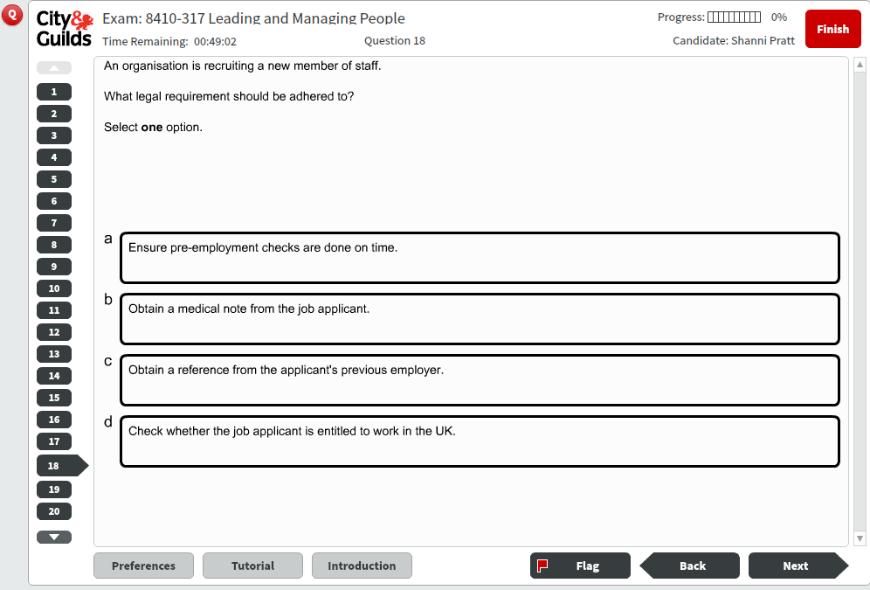

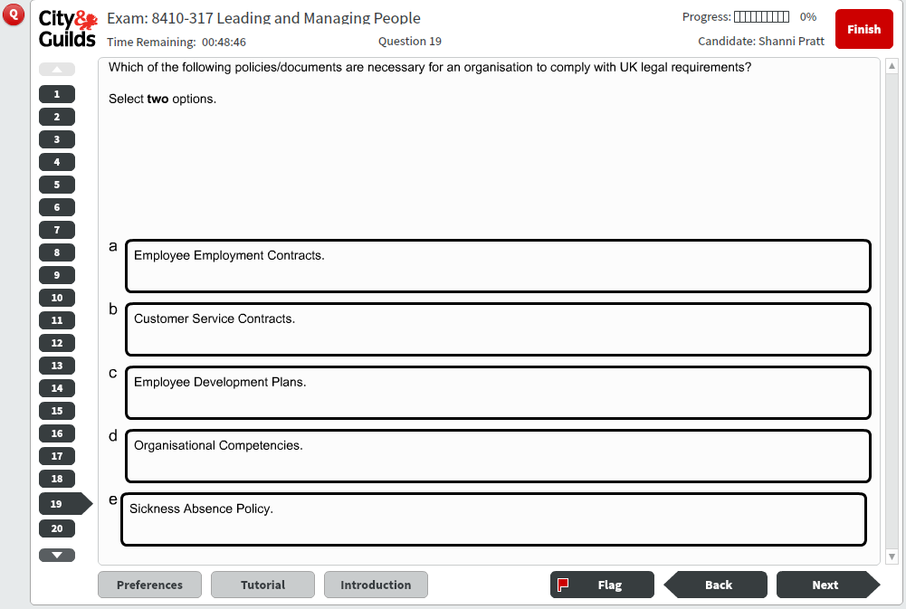

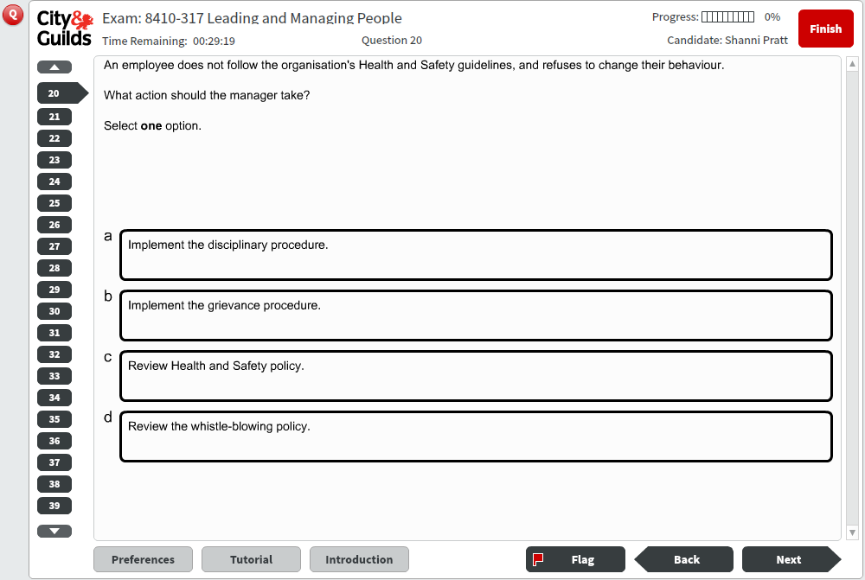

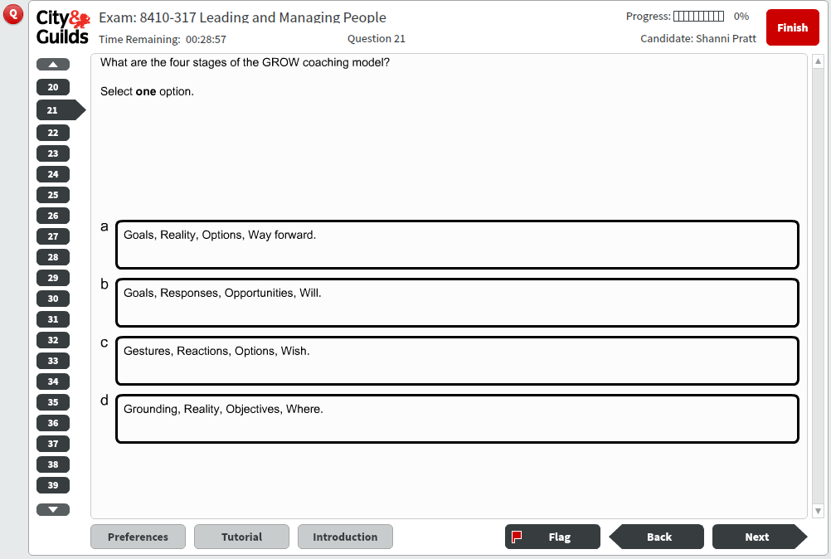

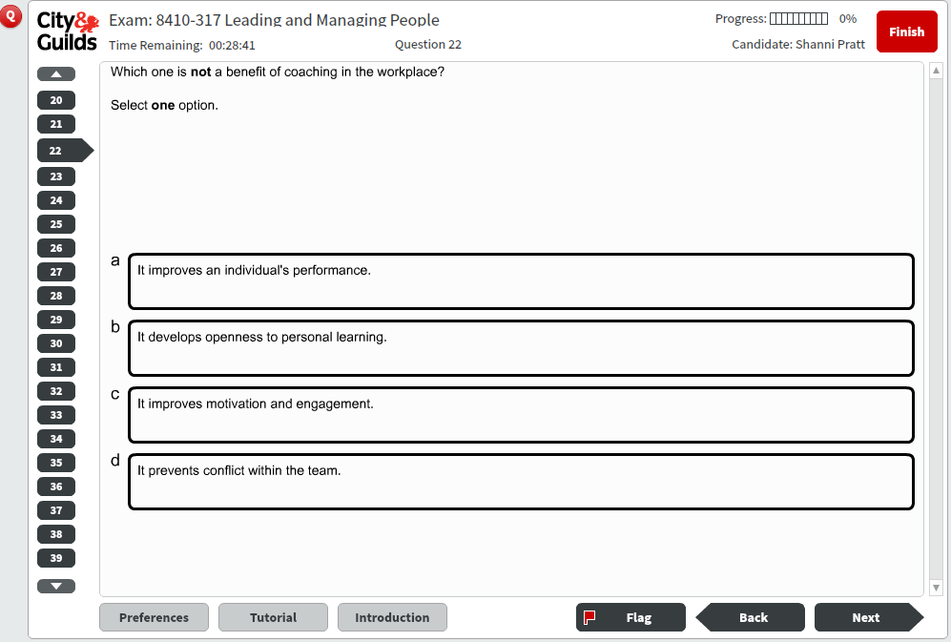

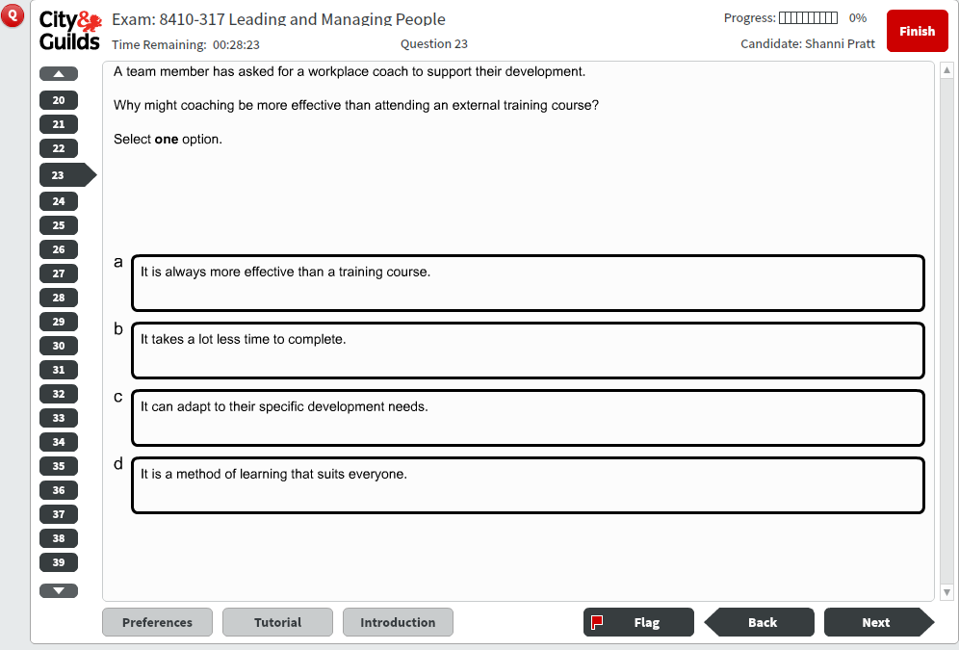

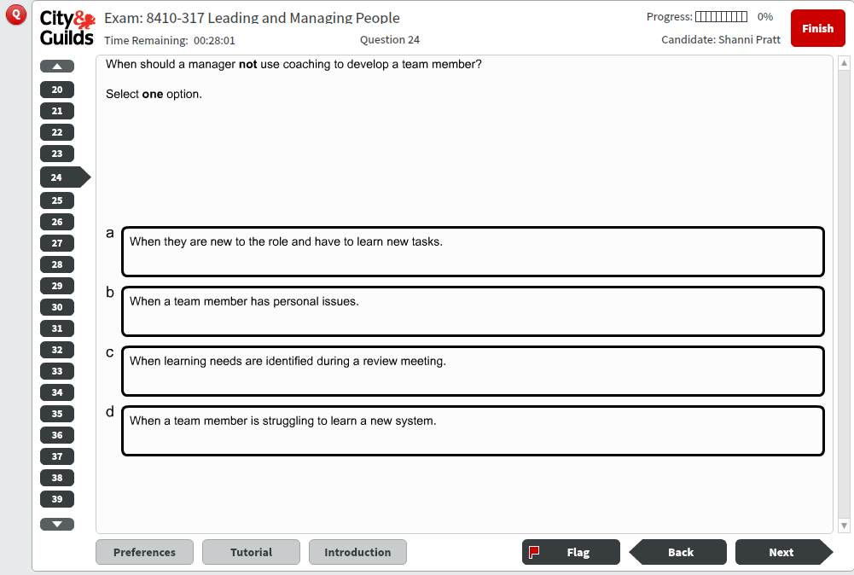

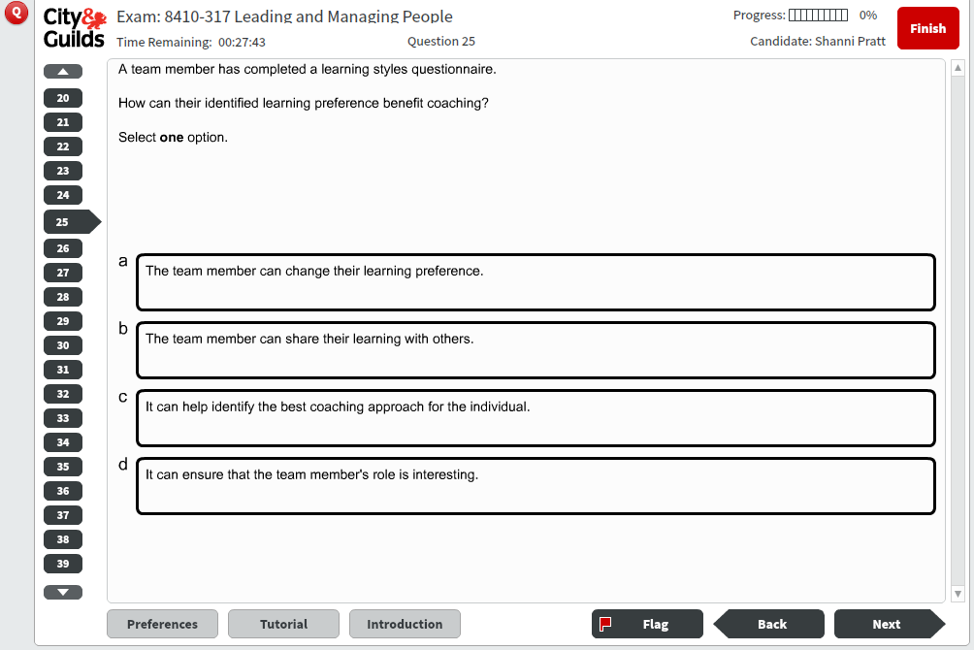

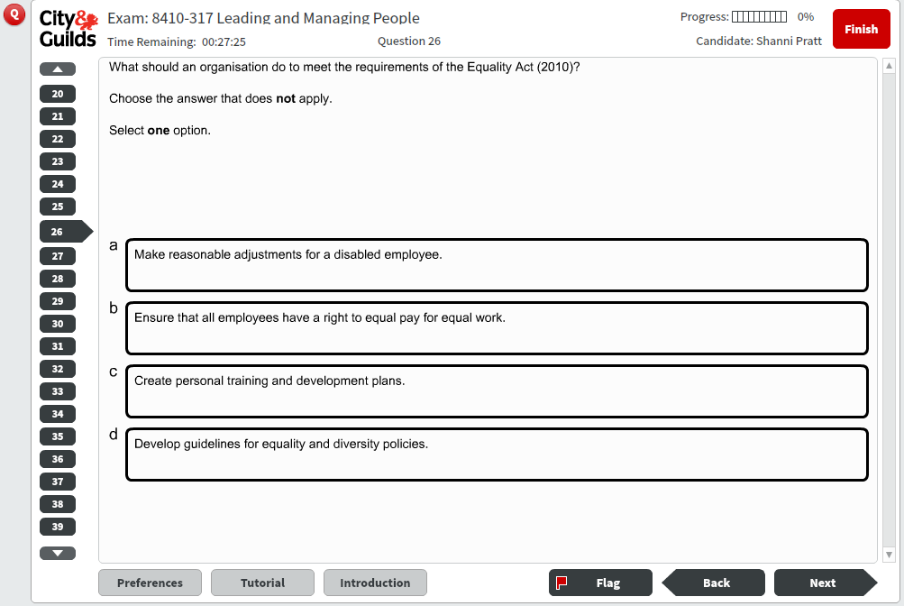

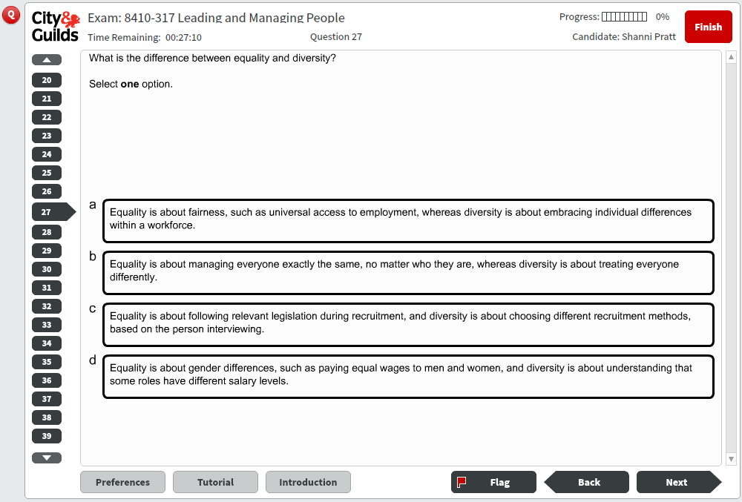

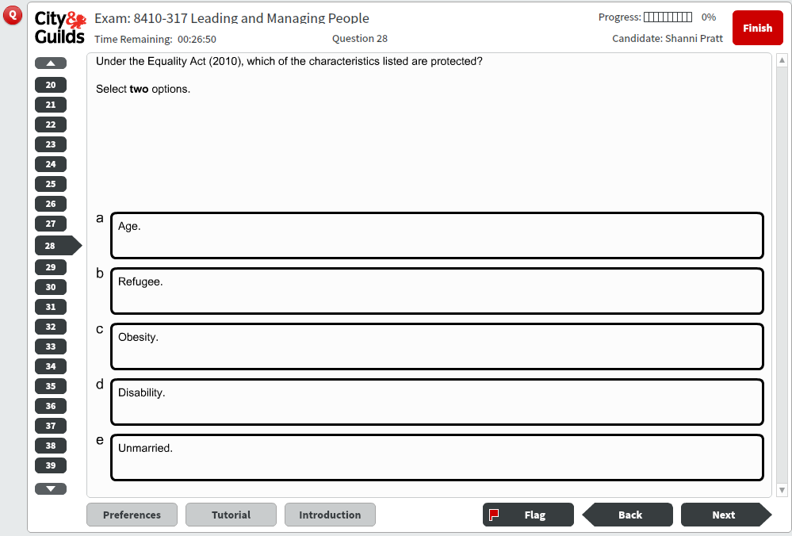

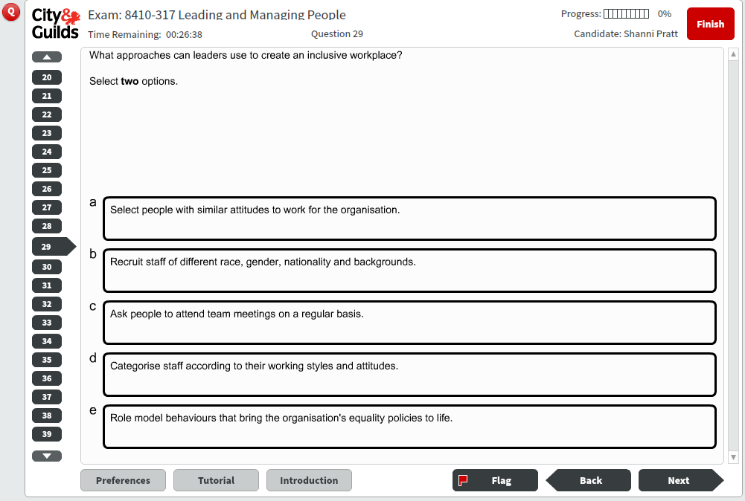

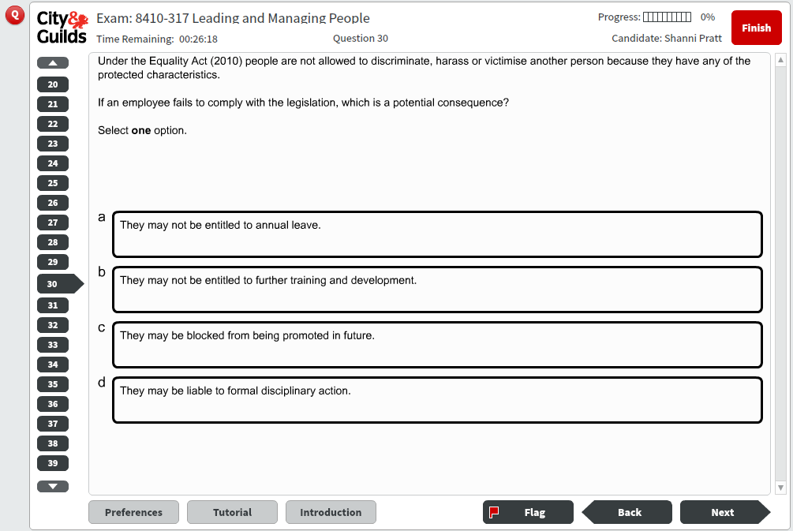

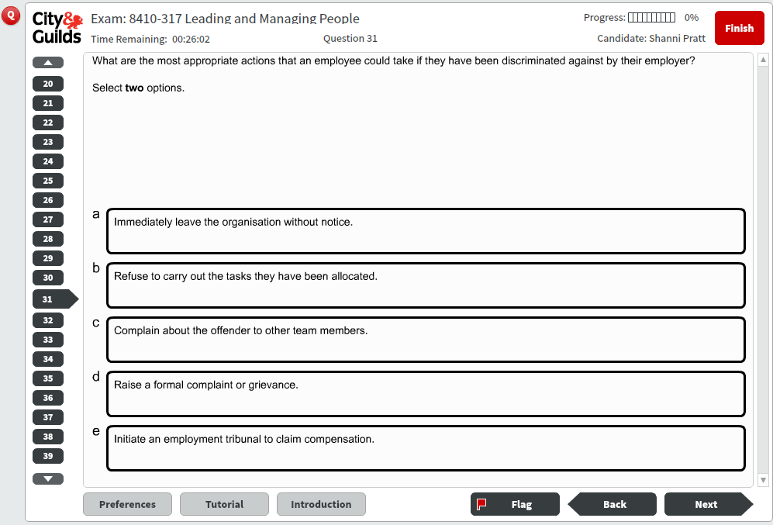

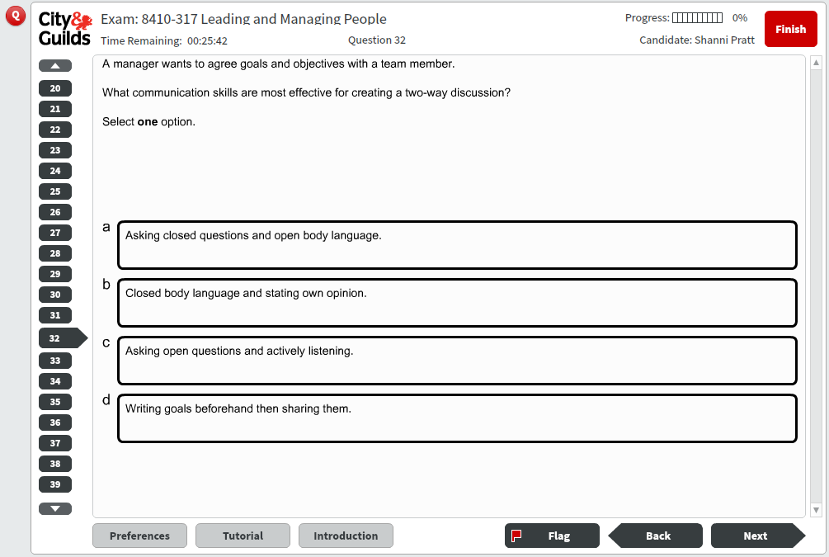

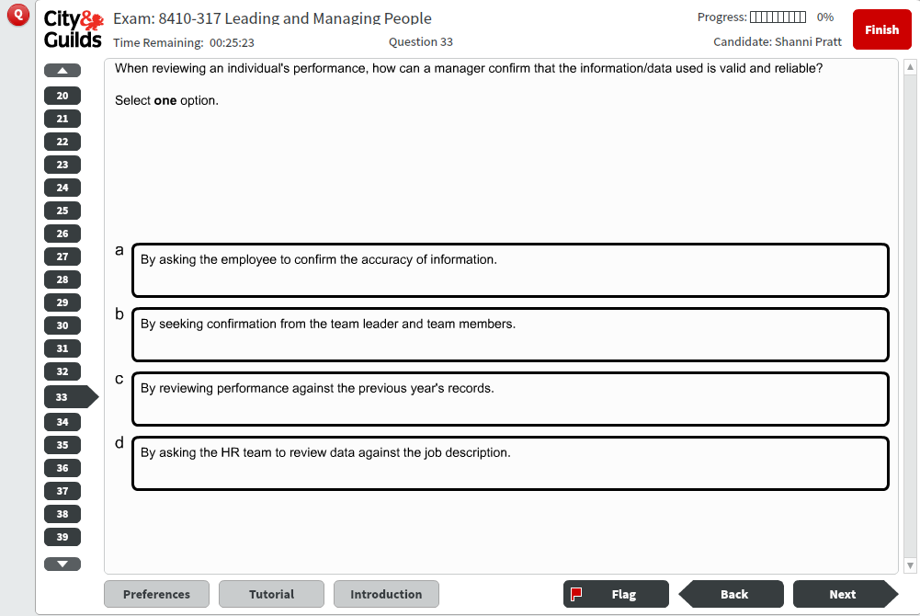

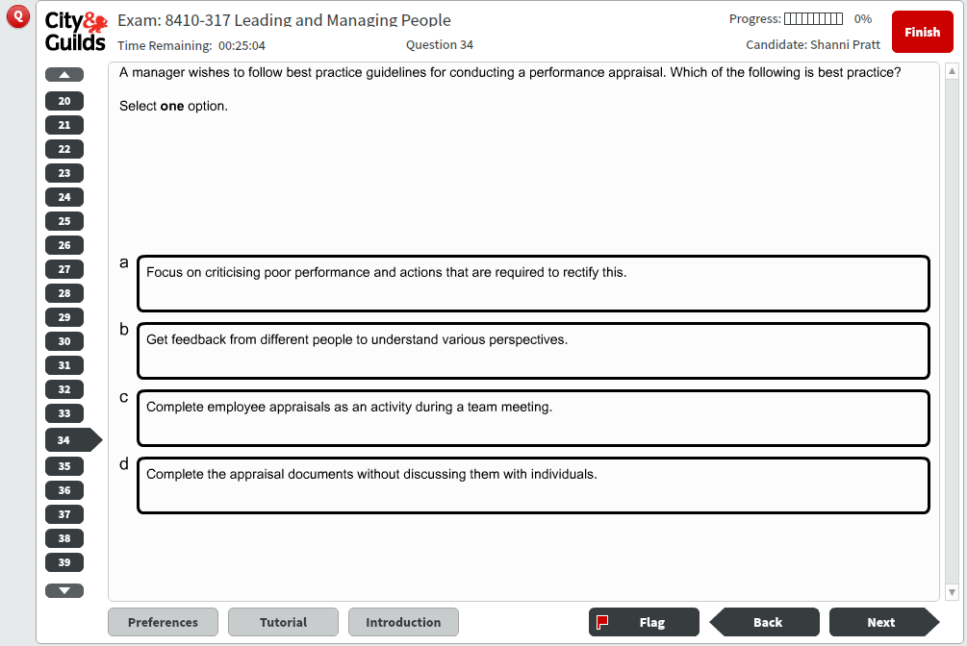

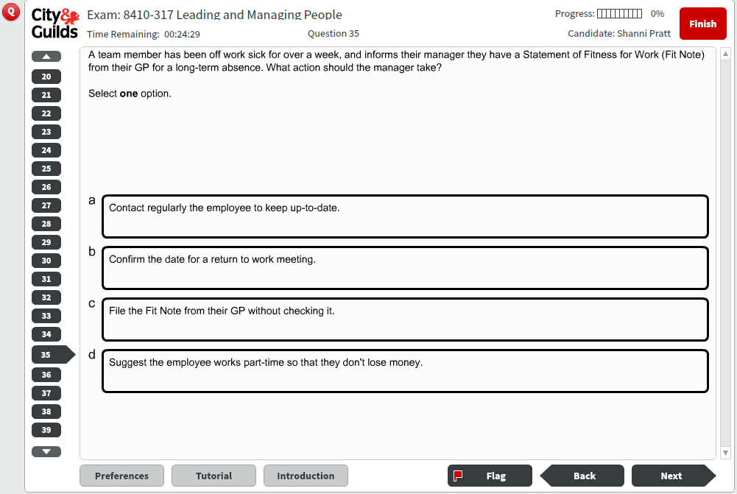

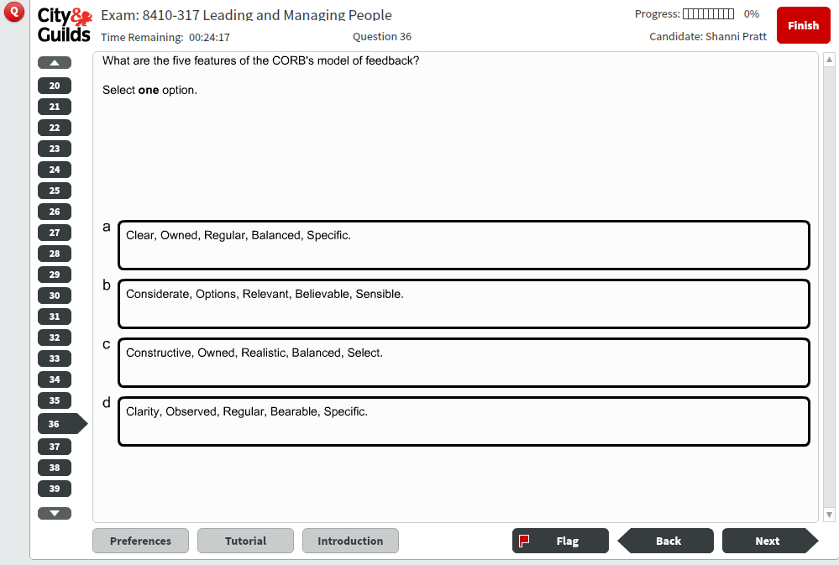

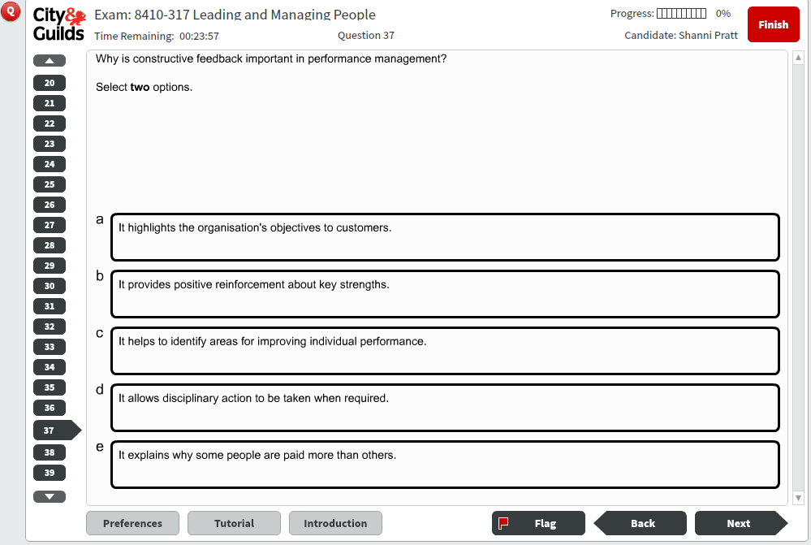

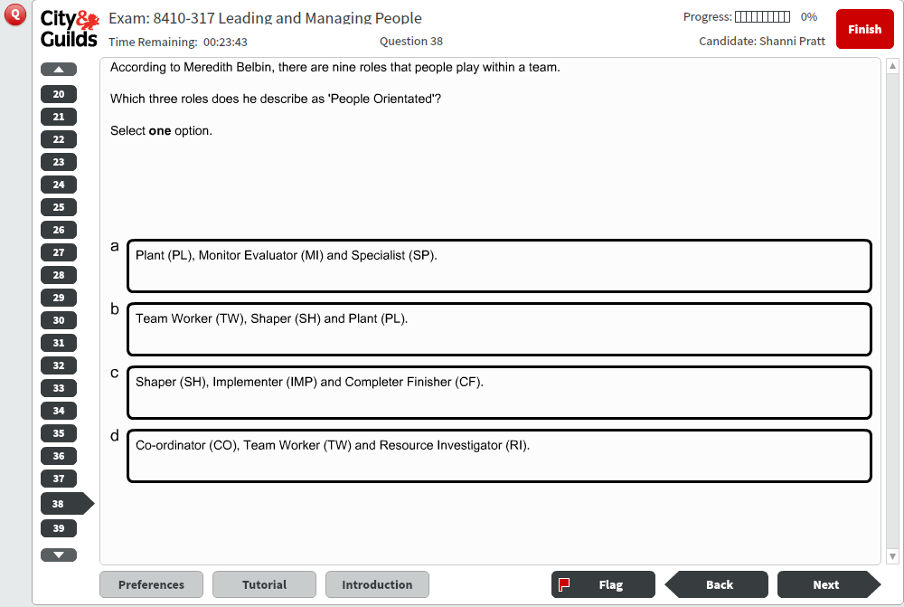

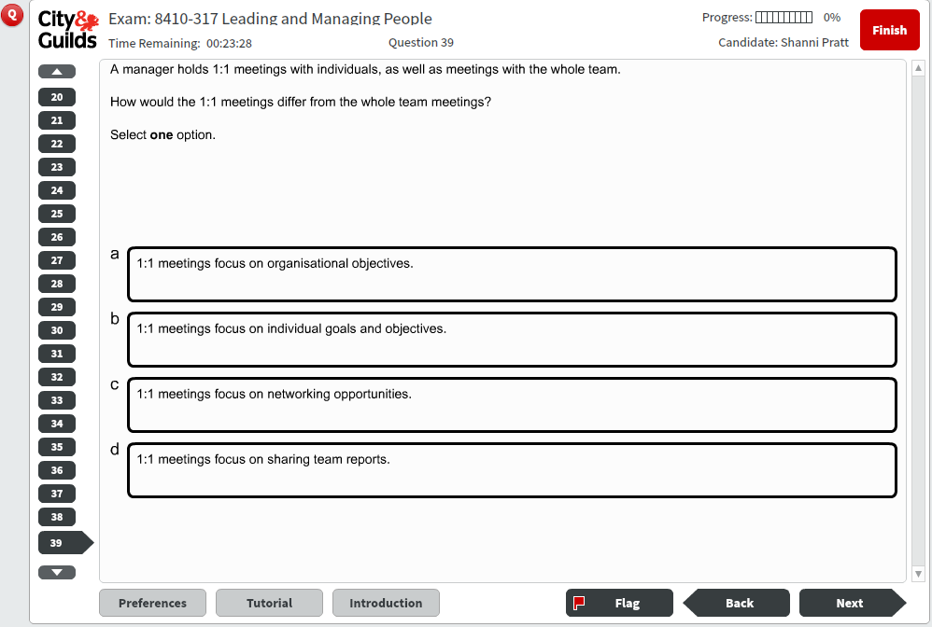

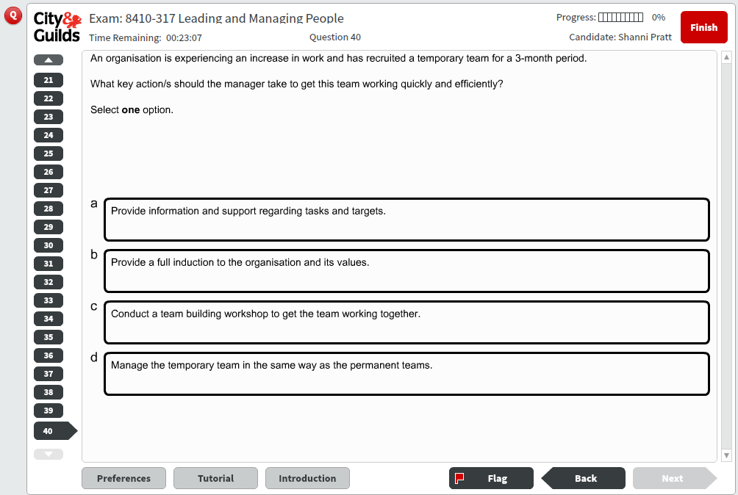

8410-317 Leading and Managing People – Sample test Mark Scheme

 | 
 | 
 | 
 | 

 | 

 | 











 | 








 | 
 | 

 | 






 | 




8410-318 Communication and Building Relationships – Sample test



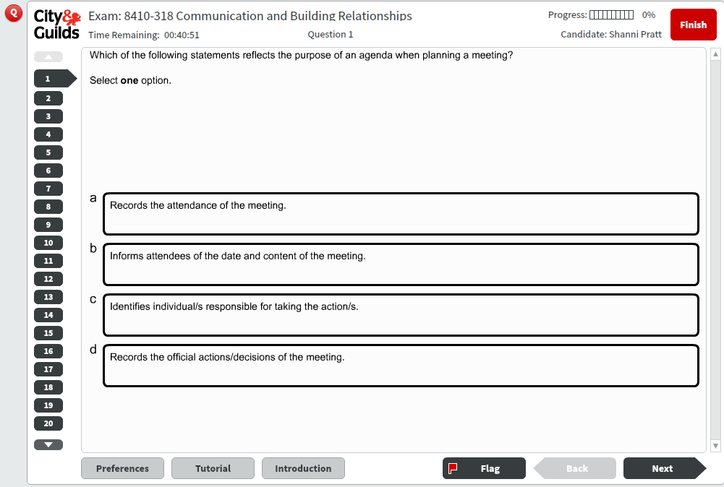

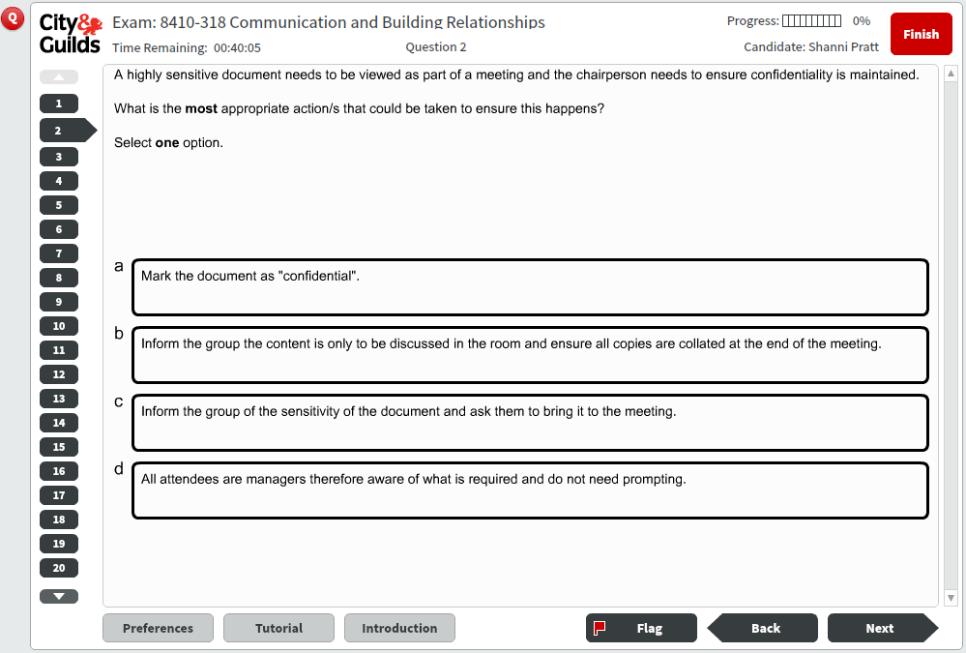

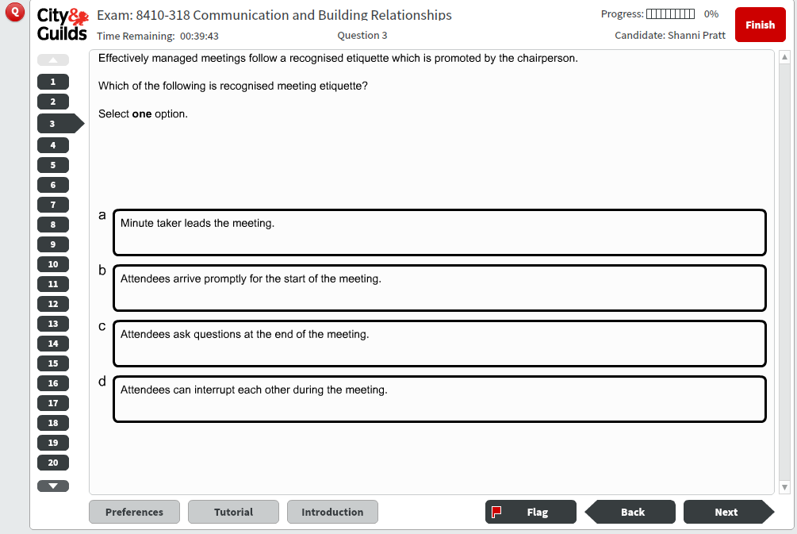

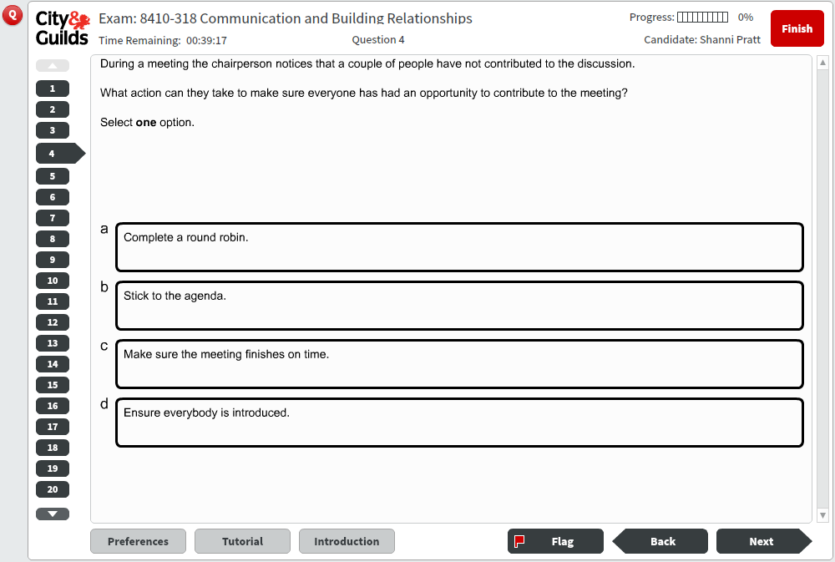

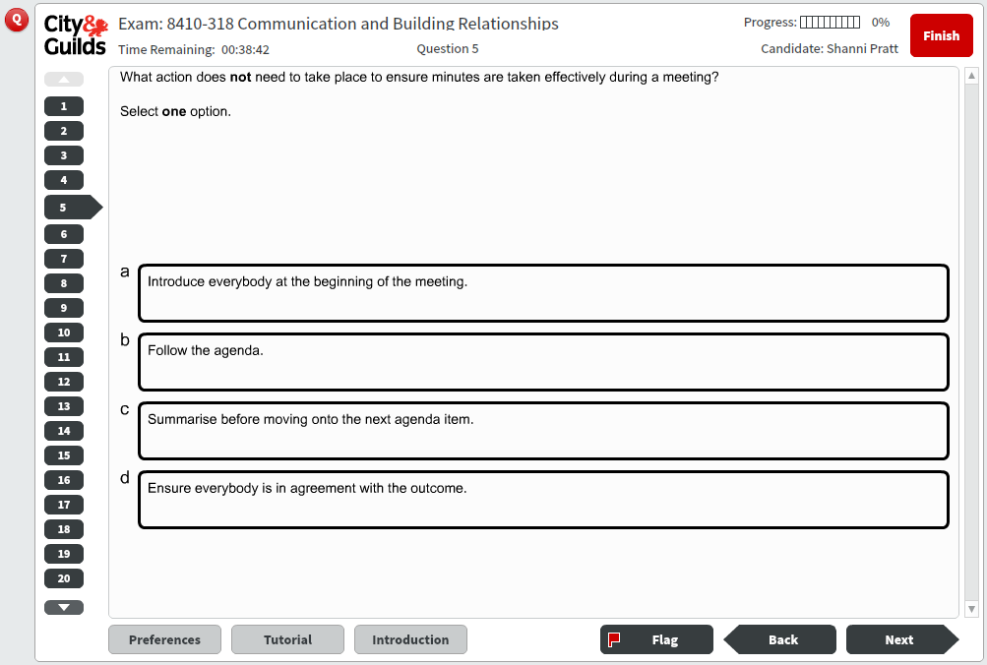

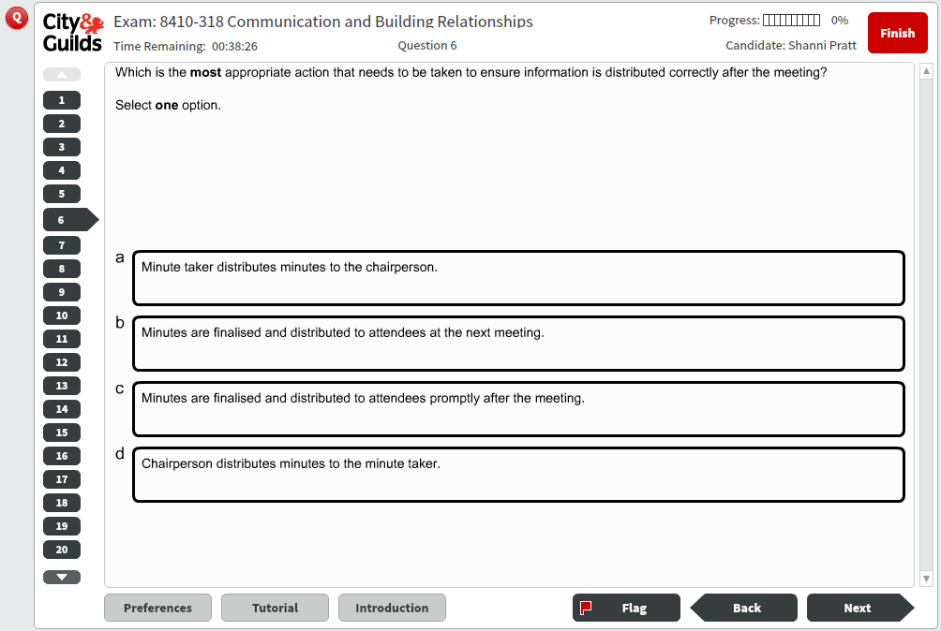

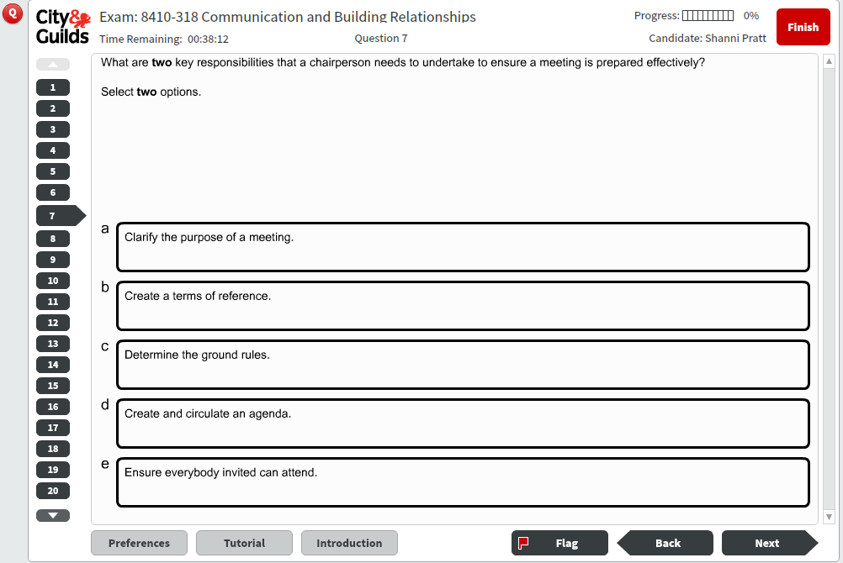

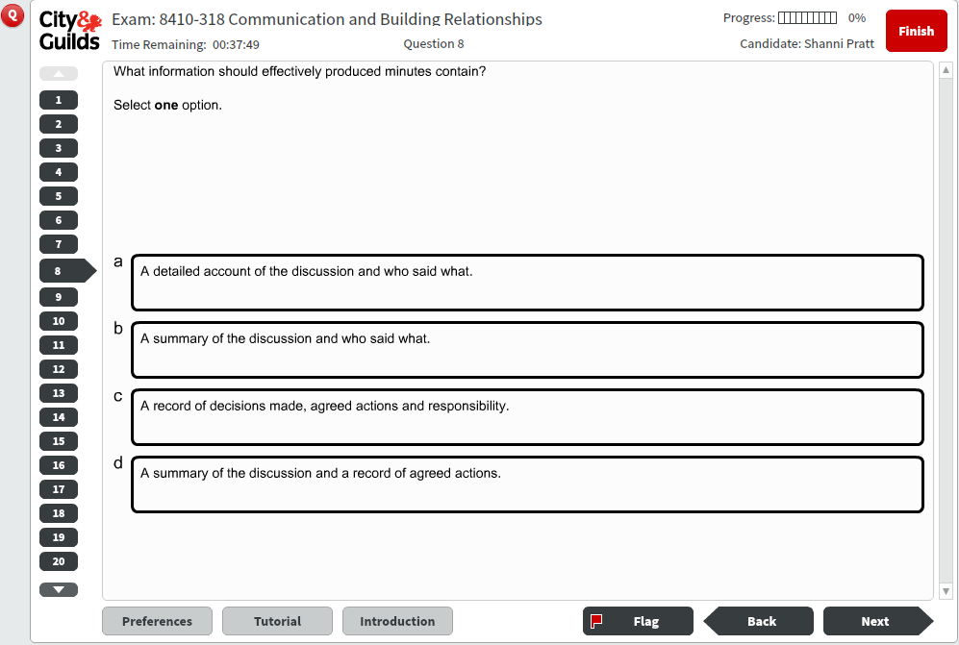

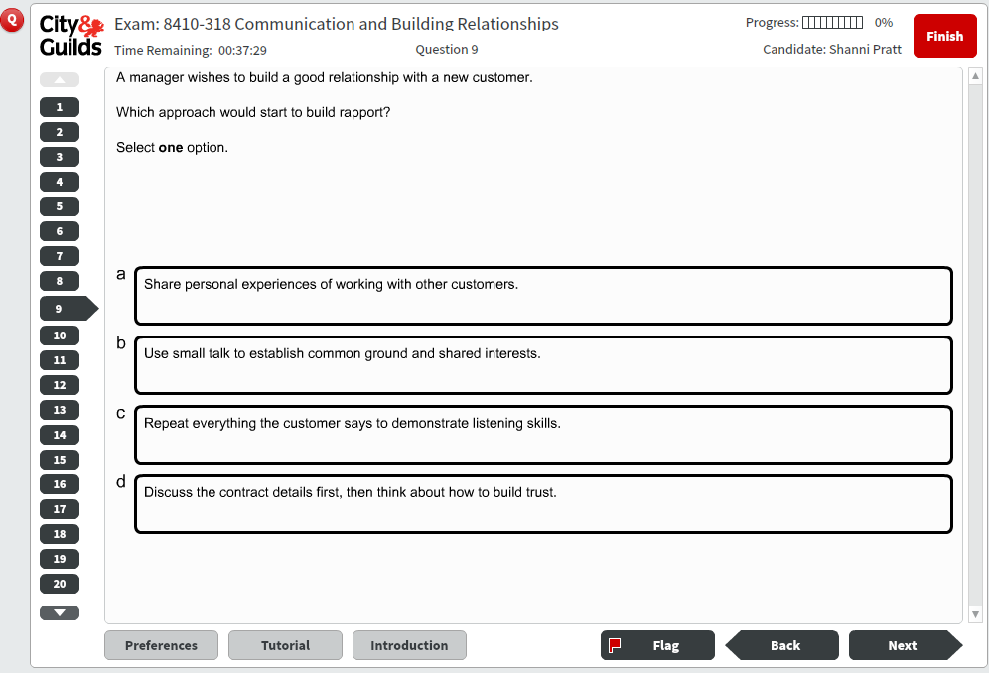

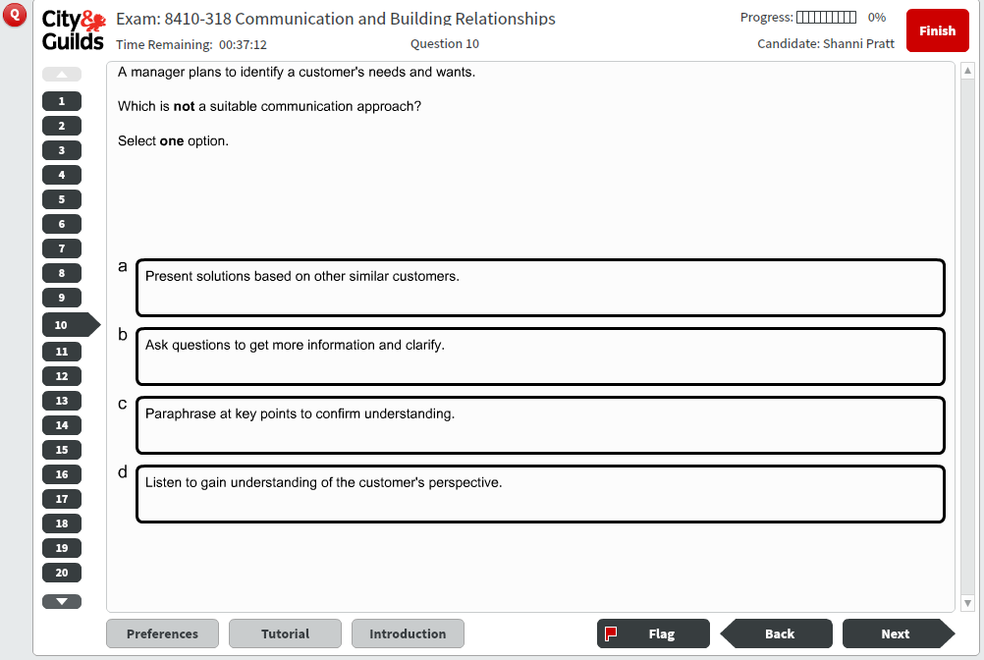

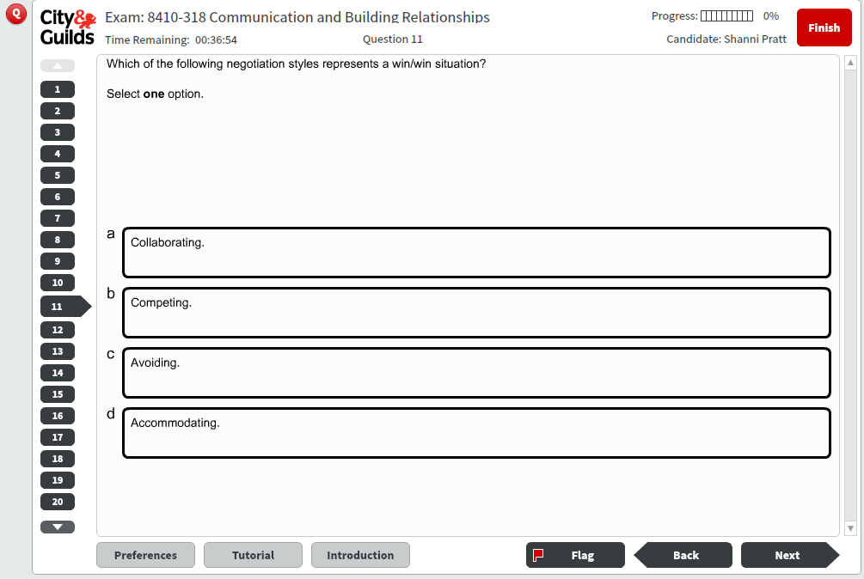

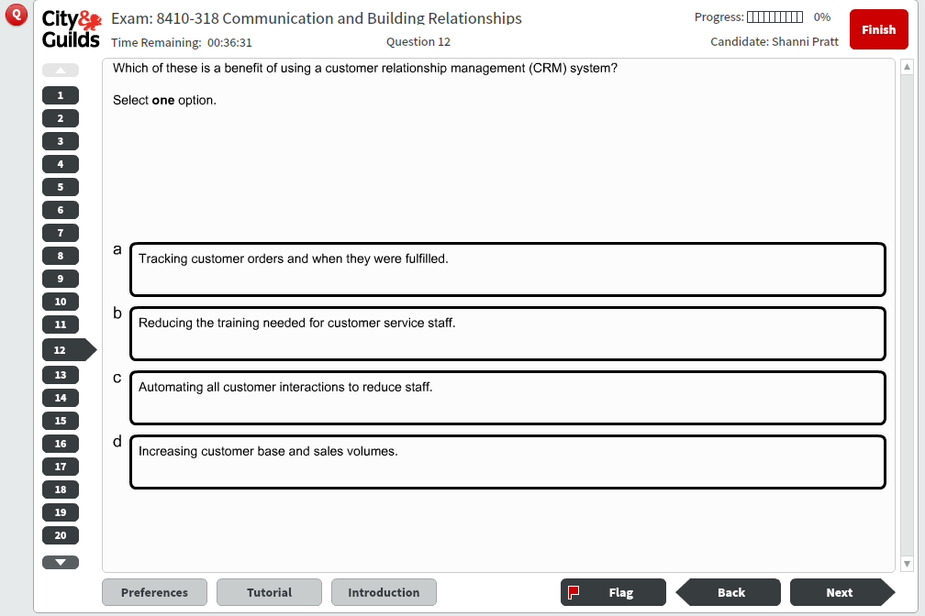

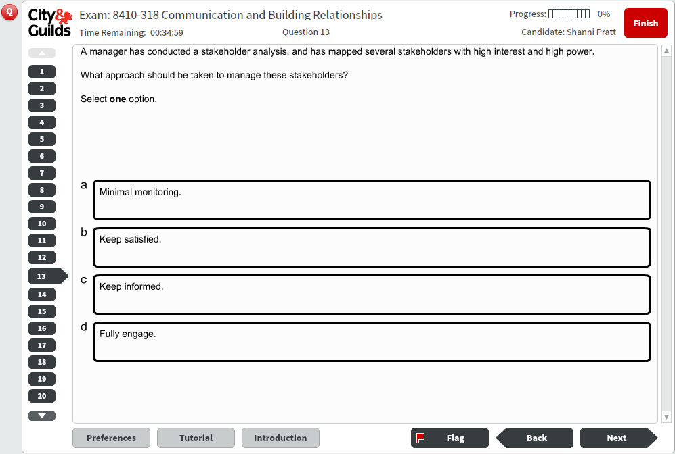

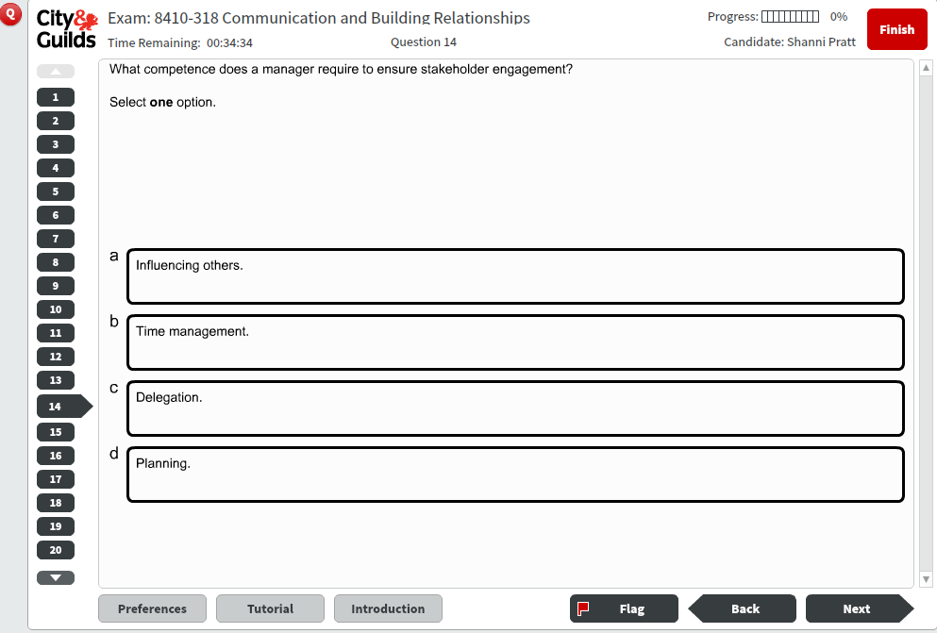

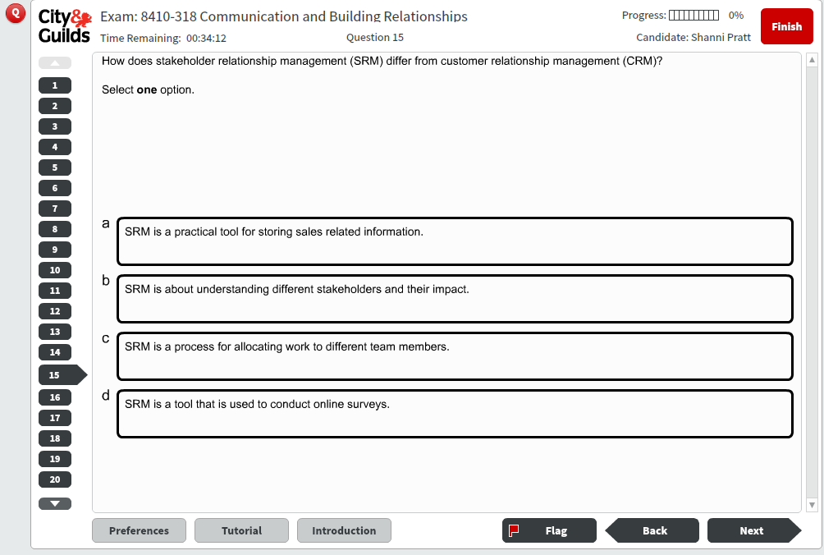

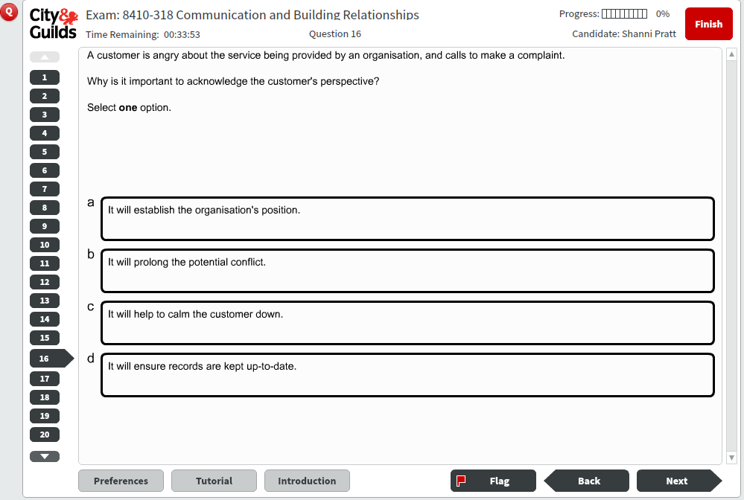

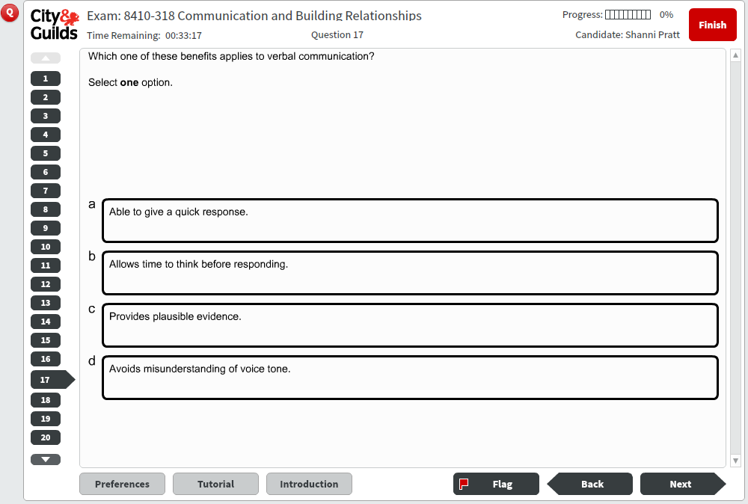

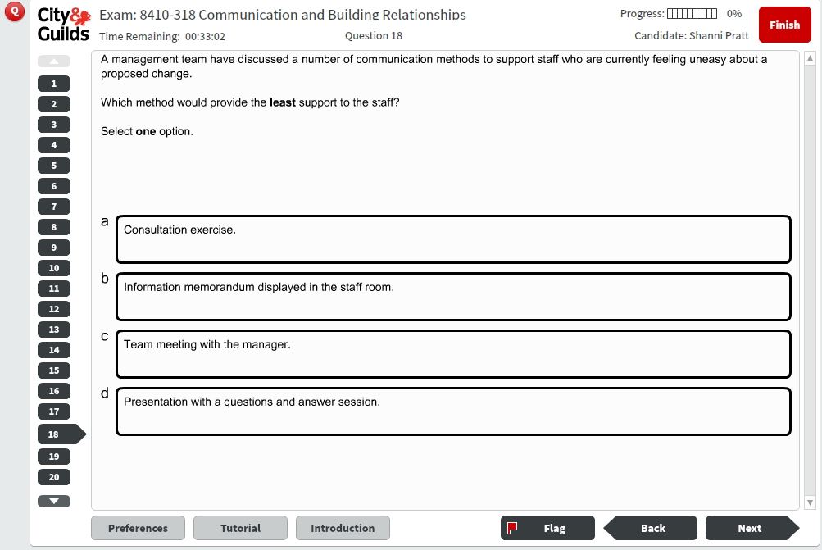

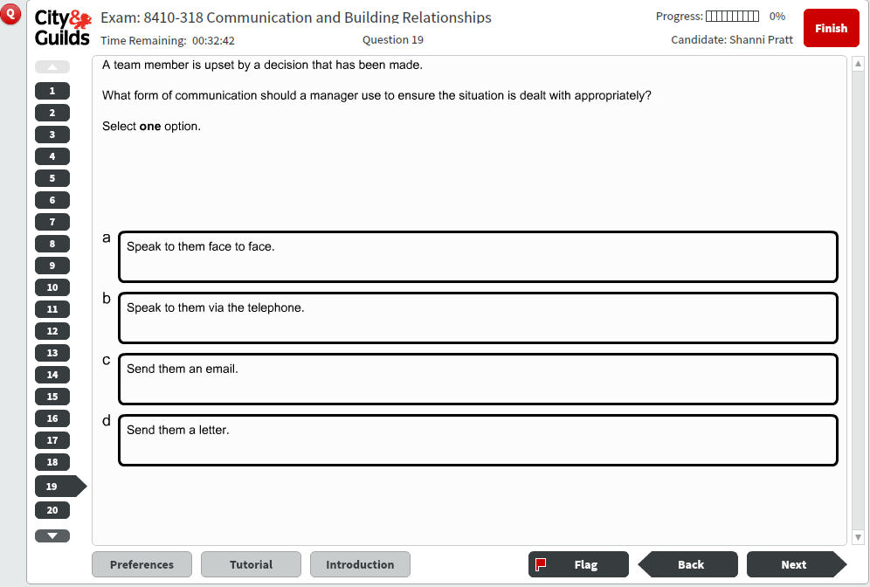

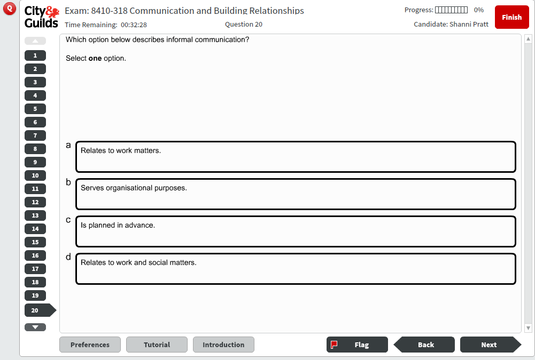

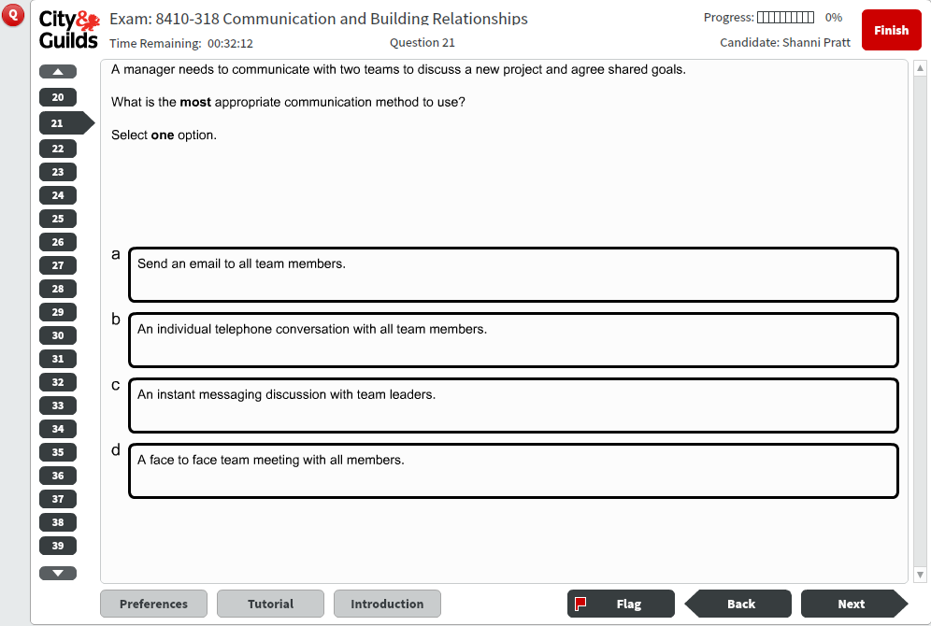

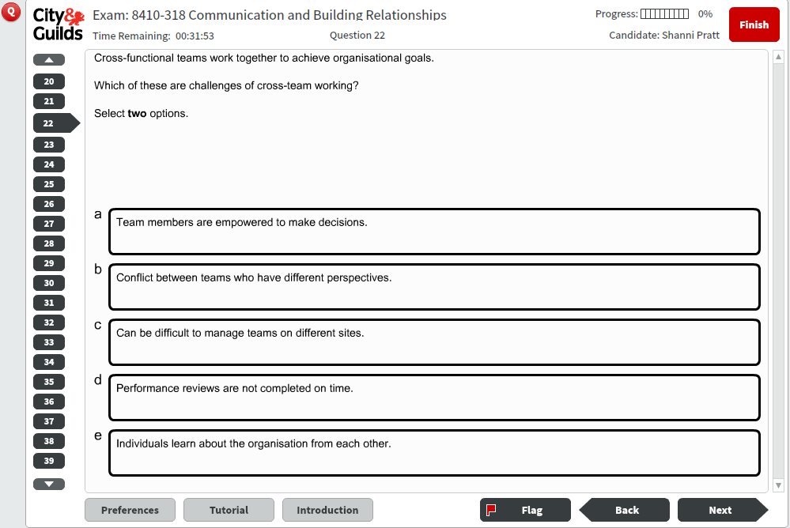

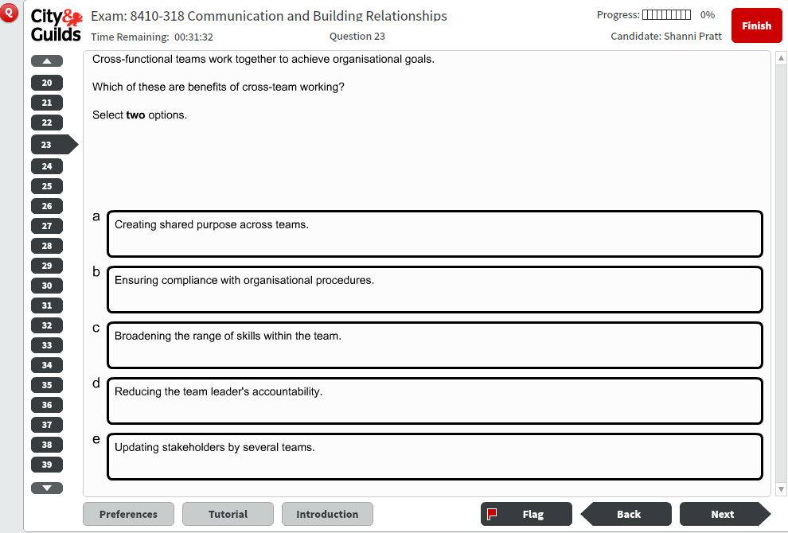

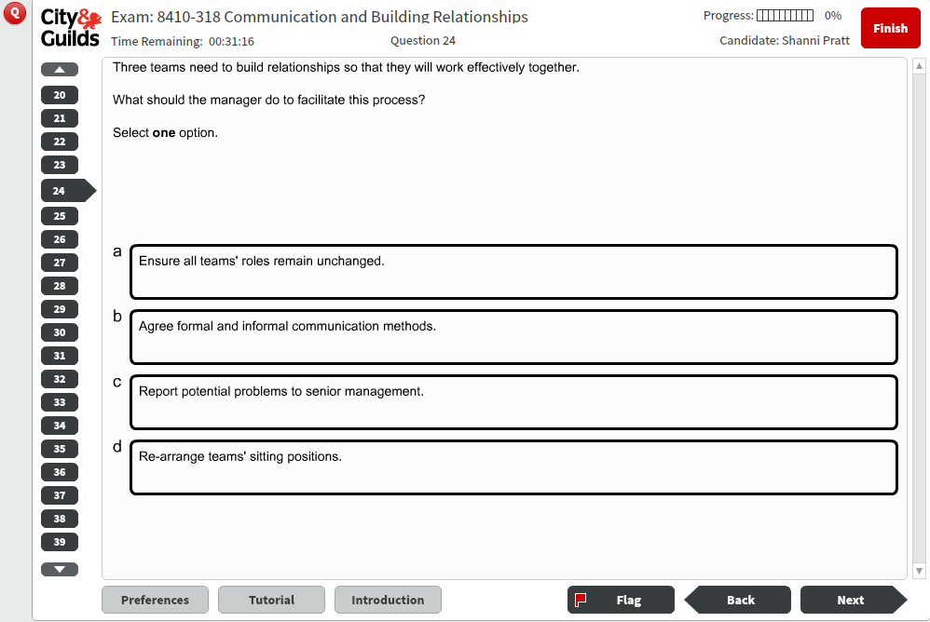

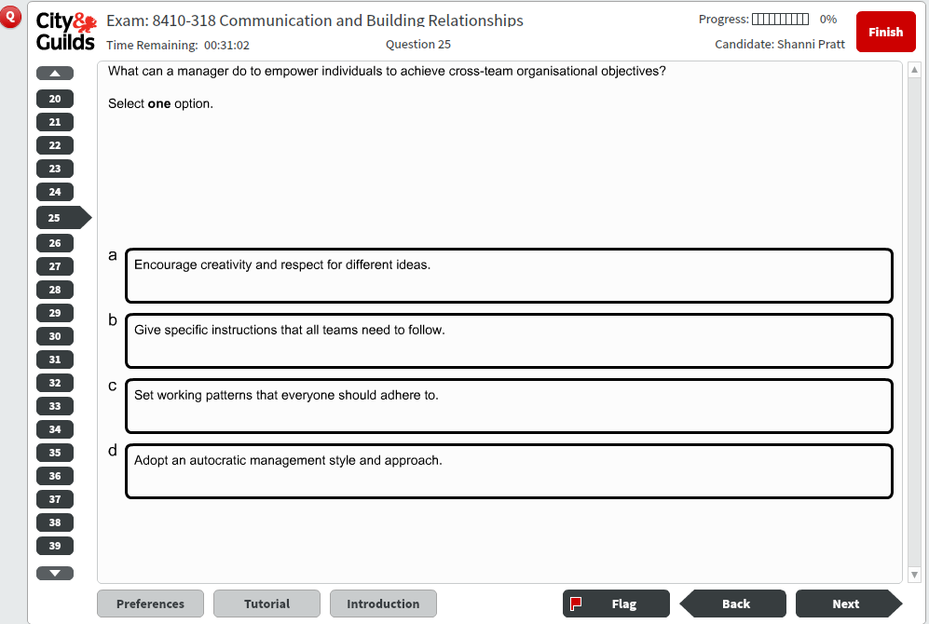

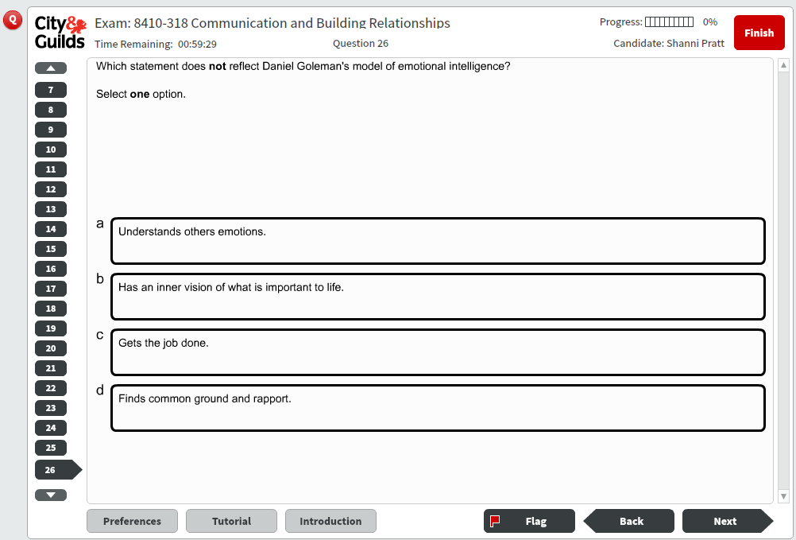

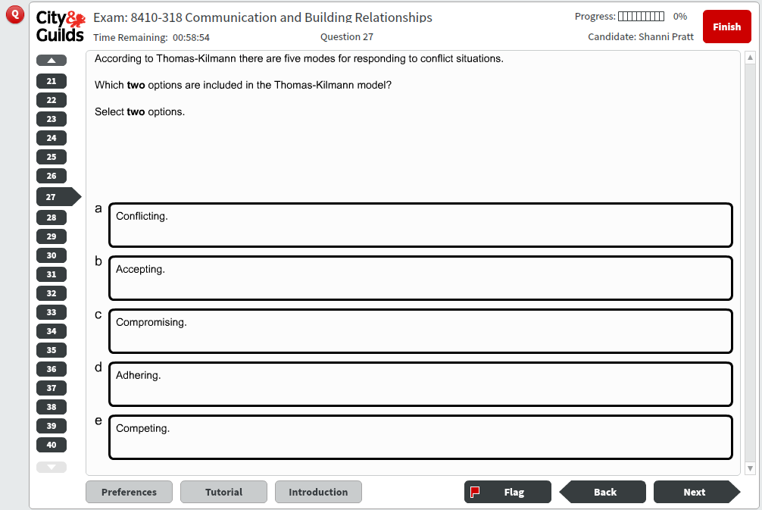

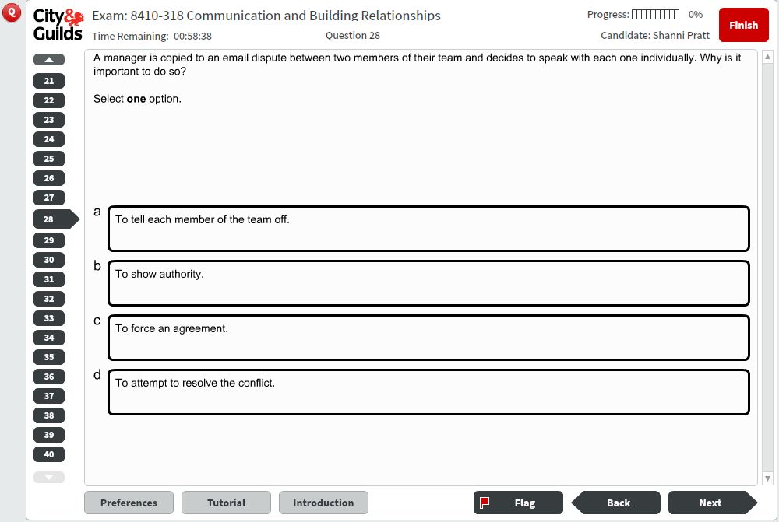

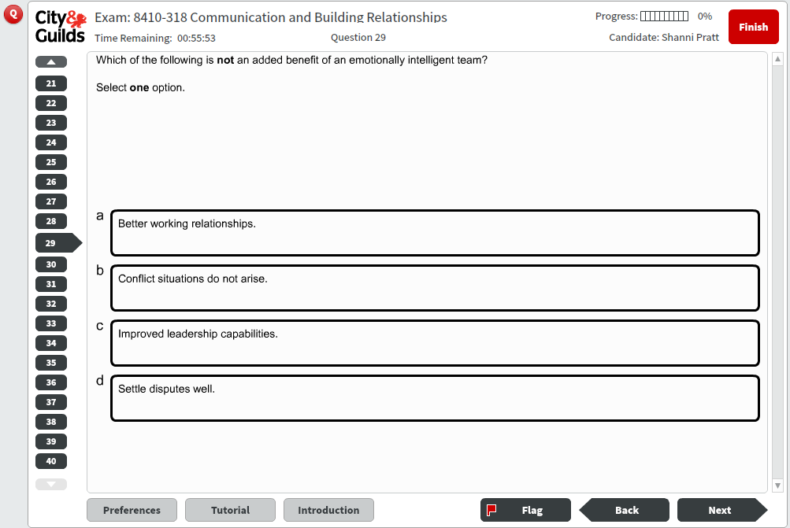

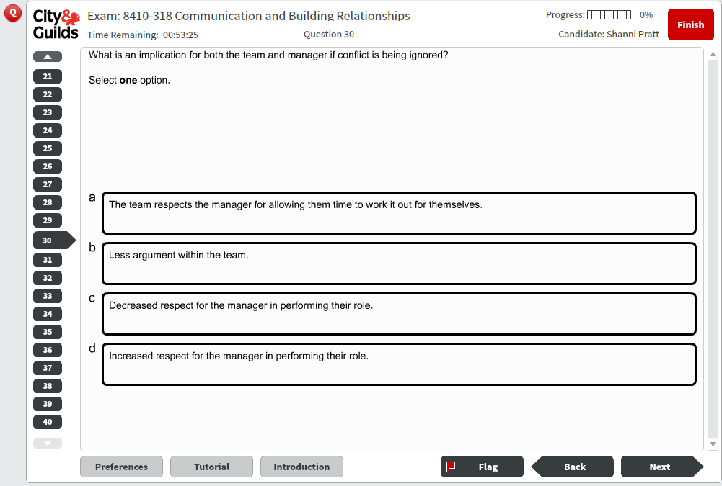

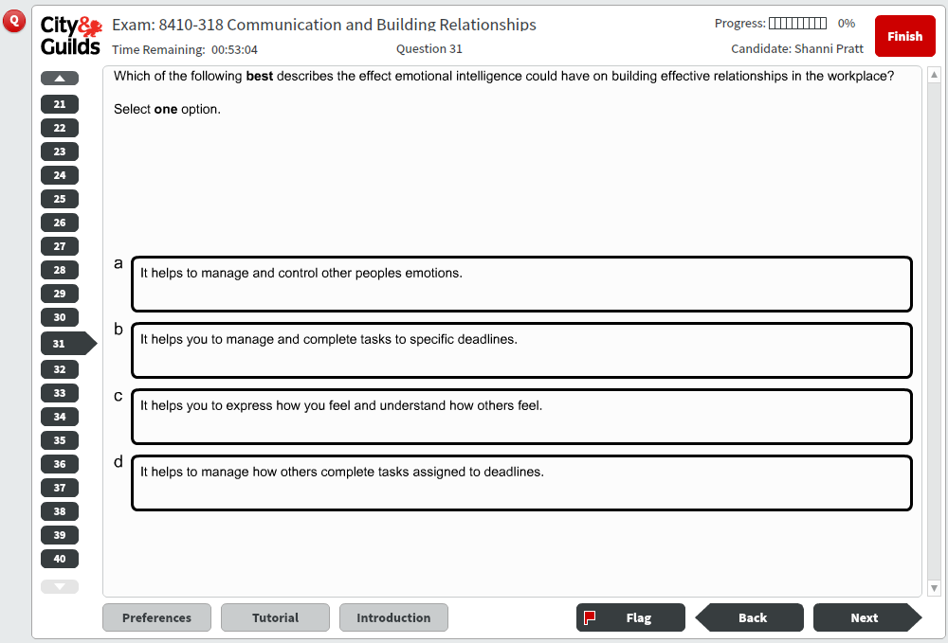

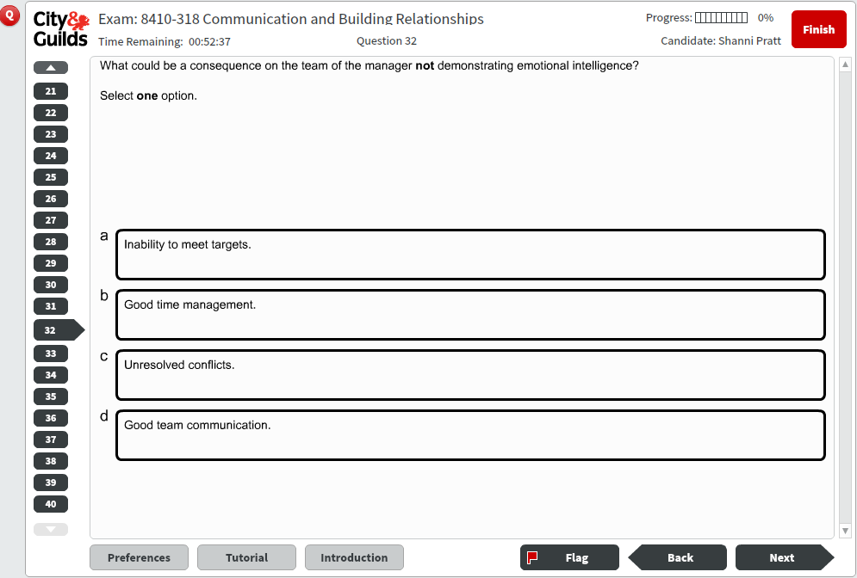

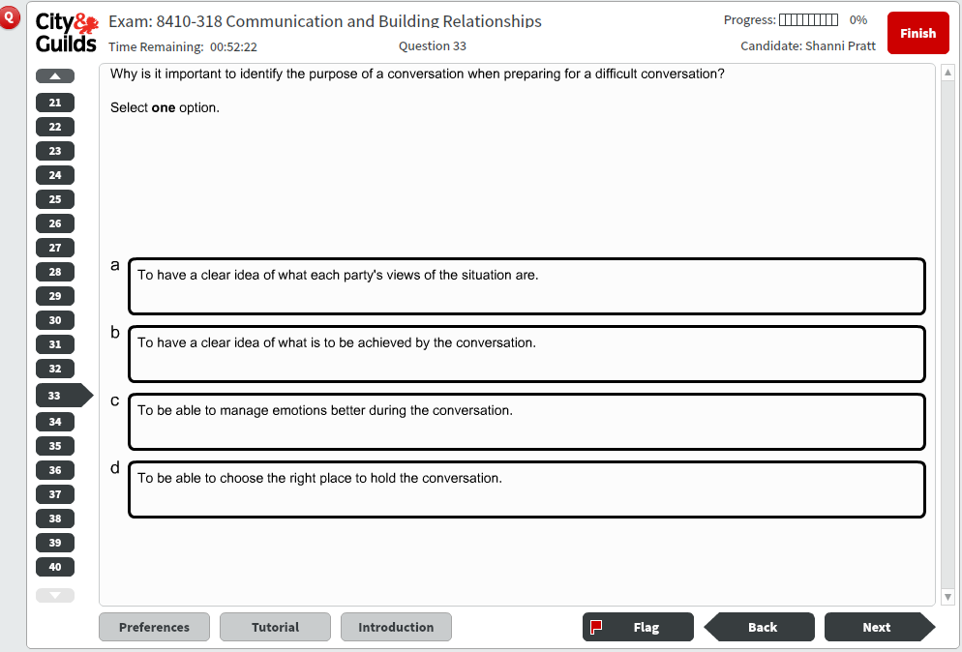

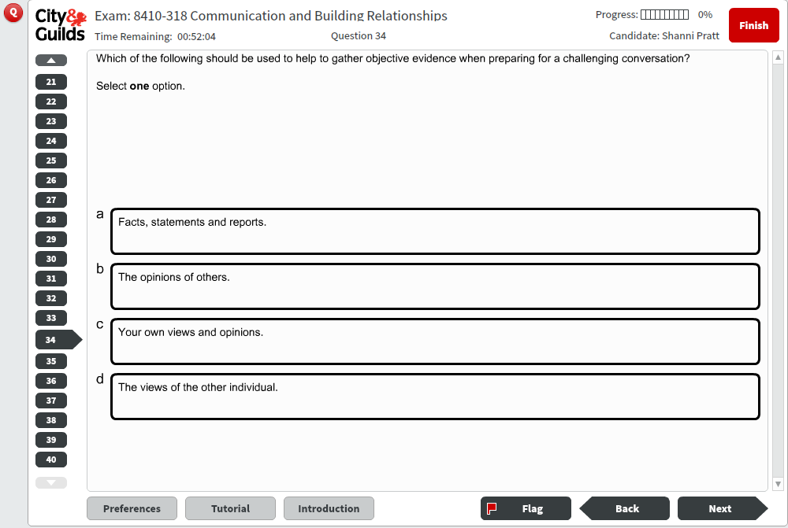

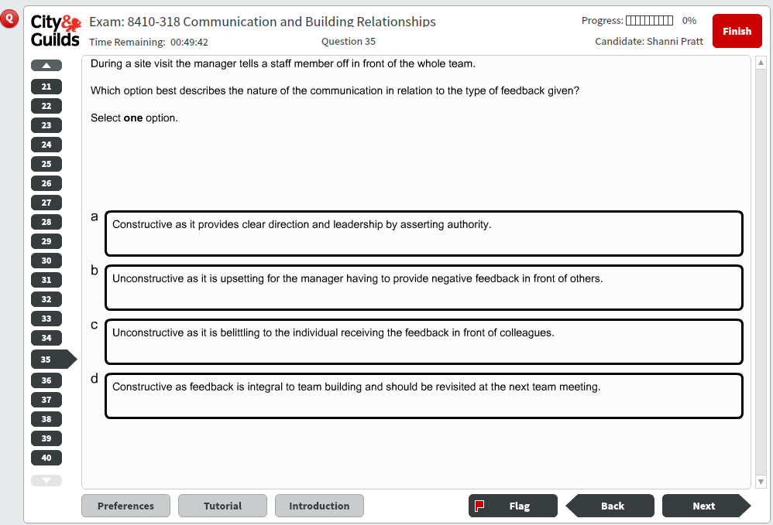

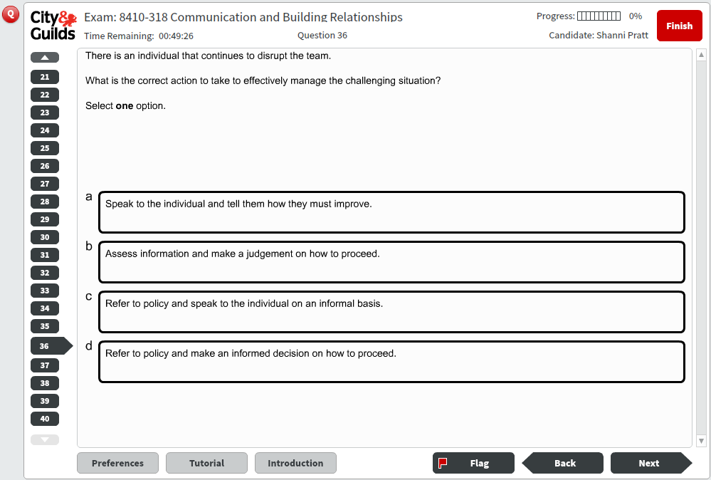

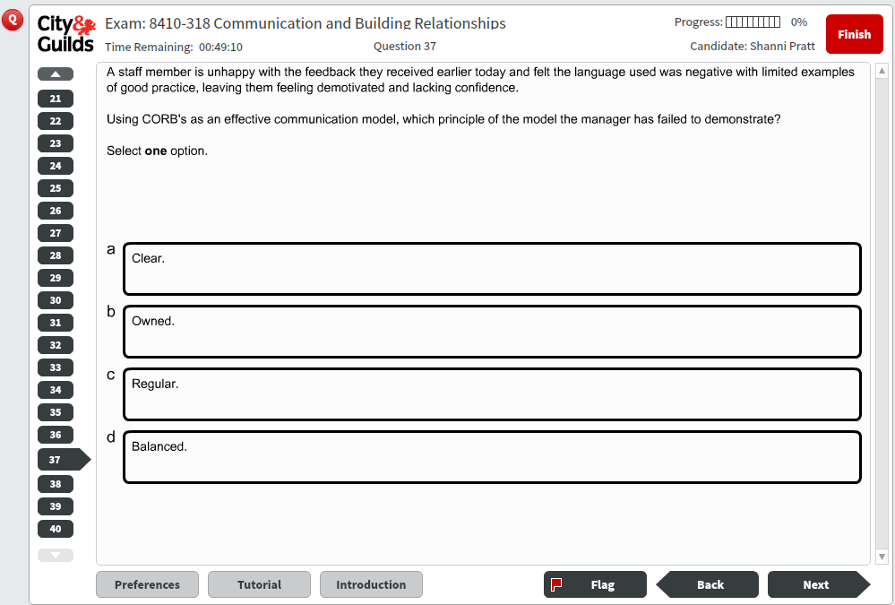

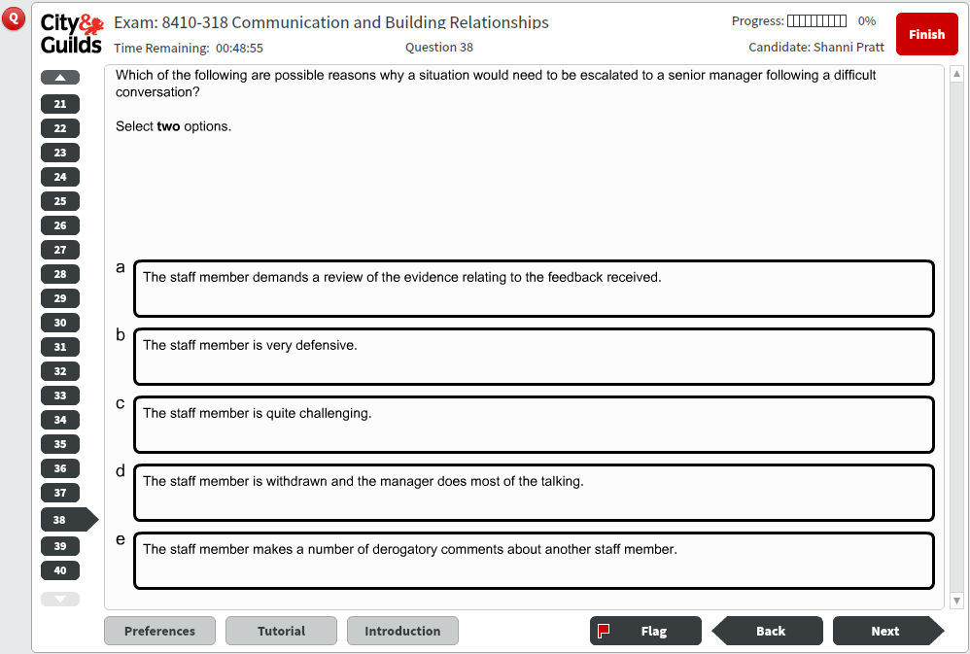

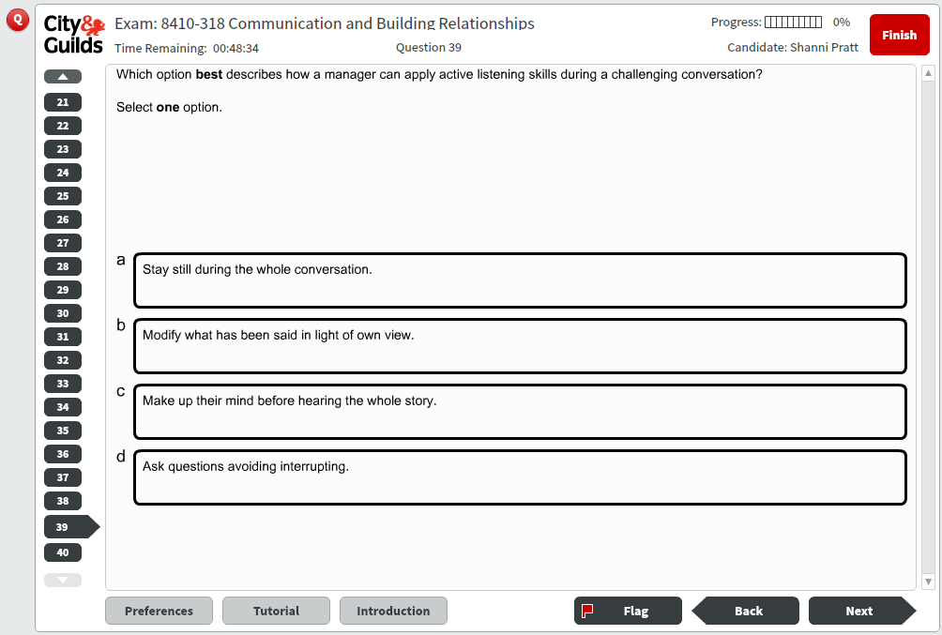

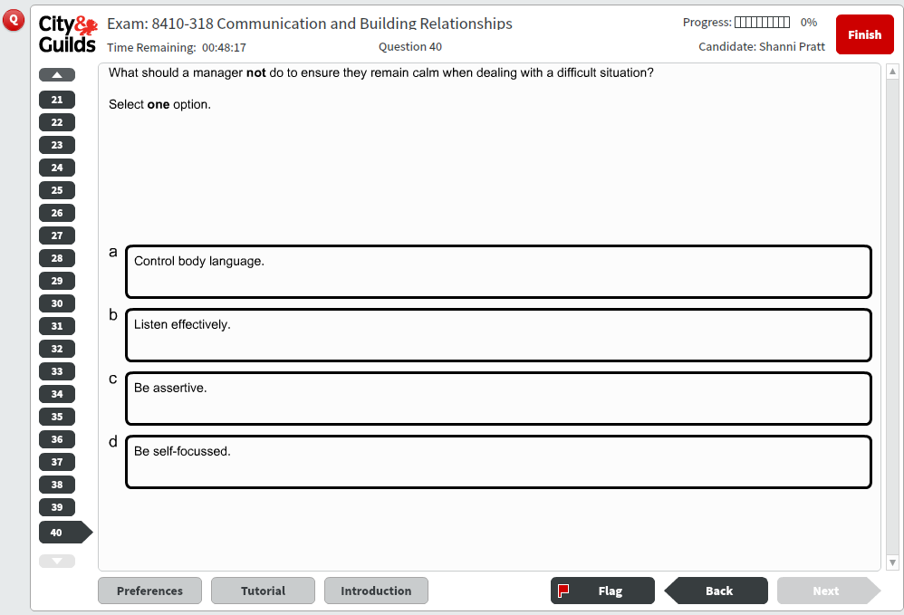

8410-318 Communication and Building Relationships – Sample test Mark Scheme



Useful contacts

ILM Customer Services  General enquiries  Events enquiries  International enquiries | E: customer@i-l-m.com
Complaints and feedback  Complaints and feedback | E: customer@i-l-m.com
ILM Regulation and compliance  Reporting malpractice/maladministration  Reporting incidents of plagiarism  Lodging appeals | E: ILMregulation@i-l-m.com

Every effort has been made to ensure that the information contained in this publication is true and correct at the time of going to press. However, ILM’s products and services are subject to continuous development and improvement and the right is reserved to change products and services from time to time. ILM cannot accept liability for loss or damage arising from the use of information in this publication.
If you have a complaint, or any suggestions for improvement about any of the services that we provide, please email: customer@i-l-m.com
About ILM
ILM is the UK’s leading specialist in leadership and management apprenticeships. Last year, we qualified over 14,000 management apprentices – seven times more than any other management body.
We believe that great leaders can come from anywhere. With the right support, anyone can grow and develop to make a real difference to their team and organisation. Which is why we help individuals from all levels to realise and apply their potential, so that the organisations they work for can reap the benefits.

City & Guilds Group
ILM is a City & Guilds Group Business. Together, we set the standard for professional and technical education and corporate learning and development around the world, helping people and organisations to develop their skills for personal and economic growth.

Copyright
Published by ILM.
ILM is a City & Guilds Group Business. The City and Guilds of London Institute. Incorporated by Royal Charter. Founded in 1878. Registered Charity in England and Wales 312832 and in Scotland SCO39578. © The City and Guilds of London Institute.

ILM
1 Giltspur Street
London EC1A 9DD
www.i-l-m.com

