How to use this badge information template to create
a Participation layer badge:
- Click file > make a copy to get an editable version of this template.

OR

Click file > Download > Microsoft word to open and edit in Microsoft Word

- Add the name of your badge to the file name

- Fill in the template with information related to your programme
Guidance is found in the grey boxes,
Swap out any highlighted sections for information relevant to the learning experience being badged
Please note that the character limits indicated include spaces.

- Check the character count before sending to your anchor

Highlight the section of text > select tools from the top menu (6th along) > word count
OR
Highlight the text > select Cntrl+Shift+C

- . Send your completed template to your anchor ready for design & build.

BADGE IMAGE  Dual-accreditation TEMPLATE | BADGE NAME
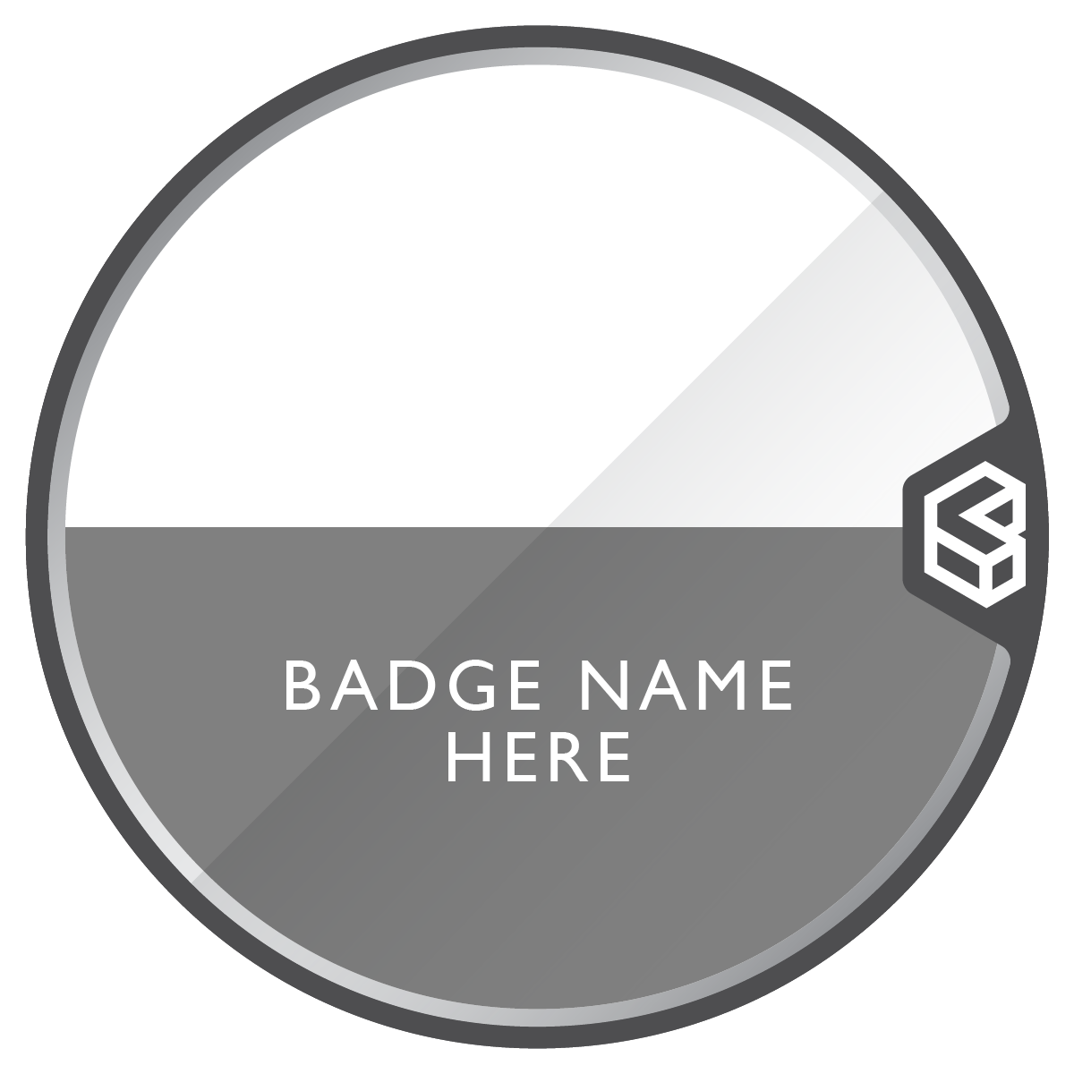 | ILM Level [level and title of qualification] achieved through dual-accreditation of modules within the [Name of University] [Name of degree pathway]
 | ORGANISATION URL
 | [Insert University programme URL]
DESCRIPTION 500 characters max
Earners of this badge have successfully achieved the [level and title of qualification] through undertaking modules within the [Name of University] [Name of degree pathway].

SKILLS TAGS
6-15 recommended
List the key skills that a learner develops through completion of the aligned modules.

If you have selected to have Labour Market Information links switched on, these skills tags will be the words that link to live job listings based on the skills in your badge meta data.

Switch LMI on? Yes/No

Example tags: Analytical skills, Communication skills, Critical thinking skills, Self-reflection, Leadership, Teamwork, Report writing, Data analysis, Theoretical modelling
[Insert your tags as comma separated list]

CRITERIA
Up to 10 max recommended
This section should convey what the individual had to do in order to complete the ILM qualification via the aligned modules, the tasks they completed and what kinds of evidence they had to provide.

Each criteria should be short and succinct, only one or two sentences long.

You can view other ILM dual-accreditation badges here:
https://www.youracclaim.com/organizations/ilm/collections/dual-accreditation/badge_templates

Each aligned module should be listed as a separate criteria

ACTIVITY TYPE | DESCRIPTION  500 characters max
Institution | List institution modules and assessment methodology
Assessment | This individual has undertaken [module title] and successfully completed [key assessment activity of that module].  Example: This individual has undertaken the University of XXXXX Concepts of Management module and successfully completed the required assessment of an individual 2,500 word business report with a supporting Excel spread sheet.
Assessment
Assessment | .
Assessment
Assessment

ACTIVITY TYPE | DESCRIPTION  500 characters max
ILM | List aligned ILM units and assessment criteria
Assessment | Through alignment to the modules above, it has been validated that the individual has met the requirements of the ILM unit Managing own continuing professional development (8607-521) and successfully met the requirements of the assignment task of an individual 2500-word assignment against the unit assessment criteria.
Assessment | Through alignment to the modules above, it has been validated that the individual has met the requirements of the ILM unit Analysing and interpreting statistics to inform management decisions (8607-516) and successfully met the requirements of the assignment task of an individual 2500 word assignment against the unit assessment criteria.
Assessment
Assessment
Assessment

STANDARD NAME | URL
ILM Level 5 Certificate in Leadership and Management – 8607-21 | https://www.i-l-m.com/Learning-and-Development/management/management-and-leadership-generic/8607-level-5-leadership-and-management
University of XXXXX BSc (Hons) Degree in Management | Insert university programme url  eg  https://www.uoxxxx.ac.uk/study/course-finder/bsc-hons-management

